**BERTELSMANN SCHOLARSHIP CLOUD DEVELOPER USING MICROSOFT AZURE**

1. **WELCOME: DEVELOPER FOR MICROSOFT AZURE**

**LESSON 1 Cloud Developer using Microsoft Azure Program Introduction**

# Welcome to Udacity



### **Welcome to Udacity!**

I am Sebastian, the founder of Udacity.

Our mission is to power careers through tech education. We’re honored that you’ve chosen us to help in your career journey. Whether embarking on a new path. Curious about a new field. Or advancing in your own field. I want you to know, you’re in the right place. We are here to help you accomplish your goals.

I can’t wait to see where this journey takes you!

# The Udacity Experience



If this is your first Nanodegree program, welcome. If you have taken a Nanodegree program with us before, you already know a little bit of what to expect. Udacity is always improving our learning experience for students. So you can watch this to see what is changed or skip ahead. You can also read this in the FAQ located in the resources tab.

Let’s get started.

We truly believe you couldn’t have chosen a better place to learn. A lot of people have worked tirelessly to create the course material and platform features, as we all want you to get the most of your learning journey. Our pledge is to provide you with resources and services that will further enable you to succeed in your Nanodegree program. As you go through the lessons, you may find some to be difficult and may feel discouraged. If this happens, we encourage you to take advantage of your community channels and mentor services to help clarify the concepts, or just to share your doubts. Our mentors are there to help you! You will get advice and guidance to ensure you are on track to complete the projects. We WANT you to succeed and graduate with a Udacity Nanodegree certificate.

We value the trust you have put in us by making this investment in your future career. We take it seriously and we are here to help you achieve whatever you came here to accomplish.

# Welcome to the Cloud Developer using Microsoft Azure Program

# Welcome to the Cloud Developer using Microsoft Azure Nanodegree Program!

Microsoft Azure is one of the fastest-growing cloud service providers around, with 95% of Fortune 500 companies trusting the platform with their business. That’s why companies across industries are looking to hire developers with Azure expertise, as Azure-related job growth is projected to hit almost 40% over the next decade. With Udacity’s Developer for Microsoft Azure Nanodegree program, you too can learn the skills you need to be in demand. In this program, you’ll develop the comprehensive knowledge and professional-level skills you need to build cloud-based applications on Azure. You will then demonstrate your practical mastery of these skills in a series of three projects, where you’ll use Azure tools to deploy storage and app solutions to for an Article Content Management System, implement a serverless microservice back-end architecture for a social networking web application, migrate a legacy web application and database to Azure, and collect and display performance and health data of an application on Azure.

### **How will you benefit from this Nanodegree program?**

In this course, you will acquire the necessary skills to advance your career as a Azure Developer in today’s cloud-native workplace through hands-on practice building, migrating and enhancing applications on Microsoft Azure. You’ll learn to:

* Assess the value, cost, and benefits of hosting their applications and systems in the cloud
* Interpret the benefits/challenges of IaaS vs. PaaS vs. SaaS and where Microsoft Azure fits into each of these
* Navigate the Azure Portal
* Choose the correct Azure Compute Service for their applications and storage needs
* Create a Subscription and Resource Group
* Manage and clean up Resource Groups
* Create a Linux VM
* Create an App Service and App Service Plan
* Manage basic app service settings
* Justify which resource to use for app deployment based on costs, scalability, availability and workflow
* Create a SQL Database in Azure
* Make updates to the schema of an Azure SQL Database and add data to it
* Create an Azure Blob Storage Container
* Upload blobs to the container
* Set up configurations for an app service to connect to both a SQL Database and Azure Blob Storage Container
* Differentiate security options between different Azure resources
* Compare security responsibilities between the developer and cloud provider for different applications
* Implement Oauth2 such as Sign in with Microsoft in their apps
* Utilize Azure Active Directory for single sign-on and multi-factor authentication in their app
* Monitor and analyze the log output of an app service running in Azure
* Distinguish the benefits of a microservice architecture versus a monolithic architecture
* Compare and contrast different services as a viable option for building microservices in Azure
* Outline the different microservices patterns in Azure
* Identify various compute options for microservice: Kubernetes Service, Docker, and Function (as a Service)
* Identify the costs of implementing microservices
* Define Azure Functions as well as common bindings and triggers
* Create Azure Functions in the Azure CLI and VS IDE
* Create a MongoDB database in CosmosDB and connect it with Azure Functions
* Secure an API endpoint with function-level authorization keys
* Create an Event Grid Topic in Azure Portal
* Apply Event Grid output binding for Azure Functions
* Create a workflow by using Azure Logic Apps
* Design a Logic App workflow for email
* Deploy API endpoints in Azure CLI to Azure
* Deploys a client-side Flask application to App Services
* Dockerize an application to a container and upload it to Azure Container Registry
* Deploy a client-side application to Kubernetes Service in Azure
* Assess cloud migration needs
* Identify different types of migration and their use cases
* Implement a migration plan using the migration cycle
* Assess web application migration paths with cost prediction
* Migrate existing web applications to Azure Web App
* Migrate a web application using lift and shift method
* Assess Azure Database options with cost prediction
* Migrate a database using Azure Database Migration Service
* Manually migrate a database from backups
* Architect offline background job services with cost prediction
* Migrate services to Azure Web Jobs, Azure Functions, and Azure Durable Functions
* Migrate background job services to Azure Batch
* Set up Application Insights
* Configure Application Insights on a VMSS
* Configure Application Insights for an AKS cluster
* Collect telemetry data
* Create an Azure Log Analytics Workspace
* Collect and ingest log data
* Write queries to return only relevant data of application performance
* Create reporting charts from data
* Create an Azure Automation Account
* Autoscale rules for VMSS
* Create a RunBook

### **What the program offers**

Throughout the program, you will work with:

Interactive lesson content Exercises Hands-on project where you will apply and practice your new skills. Professional review of your project by our project reviewers who will provide personalized feedback on how you can improve your work.

These projects will serve as a portfolio you can use to demonstrate your skills. After you complete the program, you will be ready for Azure Developer roles or bring these crucial skills to your current role.

Almost every role that involves cloud devops in today’s workforce, particularly at large enterprise technology companies, will require working with Microsoft Azure and we are excited to support you in this step in your career.

#### **We are excited and honored that you are taking this step in your journey with us!**

# Pre-requisites

* At least 1-3 years of web development experience, preferably programming in Python
* Experience creating and managing databases such as SQL Server or PostgreSQL.
* Comfortable using Git as a version control system to clone, pull, or push code.
* A free or existing Azure account needed to create and provision Azure services

# Meet Your Instructors

# Meet Your Instructors

We have a great group of instructors for each of the courses of the Nanodegree program. Each of them brings expertise from working in the field and experience teaching others. Below is a short bio of each instructor, and you'll learn more about them during the courses they teach.

### **Course 1 - Azure Applications**



#### **Chris Vasquez**

##### **Curriculum Manager at Udacity**

After beginning his restaurant and retail management career, Chris joined Udacity and utilized Udacity Nanodegree programs to build his technical skills, eventually joining the Curriculum Team to work on curriculum development for various programs before switching roles to Software Engineering.

### **Course 2 - Azure Microservices**



#### **Ann K. Hoang**

##### **Senior Software Engineer, AI Research Scientist at Raytheon BBN Technologies.**

Ann currently works on implementing maritime predictive modelings for the Department of Defense. Her experience includes building applications for Bay-Area startups to deploying AWS cloud infrastructure for medical imaging across Department of Veterans Affairs hospitals across the U.S . She holds an undergraduate degree from UC Berkeley and a Masters at Johns Hopkins.

### **Course 3 - Azure Migration**

,



#### **Golois Mouelet**

##### **Premier Field Engineer at Microsoft**

Golois is an experienced software engineer specialized in building resilient and scalable cloud native applications as well as migrating software and systems to Azure. He has worked with enterprises ranging from small, mid, to large size companies on both cloud migration projects and application performance. He is Azure Certified both as a Developer and Solution Architect. Golois enjoys mentoring and teaching other developers about Azure and cloud technologies.

### **Course 4 - Azure Performance**



#### **Nathan Anderson**

##### DevOps Engineer at the Goodyear Tire & Rubber Company

Nathan has implemented DevOps solutions for the past 8 years in the following industries: financial, educational, logistics, and manufacturing.

# Career chat with your instructors

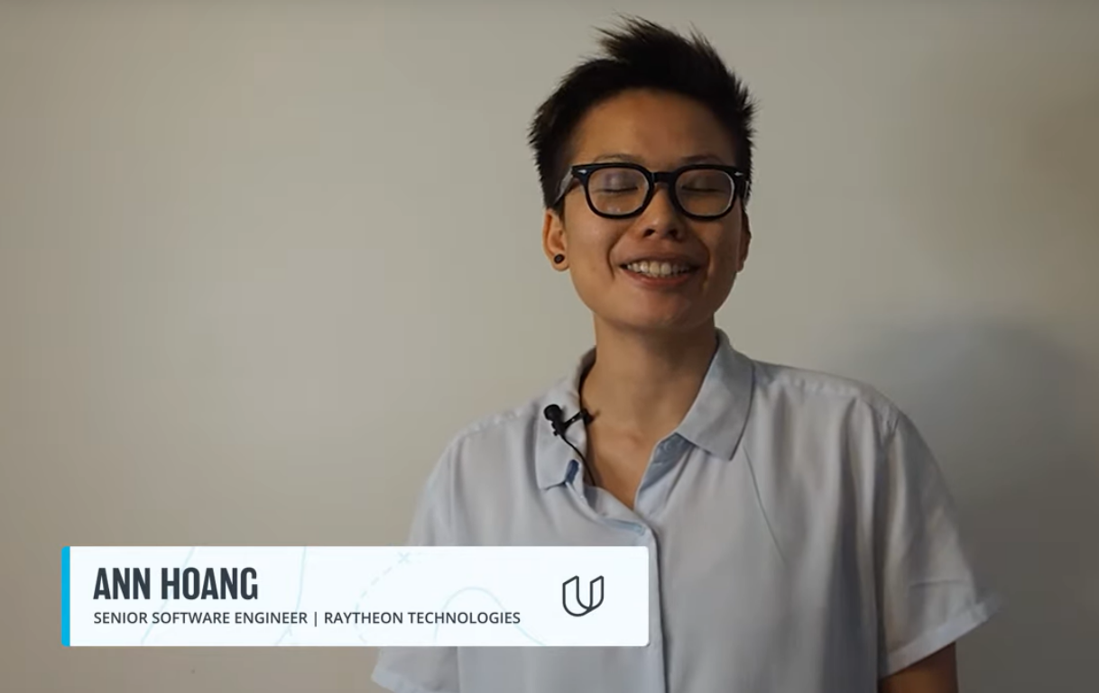

# How to Succeed



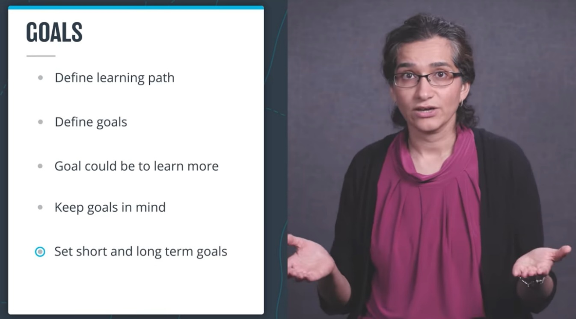

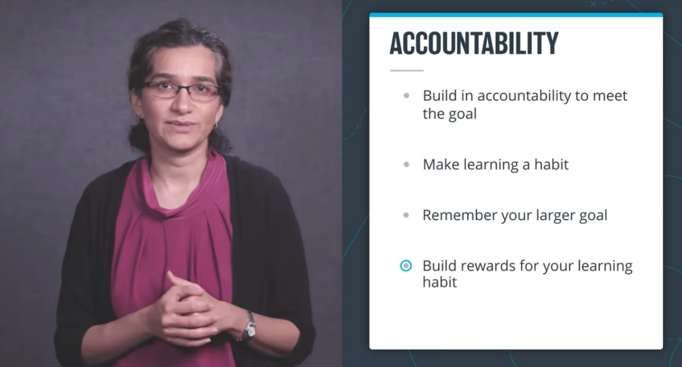

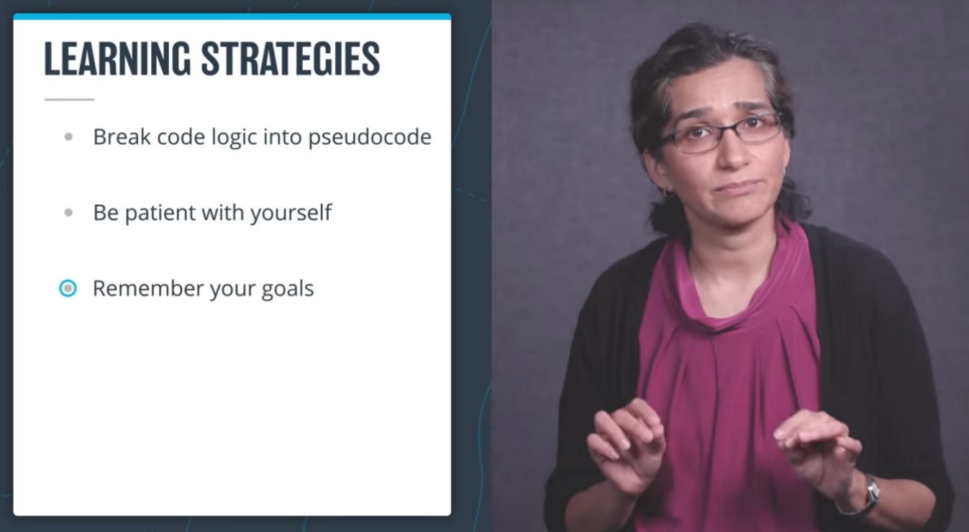



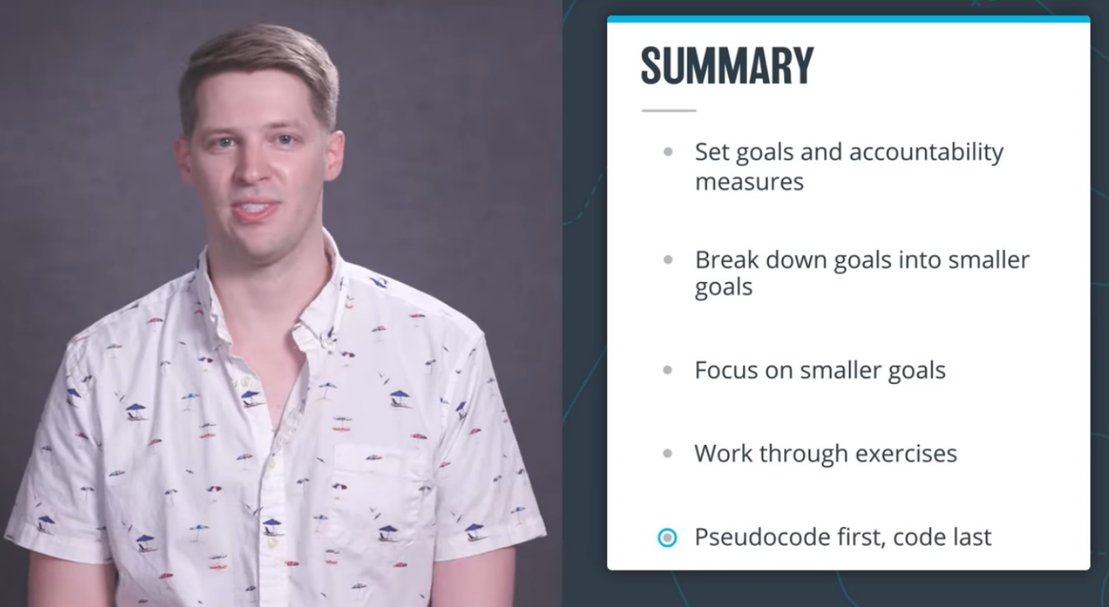

**LESSON 2 Knowledge & Community**

# What It Takes

# What it Takes

Completing a Udacity program takes perseverance and dedication, but the rewards outweigh the challenges. Throughout your program, you will develop and demonstrate specific skills that will serve you for a lifetime. Congratulations on taking the first step towards developing the skills you need to power your career through tech education!

The videos, text lessons, and quizzes you encounter in the classroom are optional but recommended. The project at the end of this course will test your ability to apply the skills and strategies you have learned in the classroom to real-world problems. It will also provide tangible outputs you can use to demonstrate your skills for current and future employers.

The project is designed to be challenging. Many students initially struggle, but with a little grit, they are able to learn from their mistakes and build their skills. Data from nearly 100,000 Udacity graduates show that commitment and persistence are the highest predictors of whether or not a student will graduate.

At some point, nearly every student will get stuck on a new concept or skill, and doubt may set in. Don’t panic. Don’t quit. Be patient, and work through the problem. Remember that you are not alone and the problem that you are encountering is likely one that many others have experienced as well. Whether you are stuck or simply looking for encouragement, you’ll find Udacity Mentors and students there to help.

# Getting Help

# Getting Help

As questions come up during this course, click on the Help button on the left sidebar of your classroom. You’ll see four options, each for a separate type of support:

* **Technical Mentor Help**: is available on Knowledge, our expert Q&A platform, by clicking on "Mentor Help". You can search for answers to questions similar to yours or post new questions related to your project or lessons. Udacity’s expert technical mentors answer all new questions.
* **Udacity Support Community:**Receive peer support and find answers to your non-technical questions quickly through [Udacity Support Community](https://udacity.zendesk.com/hc/en-us/community/topics). Receive peer support from our global community of lifelong learners that help each other succeed by sharing their experience and expertise. Start a discussion [here](https://udacity.zendesk.com/hc/en-us/community/topics).
* **General Account Help**: This is where you can get details on non-technical issues such as 3rd party tools, billing, deadlines, and more. You can even find additional help here via. live chat. Simply click on Account Help or visit our [Help Center](https://udacity.zendesk.com/hc) to find answers. .

# Mentor Help

# Mentor Help

**Technical Mentor Support**: is provided through Knowledge, our expert Q&A platform. You can search for answers to questions similar to yours or post new questions related to your project or lessons. **Udacity’s expert technical mentors answer all-new questions.**

### How to Use Knowledge

To ensure you’re getting the quality and prompt support you need, it’s helpful to follow these best practices and guidelines for Knowledge.

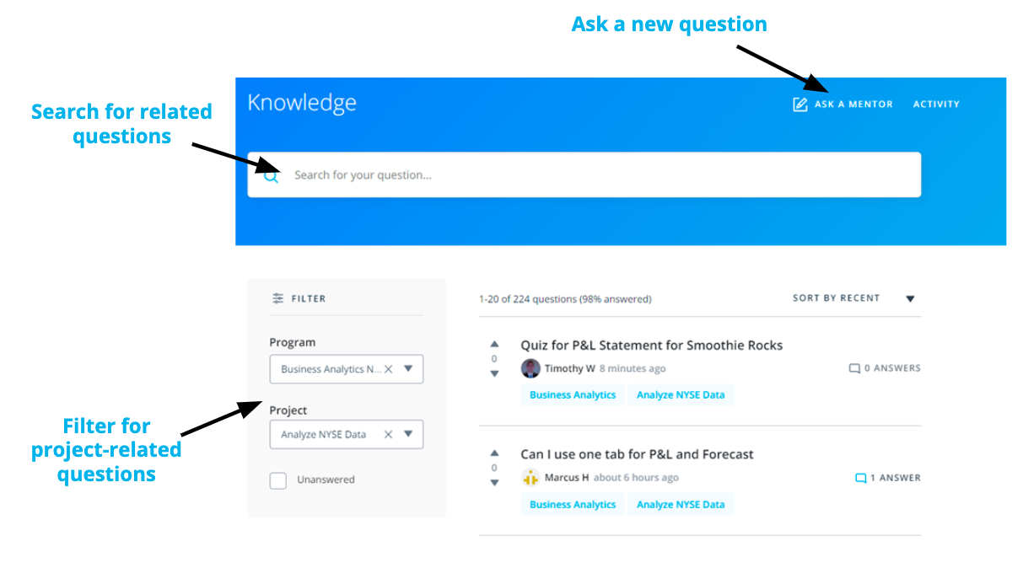

* **Search for Similar Existing Questions**: with tens of thousands of students enrolled in our programs, many of your questions may have already been asked and answered. To look for existing answers to similar questions that may provide the immediate support you need, use the **filter on the left side of your screen** to select your course and related project or write in the key terms related to your question in the **search bar** at the top of the page.
* **Ask a New Question**: if you want to ask a new question, select “Ask a Mentor” at the top of the page. Kindly remember that Knowledge is for technical questions only; for other types of support and feedback, please write to support at [support@udacity.com](mailto:support@udacity.com).

When you ask a new question, the platform immediately assigns it to one of our expert mentors spread across the globe to ensure prompt replies. Of note, when a mentor answers your question, you will see “Mentor” next to their name to differentiate their support from comments your fellow learners may also provide.

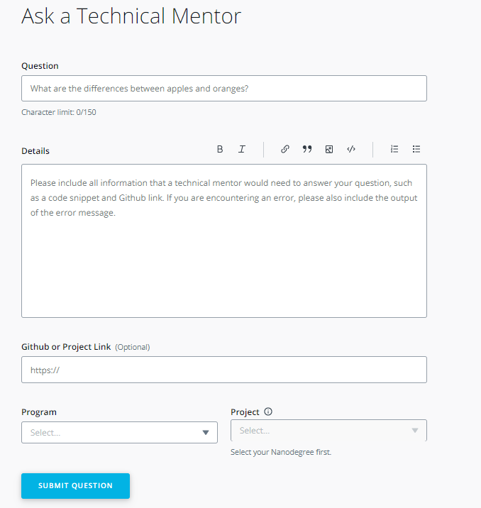

If you don't see your question, simply create a new post. You are likely to get an answer within 24 hours and you'll be helping future students who may encounter the same problem.

### How to Ask a Good Question?

Students that follow these tips typically receive the strongest initial support and avoid back-and-forth with mentors:

* **Ask Specific Questions**: if you have closely related questions that form part of a general theme, it’s okay to ask them all together. But consider using bullet points to separately list each of the questions in your post. Keeping your questions organized helps ensure mentors provide clear answers to each specific question. If your questions are less closely connected, it’s best to submit new, separate questions for each one.
* **Provide Details and Links:** explaining what (if anything) you’ve already attempted to solve the problem helps mentors know where to start when answering your question. Likewise, if your question is not related specifically to a project, but rather to an exercise, quiz, or lesson, it’s helpful to include information such as lesson or quiz name, screenshots, and classroom links.

*Overall the key to asking a good question is to imagine yourself trying to answer your own question. Imagine you were coming to it without any prior knowledge. Does the question make complete sense? Or are there gaps around the context?*

* **Start with a Clear Question Title**: attempt to summarize your entire question in one sentence. You may even write the title at the end, just before posting the question. This will help you summarize the issue before you include details in the question itself.
* **Share Code Correctly**: by using the “Code Block” option to properly format your code. If your question concerns a piece of external code, include a link to the file on Github.

*In fact, Github lets you create a link to a specific line in a file. To do so, just click to the left of the line number, and then select*copy permalink*in the ellipsis that appears in the margin. Paste the*permalink*right into the Github box on your question submission form.*

* **Figuring out Errors**: if your question is about an error message or stack trace, include the entire error message, by either formatting the error message using the “Code Block” option or creating a Gist or a Paste on Pastebin, and including a link to it in the description.
* **Avoid Screenshots of Code or Error Messages**: do not use screenshots of code or error messages. They are hard to read and the text cannot be copied to debug it.

If you receive a helpful answer, kindly select it as the “accepted answer.” For questions from other students, if you see other helpful answers kindly select the “upvote” option. Conversely, if you don’t think an answer strongly answers a question, select the “downvote” option.

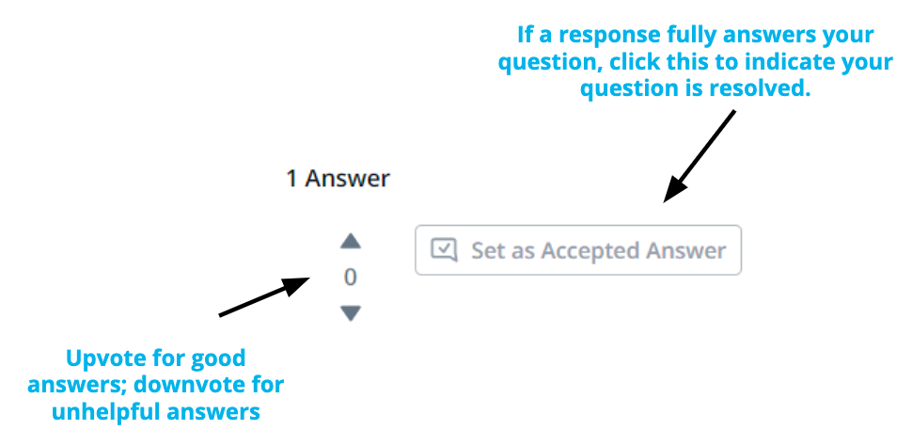

### Getting Additional Support

At times, students want support from a different mentor. As everyone learns differently, we want to make this a simple process for learners like you.

If you receive an answer that you are not satisfied with and want a different mentor to chime in, kindly select the option at the top of the page in Knowledge. If you reply directly in the comments section, without clicking on the link at the top of the page, your question will not be answered by another mentor.

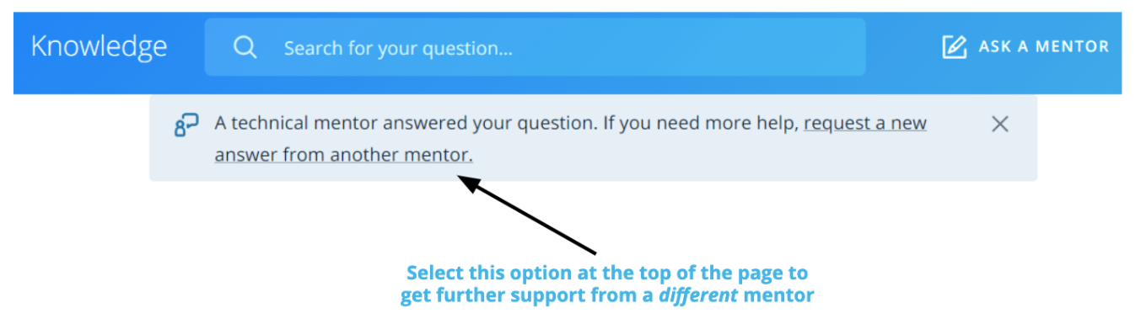

# Udacity Support Community

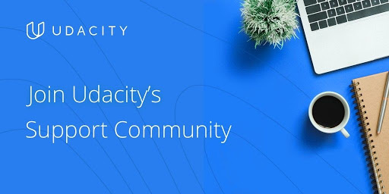

**Welcome to Udacity’s Support Community!**

Become a part of our global community of lifelong learners that help each other succeed by sharing their experience and expertise. Receive peer support and find answers to your non-technical questions quickly through Udacity Support Community.

**Find answers to your questions**

Search Udacity Support Community for answers to commonly asked questions.

**Receive peer support**

Ask the community by posting a question and following discussions.

**Share your expertise**

Get recognized for sharing your insights, experiences, and tips with fellow learners.

**Checkout status of your Support tickets**

Manage and streamline your view of the support tickets, community conversations, and people you follow in the 'My Profile' section.

**Solved, helpful, and recommended posts**

Let other learners know which posts solved your problem, highlight helpful responses, and get the answers you want faster with recommended posts.

**Build your reputation in the community**

Explore and participate in Support Community programs to earn points, levels, and badges. Have fun and unlock rewards along the way.

### Join the [Support Community](https://udacity.zendesk.com/hc/en-us/community/topics) now

# Plagiarism

# Plagiarism and Academic Dishonesty

## Overview of Plagiarism at Udacity

### Defining Plagiarism

**Any act claiming or implying another person’s work as your own.**

Examples:

* Submitting a project you didn’t create to copying code into a program without citation.
* Any action in which you misleadingly claim an idea or piece of work as your own, when it is not.

### Copying and Combining Code

**Using another person’s work in your own work**

Examples:

* Following a guide that someone may have created for completing a Udacity project, whether from a video or website.
* Taking a part of someone else's project and changing some variable and function names, - regardless of whether you give the source credit or not.
* If you have not done the work yourself and attempt to mask it.

### Using Someone Else’s Code to Inform your Solution

You should never knowingly view someone else’s work until you have completed the project yourself - nor should you share your project with someone who has not yet completed theirs. However, once you have completed your project, you are encouraged to see how other people have approached the same challenge in a different way. This allows you to compare your different strategies and ways of thinking.

### Submitting Identical Works Post Collaboration

If you decide to work together with another student on a project, you are then expected to write your code separately. Submitting identical projects or submissions with identical portions is considered plagiarism as described in the Udacity [Honor Code](https://www.udacity.com/legal/en-us/honor-code).

## Seeking Help without violating the Honor Code

To be clear, you are encouraged to seek help by talking to Mentors on Knowledge, other students, and alumni. You’re also welcome to use frameworks and libraries to assist you, as long as they aren't removing important goals from the project that you should know how to do yourself.

If you are struggling and need help, we encourage you to ask technical questions on Knowledge to explore why your approach is not the correct approach. Mentors typically provide answers within an hour of questions being posted, so you can expect quick guidance on your question.

If you’re ever in doubt as to whether or not something would be considered plagiarism, ask a Mentor on Knowledge. Our goal is for every student to graduate armed with a toolbox of skills that they can apply across a variety of concepts and problems. The best way to achieve this is to ensure every student does their own work and is able to demonstrate their skills in each project submission.

**LESSON 3 Getting Started – Azure Setup**

# Setting up Your Own Azure Account

For this program, If you already have a Microsoft Azure account, you can use it for exercises and projects. If you would like to create a free Azure account, follow the instructions below.

Udacity's Cloud Lab and instructions on how to use it can be found on the **'Using Udacity Cloud Lab on Azure VM'** page found in this lesson.

When you set up a new account, you can get access to **some specific services for free (up to the specified amounts)**. Certain services may be contingent upon resource and region. After you've got your account set up, be sure to have a look at the following page on managing your costs in Azure.

### Steps to set up your Azure account

1. Go to the [Azure home](https://azure.microsoft.com/en-us/free/) page.
2. Click on the "Start Free" Button.
3. You can use your existing "GitHub" or "Outlook" account—or click on "Create One".
4. Finish your registration. Note that**you will need to enter your Credit Card information.**

## Upgrading Your Azure Account After 30 Days

You have up to 30 days to use up the $200 credit, after which you must upgrade your Azure account to gain access to additional services for a year. Please upgrade your Azure account in order to complete this program without incurring costs.

When you upgrade your Azure account, you are really upgrading a Subscription. Subscriptions are tied to payment details and are the resource in the Azure Portal you attach to payment information and Resource Groups. You can find [more details about Subscriptions](https://classroom.udacity.com/nanodegrees/nd081/parts/e5c3bee8-599f-4480-9a6c-1ea14a5d9b0d/modules/3c42260e-09bf-4fb5-8652-3ed6370263d1/lessons/b2ca2f8f-bf72-48aa-a18f-06ccc5b7181c/concepts/97c83bed-c3a7-4a6f-a0e0-65d7d3ae4ea5) in the Azure Applications Course.

### How To Upgrade Your Azure Account:

1. Log in to the Azure Portal with the account you wish to upgrade. Choose to upgrade your account directly from the top bar of the Azure portal, or by searching for subscriptions, selecting the subscription, and choosing “Upgrade Subscription” at the top of the Subscription screen.
2. In the Upgrade screen, scroll down and **choose the “Basic - Included (free)” support plan**. If you do not see the Basic choice, make sure you scroll down to find it on this screen and select it.
3. Click on the **Upgrade** button
4. Re-enter your credit card information and follow the phone verification if prompted.
5. You should get an email confirming the account upgrade

After your account is upgraded you will have access to [these Azure resources and limits](https://azure.microsoft.com/en-us/free/free-account-faq/)for one year. **PLEASE REVIEW THIS LIST CAREFULLY to see what services are free and for what time period.** Happy cloud computing!

**References**

[Upgrade Your Azure Subscription](https://docs.microsoft.com/en-us/azure/cost-management-billing/manage/upgrade-azure-subscription)

# Cost Management in Azure

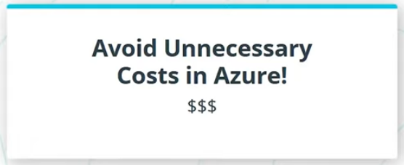

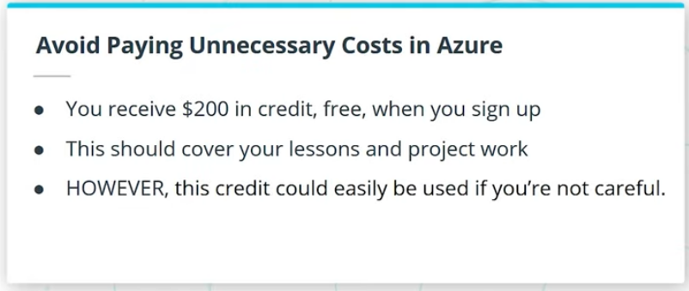

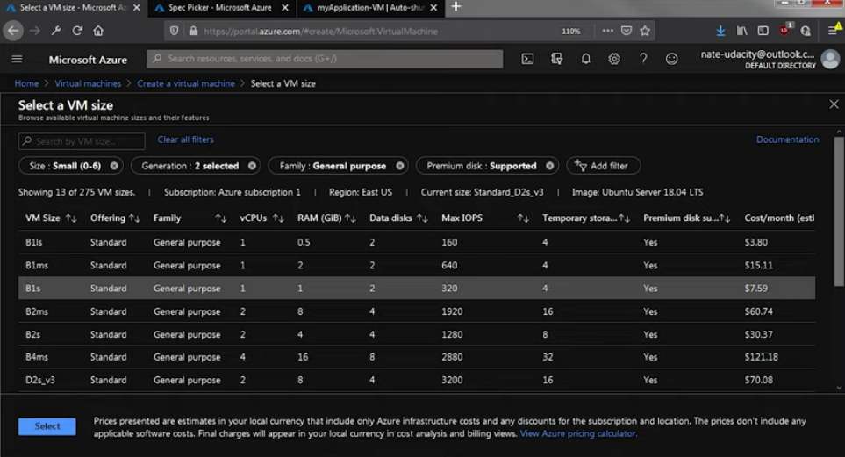

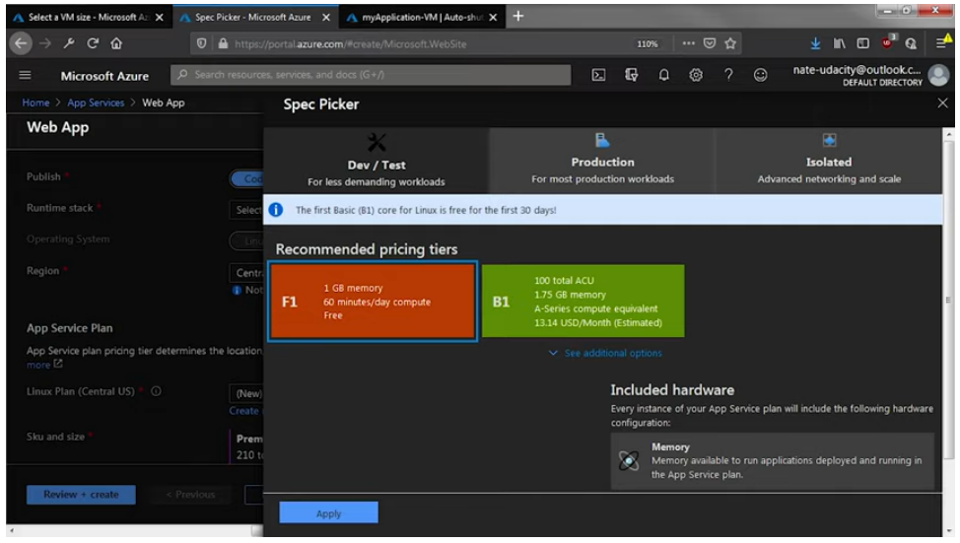

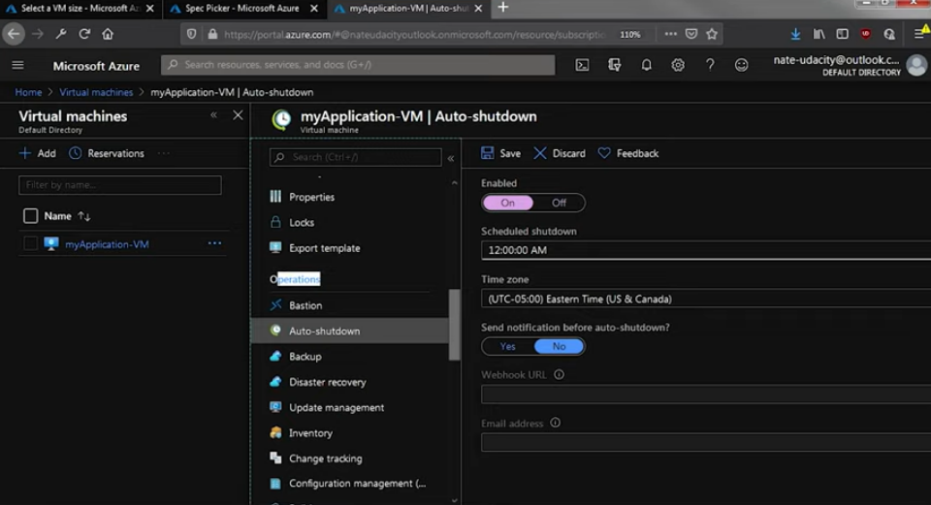

## Verify Azure Costs

**BE CAREFUL - When you create your Azure account you will be provided a $200.00 credit with no charge ONLY for 1 month.**

### If you are NOT careful about TURNING OFF THE RESOURCES after each exercise and project, you can very easily use up the $200 limit.

**Please use the Standard_B1s size for your VM,** and you should be able to keep the AppService at the free tier with no problem.

## Verify Azure Costs

BE CAREFUL - When you create your Azure account you will be provided a $200.00 credit with no charge, but this could very easily be used if you’re not careful. **Please use the Standard_B1s size for your VM,** and you should be able to keep the AppService at the free tier with no problem.

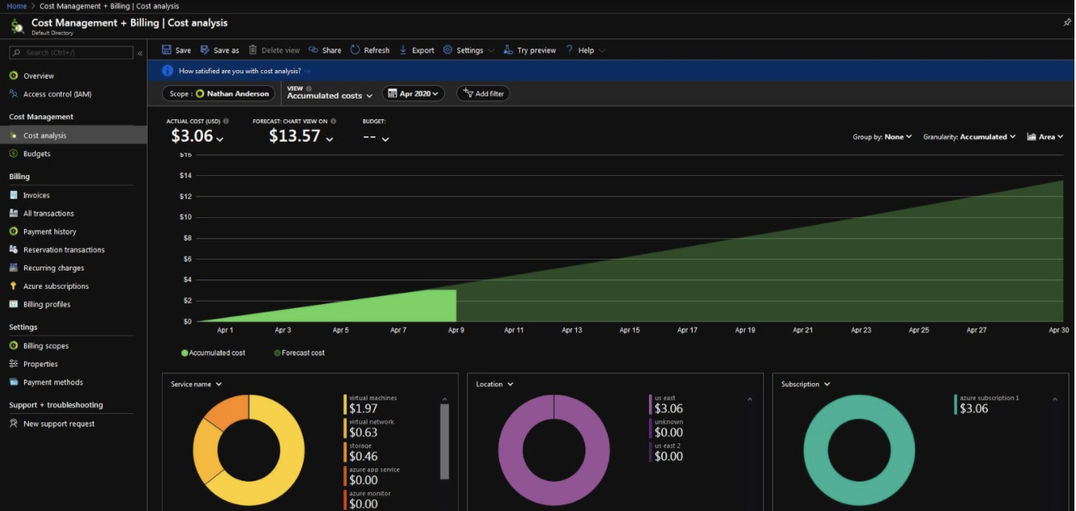

**Azure Cost Management and Billing Screen**

### Cost Management

Once you set up your Azure account, keep tabs on your Azure cost and **ensure your costs don’t exceed what’s provided to you** in the Azure free tier. To do so,

* Choose a subscription (such as Pay-As-You-Go or Free tier)
* View the Cost Analysis

This shows a cost breakdown of the resources in your subscription. **Be sure to check this each day,** especially if you are using Terraform to create resources. **Also please enable Auto-shutdown for your VM by going to the Azure Portal > your VM > Operations > Auto-shutdown.**

# Udacity Cloud Lab

Students can opt in to use Udacity Cloud Lab to run Azure VM for the exercise and project in this program. The Cloud Lab eliminates the time and complexity involved in setting up an Azure account. However, there are several restrictions and resource constraints when using this Cloud Lab, as described below.

### How to use the Azure Credentials

Udacity Cloud Lab will generate a pair of temporary credentials for you to use on the Azure Portal <https://portal.azure.com/> . Heere are the steps:

1. Click on the **ACCESS LAB** button in the panel to the right **→**
2. Wait until the Cloud Lab loads. It could take up to 10 minutes.
3. Open the Azure Portal <https://portal.azure.com/> in a new tab.
4. Use the Cloud Lab **username** and **password** provided to log into the Azure Portal.

### Getting Help

If you have a technical problem while using your VM, you can send an email to Udacity Support at [udacity-labsupport@udacity.com](mailto:udacity-labsupport@udacity.com). Please be sure to send your message from the email you used to enroll in the Nanodegree program.

Please copy the below text into your email and fill out the following information:

* Subject Line: Error in [Lab name]
* Timestamp and Timezone:
* Brief description of what you were doing when the issue occurred:
* Screenshots:

### Restrictions while using the Udacity Cloud Lab

* The Cloud Lab has a 4-hour session time limit. **After the time session expires, any resources you have created (VMs, Databases, Web Apps and their files, etc.) will be deleted**. You will have to start a new session in the Cloud Lab by refreshing this page and use the newly generated credentials. You can track the session time as shown in the snapshot below.

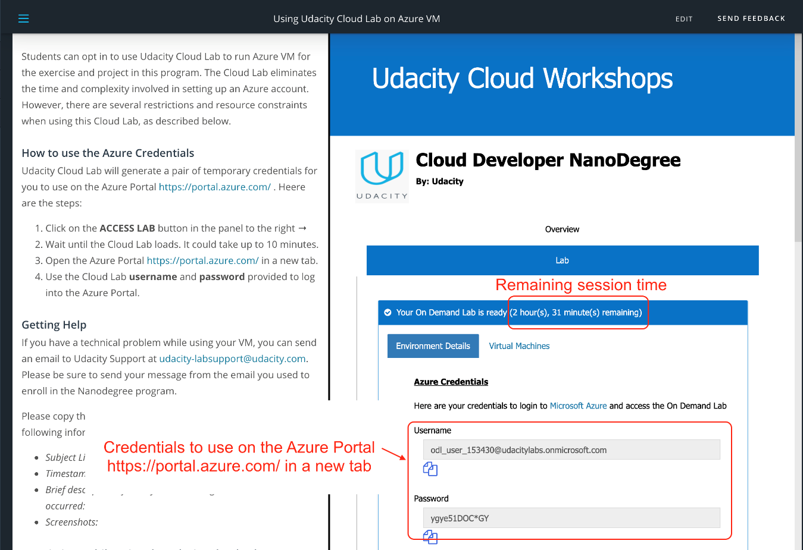

Cloud Lab - Remaining session time

* You will not be able to create additional Resource Groups. **There is one resource group already created for you named cloud-demo-XXXXXX**. Choose this Resource Group when creating resources. There might be instructions in your classroom to create a Resource Group, but you should use the existing Resource Group instead. Create/delete resources out of it if you do more than one exercise in a session. Creating multiple Resource Groups is not a requirement for any project/exercise.

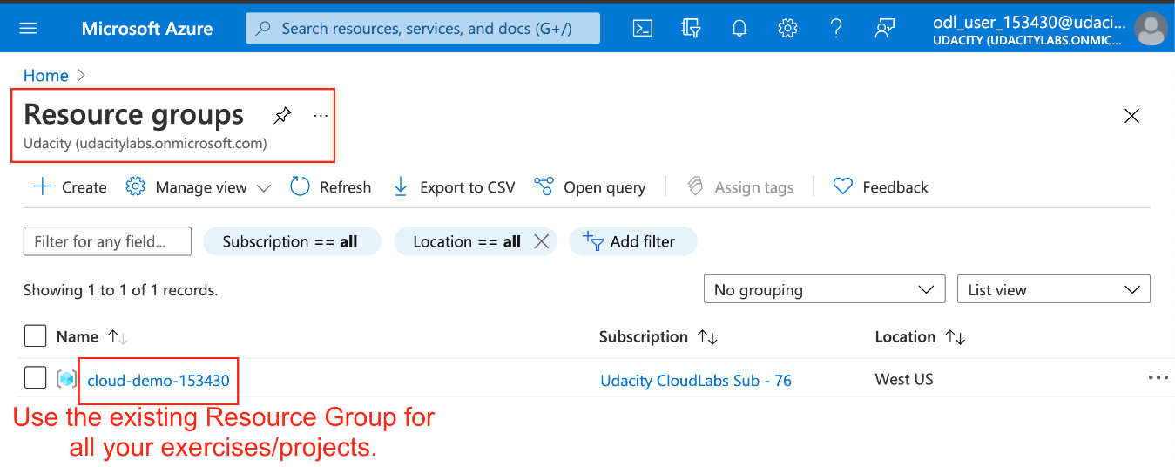

Cloud Lab - Predefined Resource Group

* When you create a new Virtual Machine, make sure to choose the following configuration, otherwise, the Azure portal may trigger a "Validation failed" error message.:
  1. **VM Size**: Acceptable values are B1s, B1ls
  2. **OS Disk Type**: Change the default disc type from "Premium SSD" to "Standard HDD"

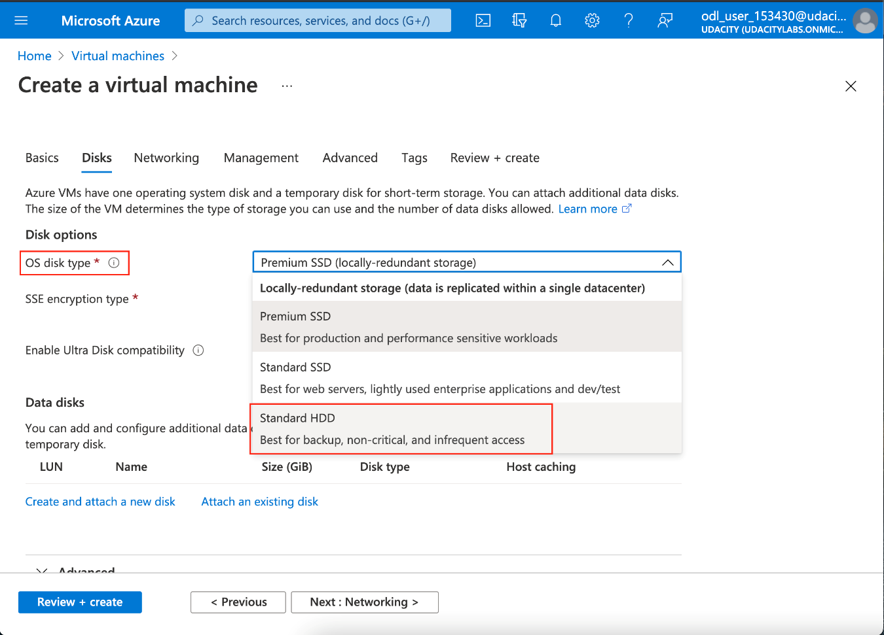

Cloud Lab - Changing the default disc type from "Premium SSD" to "Standard HDD"

* You will not be able to create Active Directory resources.
* You will not be able to create Log Analytics workspace resources. Instead, you will get a pre-created Log Analytics workspace in your account. You can use the existing Log Analytics workspace for your exercises, wherever applicable. See the snapshot below.

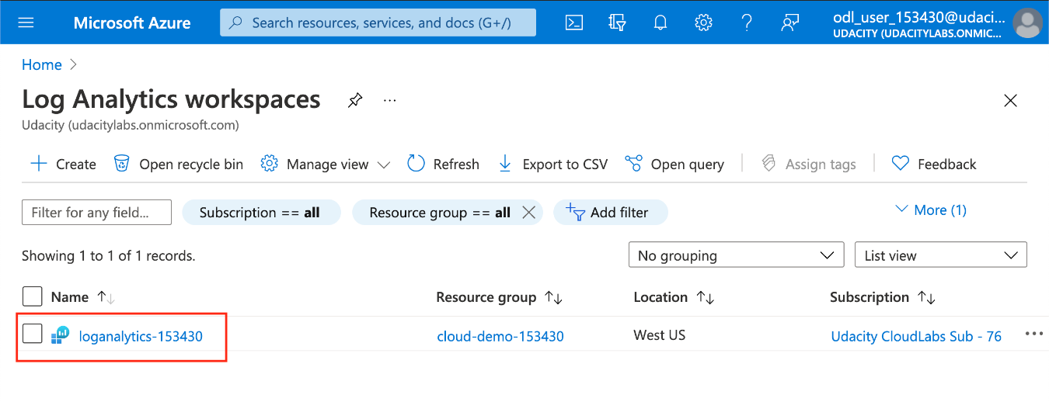

The pre-created Log Analytics workspace in your account.

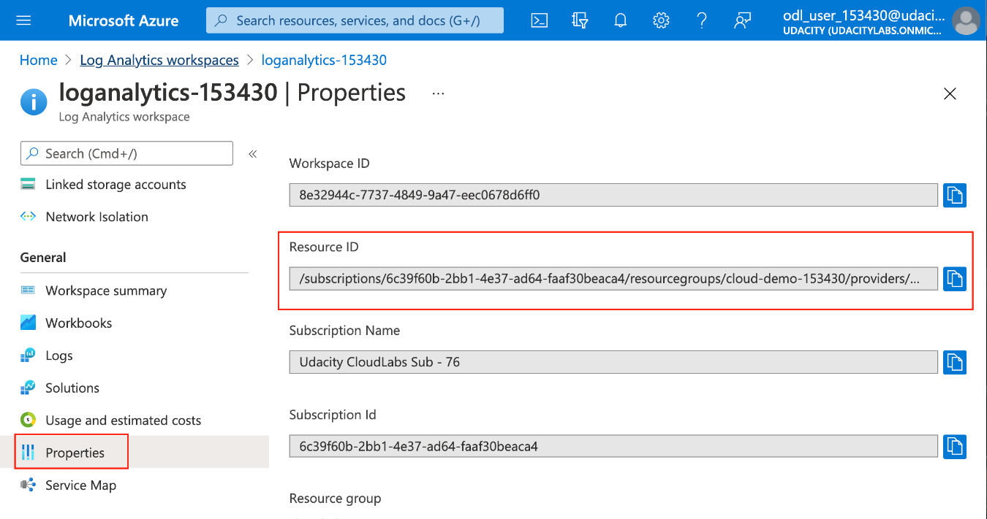

Use the Resource ID of the existing Log Analytics workspace for your exercises, wherever applicable.

1. **AZURE APPLICATIONS**

**LESSON 1 Introduction to Microsoft Azure Development**

# Meet Your Instructor



Chris Vasquez, All-Star UDACITY Curriculum Manager with years of practical experience building courses and also in Azure, will lead us through the course! Chris gained some of his own technical skills through Udacity courses and Nanodegree programs, just as you will.

# Prerequisites

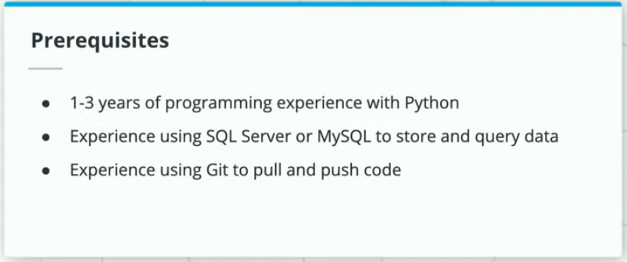

To succeed in this course, students should have experience in the following areas:

* Python (1-3 years of programming experience preferred), with experience building Flask apps
* SQL Server or MySQL to store and query data (you can get by with other SQL flavors as well)
* Using Git to pull and push code

# Lesson Outline

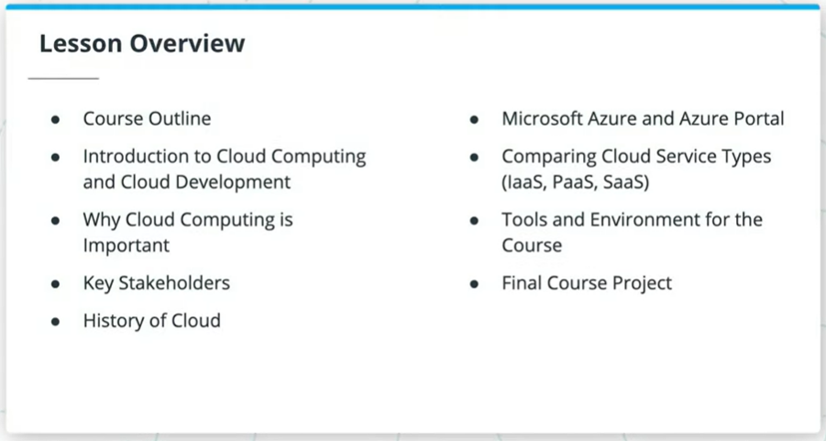

This lesson will focus on the following topics under Microsoft Azure Cloud Development:

* Why cloud computing is important, when to use it, and who are the key stakeholders
* History of *the cloud*
* Microsoft Azure and Azure Portal
* Comparing cloud service types (such as Infrastructure as a Service, Platform as a Service, and Software as a Service)
* Tools and environment set up for the course
* The final course project

# Course Outline

The course is divided into 3 major sections - Azure Compute Services, Storage Options in Azure, and Security, Monitoring and Logging.

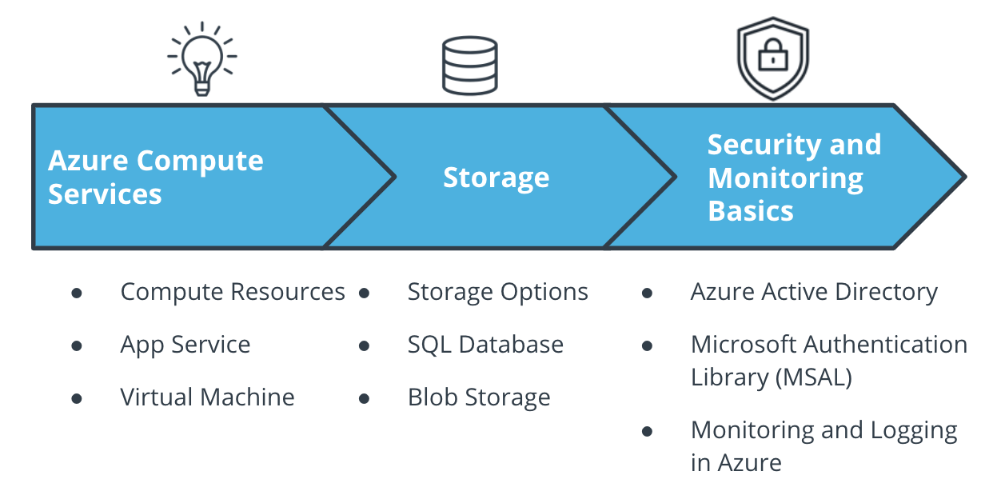

The Course Outline

# Introduction to Cloud Development

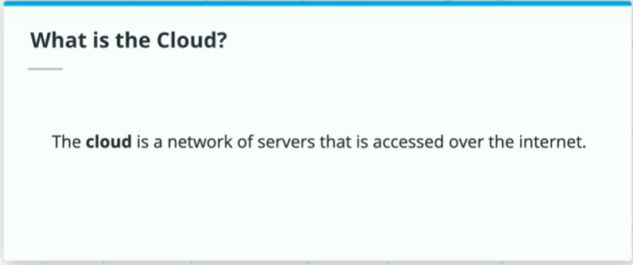

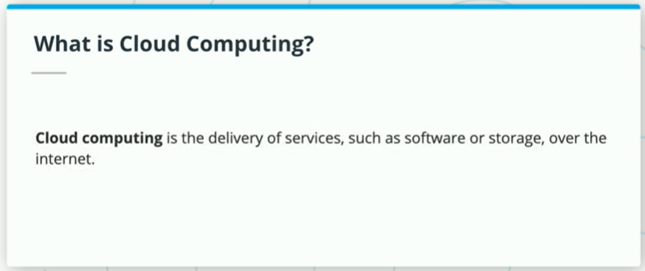

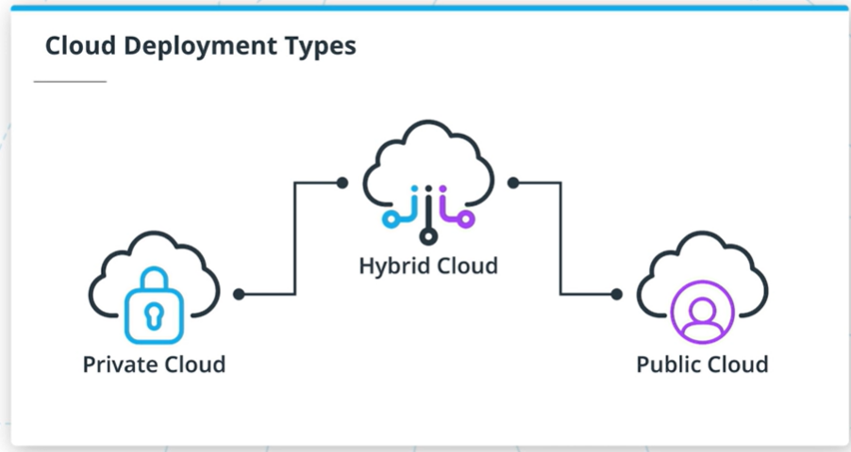

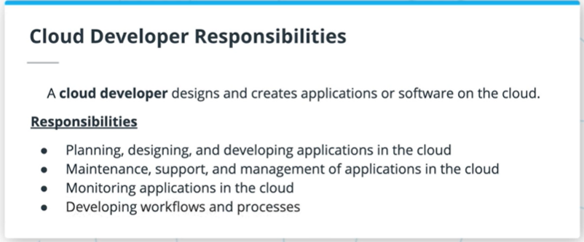

The **cloud** is a collection of servers on the internet that store and manage data, run apps, and deliver content such as email or videos. **Cloud computing** is the delivery of software and storage over the Internet (i.e. *the cloud*).

Some of the benefits of using cloud computing are:

* Cost
* Scale
* Reliability
* Security

The three major types of cloud services are **Public**, **Private**, and **Hybrid** cloud.

The major differences between these are in where they are deployed, and who manages them. Microsoft OneDrive, Microsoft Azure, and Microsoft Office365 are examples of public cloud options.

Cloud Developers perform some of the following:

* Plan and design cloud based apps
* Monitor, maintain and support cloud applications
* Develop work flows and processes

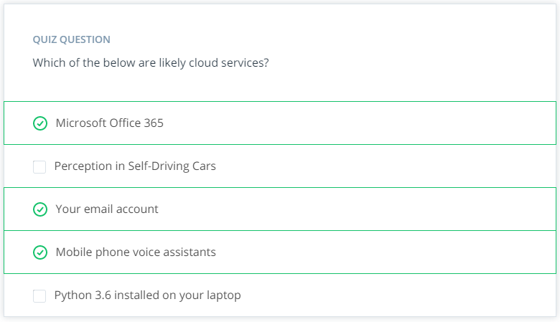

# Why Cloud Development Is Important

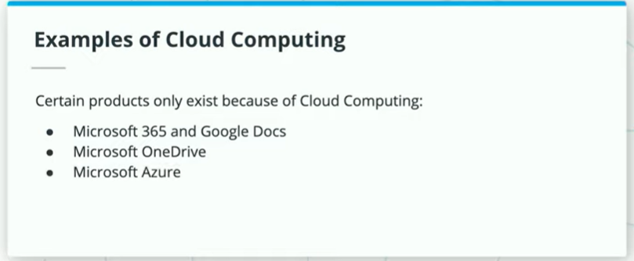

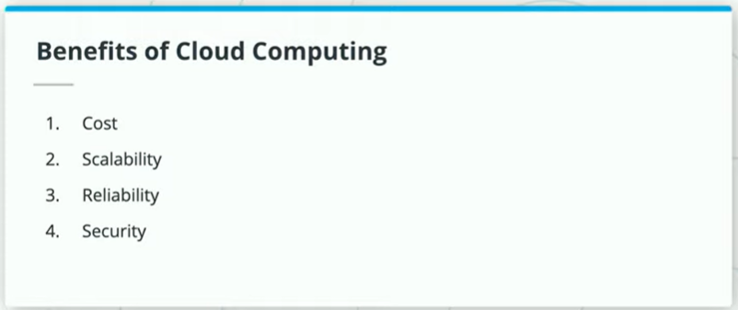

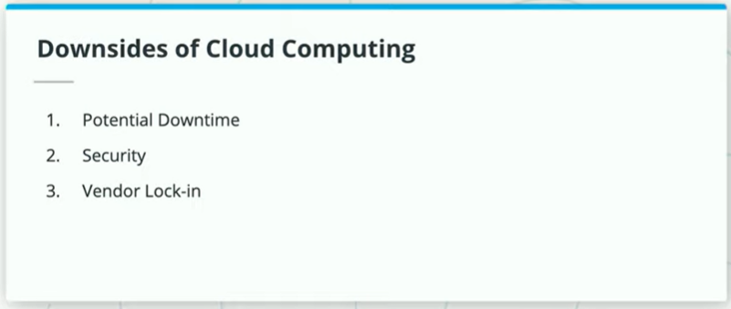

You've probably worked with various cloud services before, such as Microsoft OneDrive and Google Docs, and of course, you'll be working with Microsoft Azure in this course.

Some of the advantages of cloud computing are:

* Cost: The cloud provider handles all the upfront costs associated with buying hardware, along with on-going maintenance costs
* Scale: Most are pay-as-you-go depending on demand (elasticity), and can be expanded as needed
* Reliability: Management of backups, disaster recovery, etc. is made easier
* Security: Policies and controls are already in place to protect your data

Some of the disadvantages of cloud computing are:

* It is internet-based, so it can be prone to outages and fluctuations in speed
* Sensitive, private and core data is physically located on someone else's server
* Cloud services will be tailored and customized for your specific cloud instance, potentially making it hard to quickly change providers

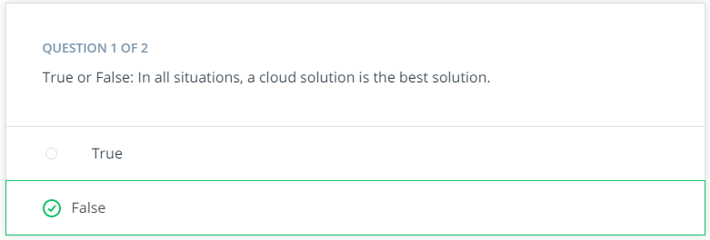

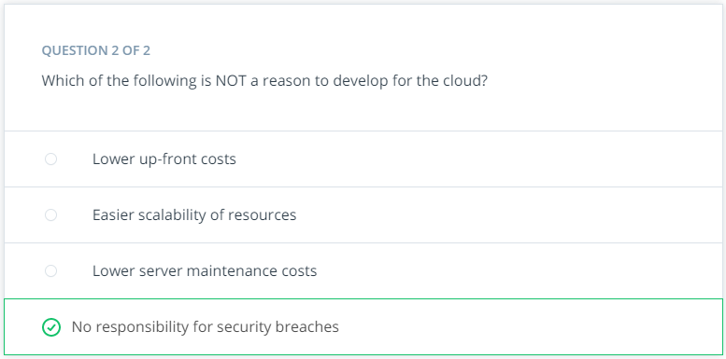

**Business Stakeholders**

As a cloud developer, you will interact and engage with numerous stakeholders, each of whom has different priorities. Some of these are:

* Your users
* Company executives
* I.T. Department
* Cloud Service provider
* Finance Department

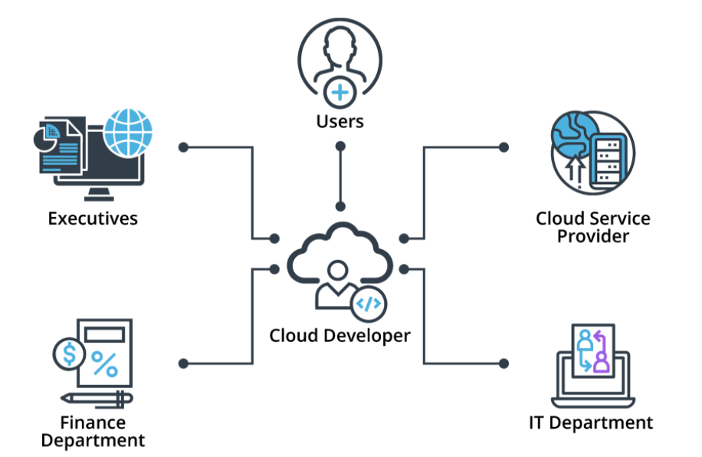

The key stakeholders in cloud development

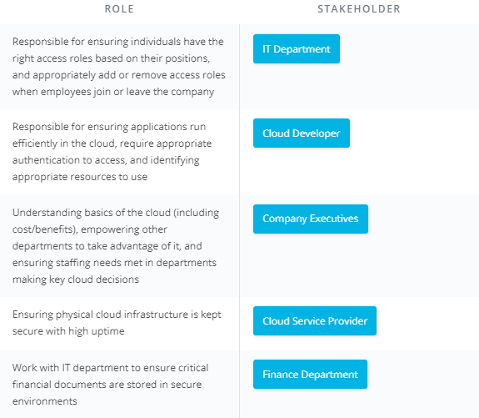

# History of Cloud Development

## History of Cloud Development

The roots of cloud computing go as far back as the 1960s.

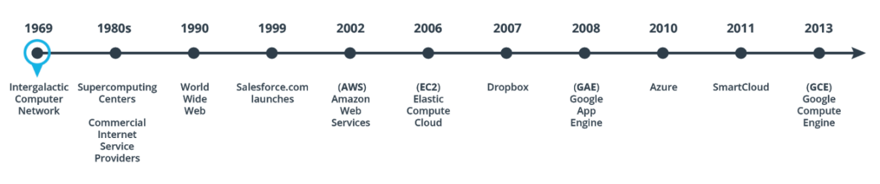

The timeline of cloud development

1969 - JCR Licklider aimed to create a system where information could be accessed anywhere in the world called the “Intergalactic Computer Network”.

1980s - Supercomputing Centers start to form and Commercial Internet Service Providers start to emerge in the late 1980s.

1990 - The internet becomes visible to all when Tim Berners-Lee invents the World Wide Web.

1999 - Salesforce.com launches and becomes a pioneer in delivering enterprise applications over the internet, which is known as Software-as-a-Service(SaaS). This paves the way for other SaaS applications such as Microsoft 365 and Gmail.

2002 - Amazon launches its Amazon Web Services (AWS) platform. AWS is formally launched as a business unit in 2006.

2006 - Amazon launches its Elastic Compute Cloud (EC2), a commercial web service that allowed users to rent computers to run their applications. EC2 paved the way for application delivery over the internet, which allowed web-scaled businesses like Netflix and Spotify to exist.

2007 - Dropbox introduces its file hosting service, and with that cloud storage becomes a commodity.

2008 - Google launches its Google App Engine (GAE) Platform-as-a-Service (PaaS). This service allowed developers to host their web applications on Google’s managed data centers.

2010 - Microsoft launches its cloud computing platform, Azure, after announcing it back in 2008. Azure now covers Software-as-a-Service(SaaS), Platform-as-a-Service(PaaS), and Infrastructure-as-a-Service(IaaS).

2011 - IBM launches SmartCloud, a suite of enterprise-class cloud computing technologies for building private, public, and hybrid clouds.

2013 - Google launches Google Compute Engine (GCE) as an addition to its Google Compute Platform. This is an Infrastructure-as-a-Service (IaaS) component of the platform that allows a user to spin up Virtual Machines (VMs) on demand.

So what’s next? Cloud computing is on the rise in this day and age. As cloud computing continues to become more mainstream, more and more companies are looking to adopt it. Industries such as marketing, education, and healthcare are beginning to increase their use of cloud-based services and platforms.

# Microsoft Azure

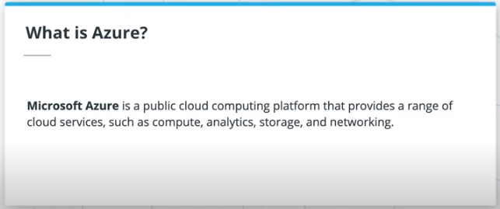

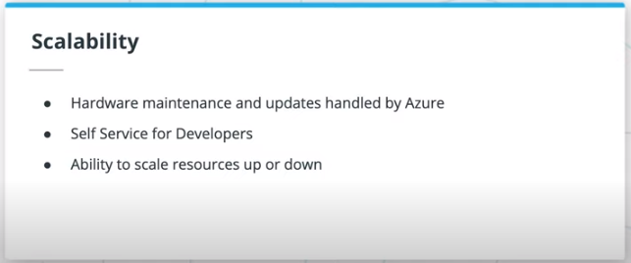

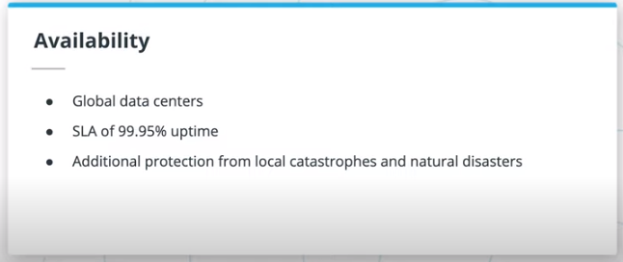

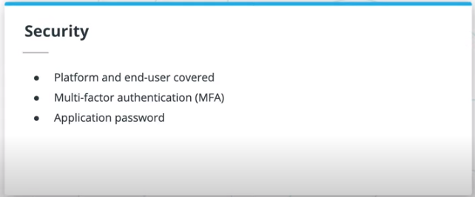

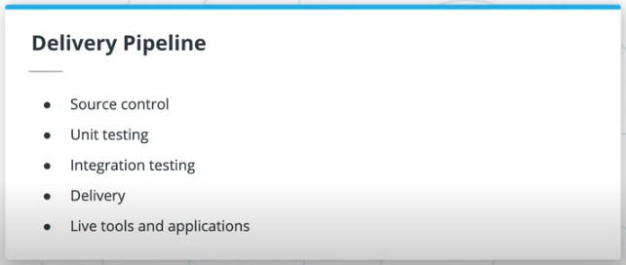

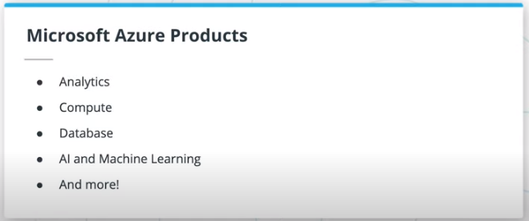

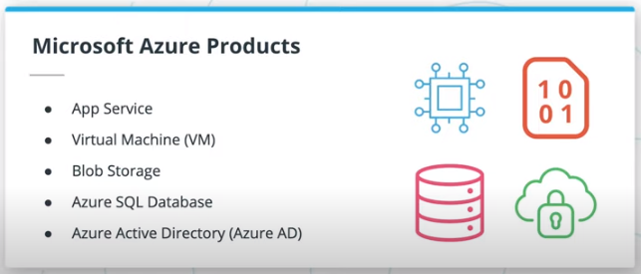

Azure is a public computing platform with tremendous value and benefits:

* Scalability: can dynamically handle changes in volume, bandwidth, storage size
* Availability: redundant on a global scale with 99.9%+ uptime (see SLA by service [here](https://azure.microsoft.com/en-us/support/legal/sla/summary/))
* Security: replicated data helps protect against natural disaster, while authentication strategies help secure access to the data
* Standard delivery pipeline development services, such as:
  + Source control
  + Unit testing
  + Integration testing
  + Delivery
  + Live development tools

Azure products span multiple categories, such as Compute, Analytics, Databases, A.I. and Machine Learning.

The Azure products this course will focus on are:

1. App Services
2. Virtual Machines
3. Azure SQL Databases
4. Blob Storage
5. Azure Active Directory
6. Aspects of Azure Monitor, such as logs and alerts

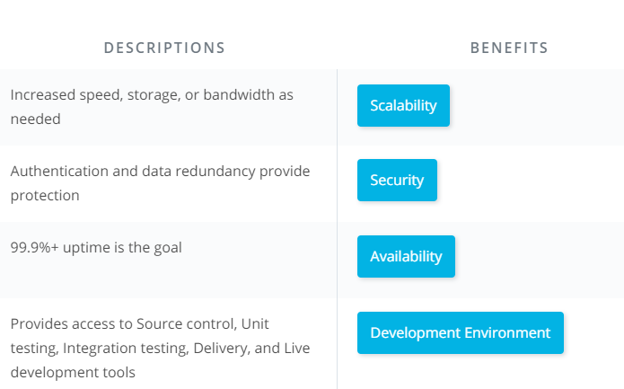

# The Azure Portal

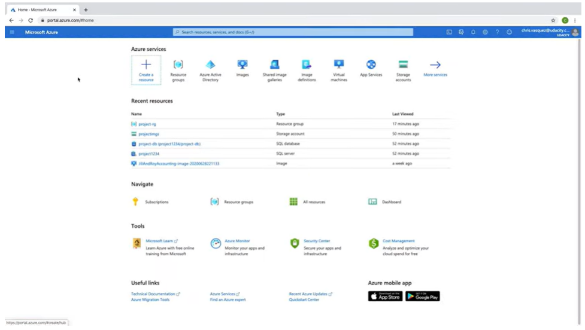

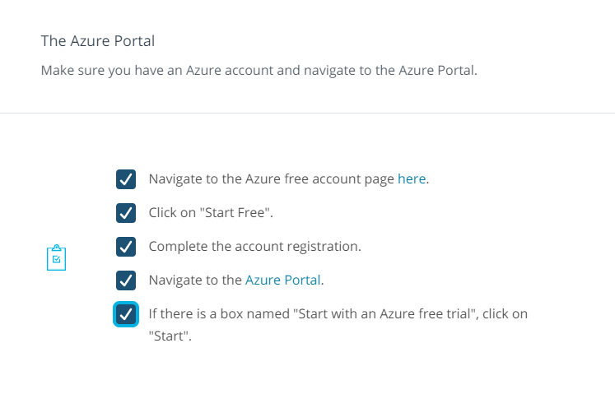

# IaaS, PaaS, and SaaS

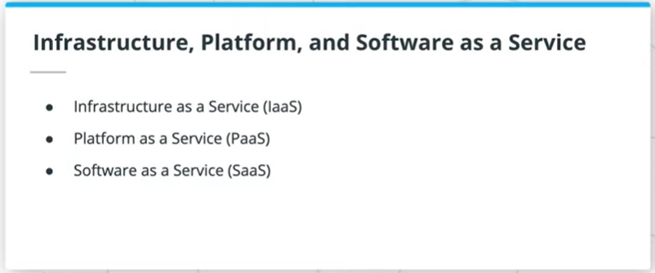

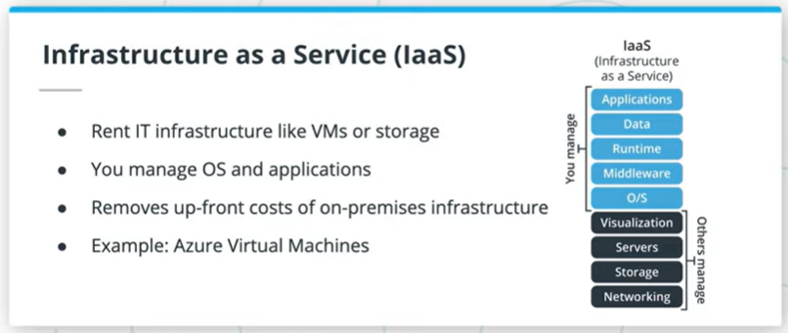

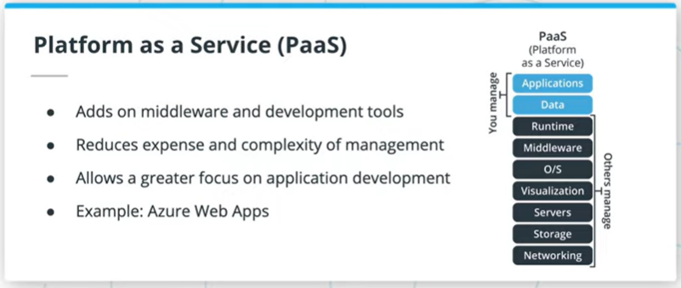

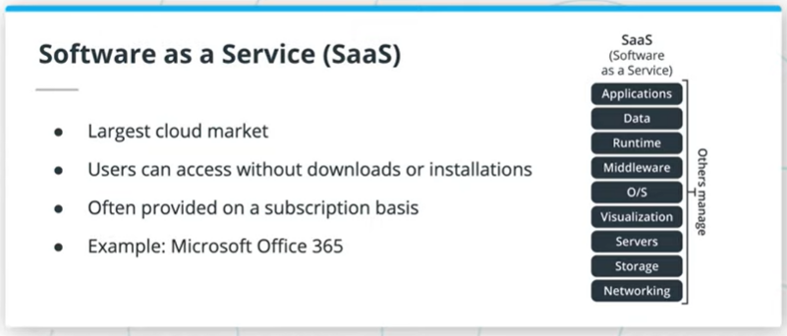

In contrast to on-premises solutions, there are three types of services that Azure offers us:

* Infrastructure as a Service (IaaS) - removes the expense of up-front costs of hardware, software and test environments
* Platform as a Service (PaaS) - handles networking, provides middleware and development & database tools
* Software as a Service (SaaS) - provides end-users access to online cloud solutions

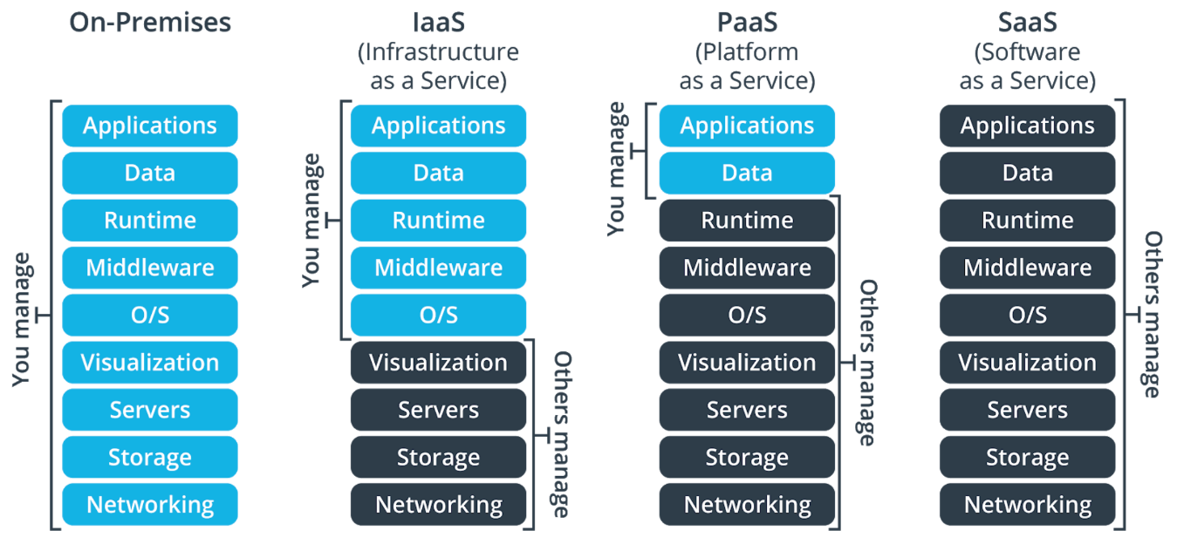

Azure services organized by IaaS, PaaS and SaaS

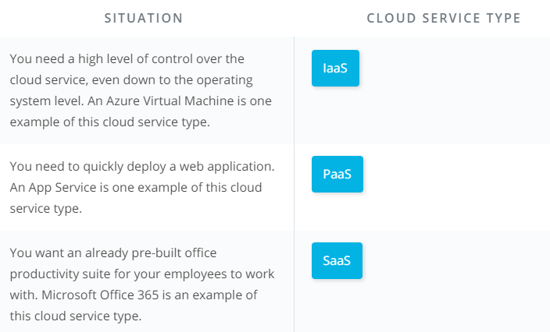

# Tools & Environment

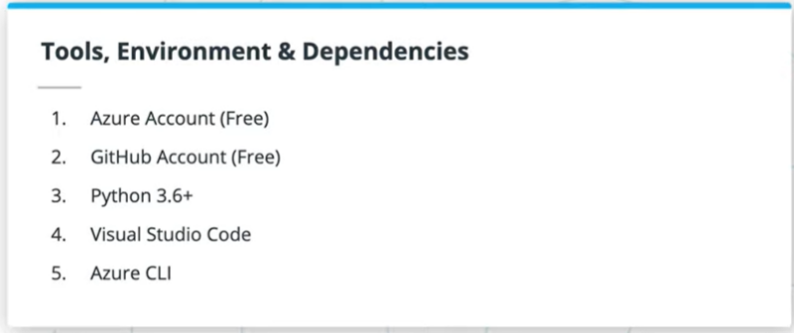

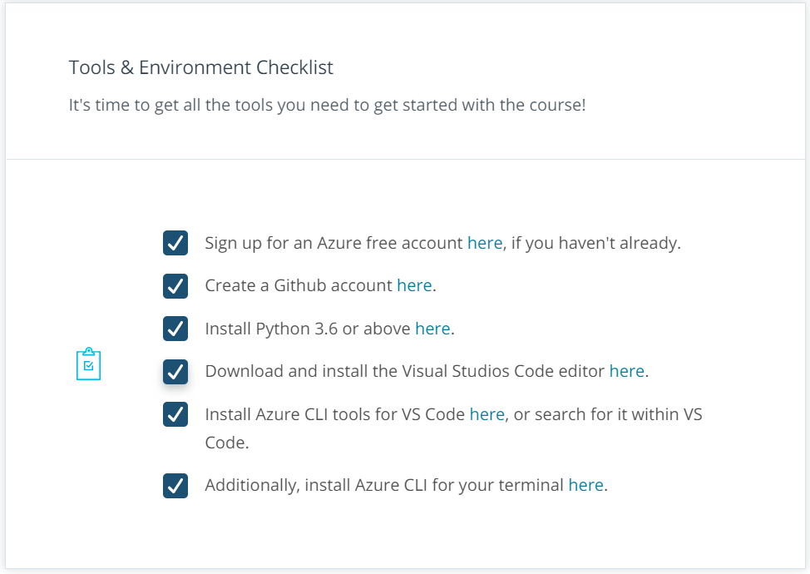

# Project: Deploy an Article CMS to Azure

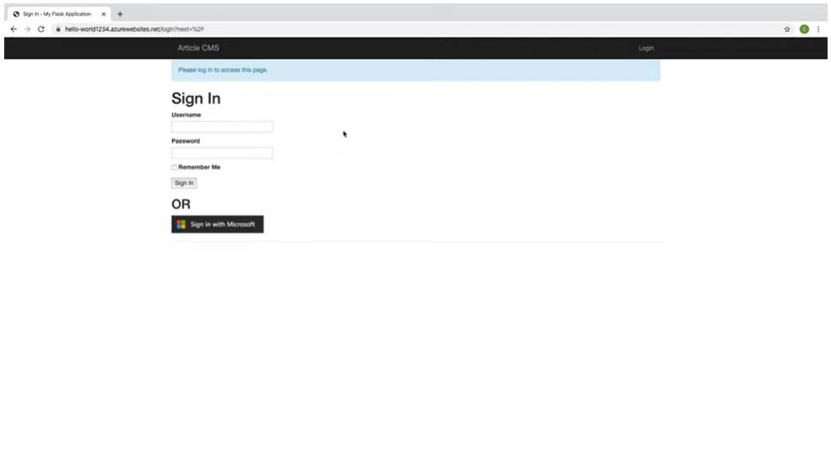

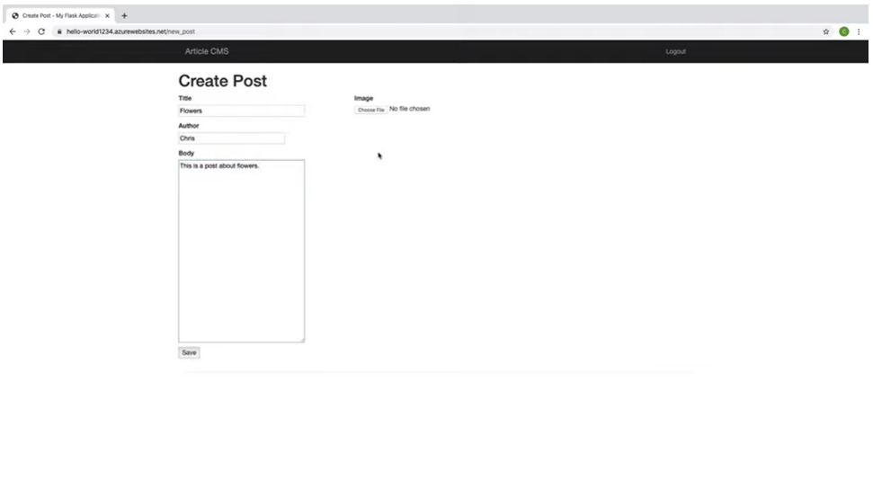

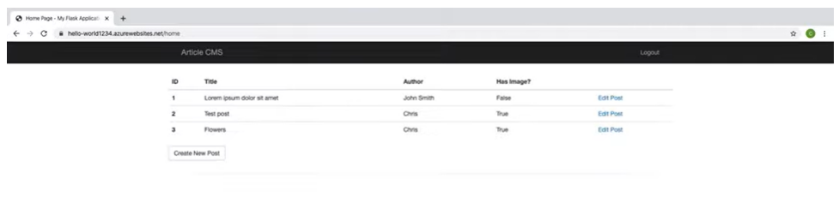

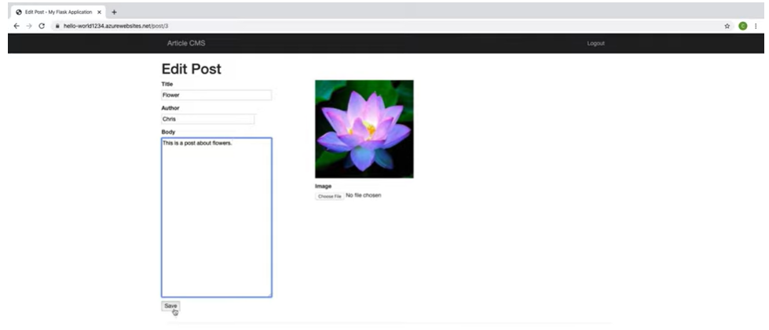

It is exciting to take a look at what we will be creating in our **final course project**. Similar to many such systems that exist in the real world, we will be designing, building, and deploying an **Article Content Management System (CMS)**, which will include the ability to :

* **Login and authenticate**
* **Read posts**
* **Create and save a post**
* **Edit and save an existing post**

The project looks straightforward from the user interface, but there is a lot going on under the hood of this Flask app. **The Sign In page makes use of the Microsoft Authentication Library (MSAL) and Azure Active Directory to log in with a Microsoft account,** while data related to article titles, authors and text bodies is stored in an **Azure SQL Server.** **An Azure Storage Account with Blob Storage is used to store the images,** and the web app itself can be deployed using either an **Azure Virtual Machine or an Azure App Service.** All of these resources are likely tied to a single resource group.

All these terms may not make much sense to you yet, but by the end of the course, you'll know each resource involved quite well, and be able to deploy your own Article CMS with Azure!

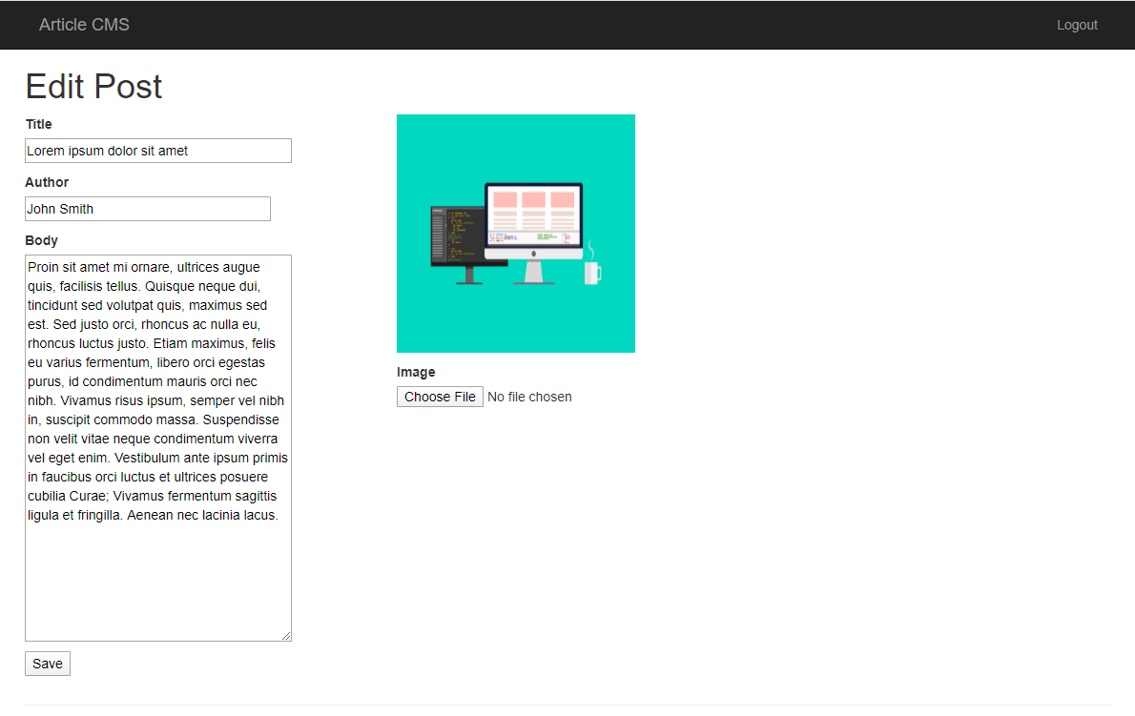

An example article within the deployed CMS

# Lesson Recap

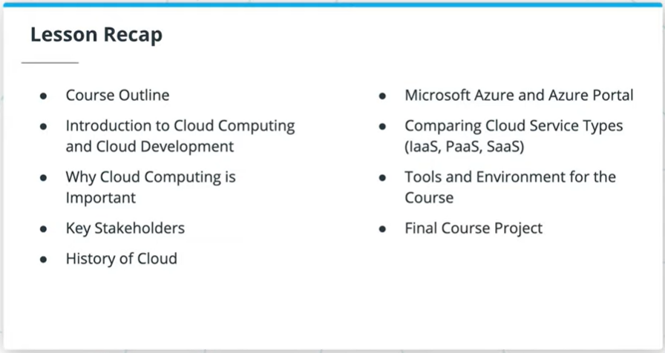

What did we learn in this introductory lesson on Azure Cloud Development?

* Why cloud computing is important, when to use it, and who are the key stakeholders
* History of *the cloud*
* Microsoft Azure and Azure Portal
* Comparing cloud service types - IaaS, PaaS and SaaS
* Tools and environment set up for the course
* The final course project

# Good Luck!



Chris will be with you for the entire course's journey! Good luck and see you in the next lesson!

# Glossary

| **Key Term** | **Definition** |
| --- | --- |
| The Cloud | A collection of servers on the internet that store and manage data, run apps, and deliver content such as email or videos. |
| Cloud Computing | The delivery of software and storage over the Internet (i.e. the cloud). |
| Public Cloud | Cloud computing resources shared amongst multiple customers, with applications and data still separate. |
| Private Cloud | Cloud computing resources that are dedicated to only one entity. This is most similar to how on-premises resources operate, but with the resources still hosted off-site by a third party. |
| Hybrid Cloud | Utilizing a mix of public and private cloud resources. |
| Cloud Developer | Developers who build cloud applications or utilize other cloud resources in their applications. They are responsible for ensuring applications run efficiently in the cloud, requiring appropriate authentication to access, and identifying appropriate resources to use. |
| Microsoft Azure | A public computing platform provided by Microsoft, with many products spanning many categories, such as Compute, Analytics, Databases, A.I. and Machine Learning. |
| Azure Portal | The browser-based and GUI version of working with Azure resources. |
| Elasticity | The ability to scale up or down resources to match demand. |
| On-Premises | The non-cloud option where companies host all their necessary compute, storage and other resources on-site. |
| Infrastructure as a Service (Iaas) | Removes the expense of up-front costs of hardware, software and test environments, as the cloud provider is instead responsible for providing physical hardware. |
| Platform as a Service (Paas) | Handles networking, provides middleware and development & database tools, in addition to the physical hardware provided at the IaaS level. |
| Software as a Service (Saas) | Provides end-users access to online cloud solutions, without the need to build or support the underlying applications themselves. |

**LESSON 2 Azure Compute Services**

**Introduction**

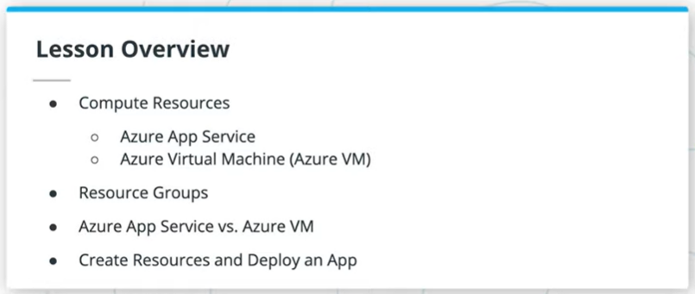

In this lesson, we'll focus on Azure Compute Services:

* First, we'll take a look at some of the various compute options available
* Then, we'll get you set up for success by discussing subscriptions and resource groups
* From there, we'll take a deeper dive into two compute services in Azure: Virtual Machines and App Services
* After comparing and contrasting these two, you'll create both resources and deploy an app to them

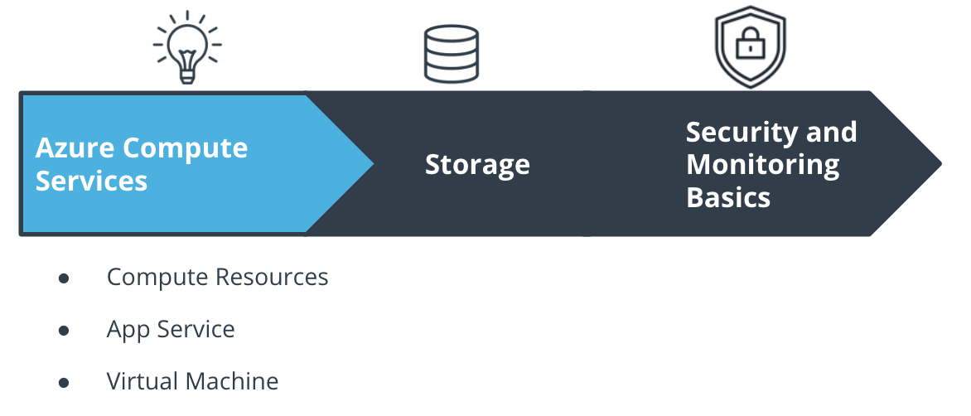

The Course and Lesson Outline

**Big Picture: Compute Services**

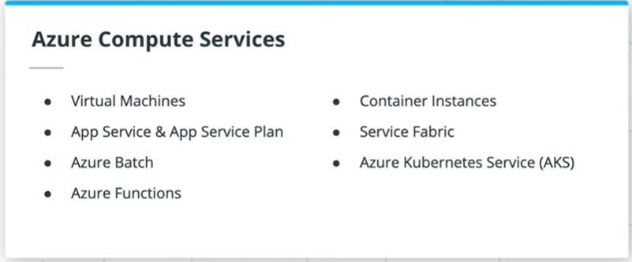

There are a lot of compute services available through Azure, each with their own use cases. You can check out a good chart for deciding when to use each (which you'll see more of in later lessons and courses) in the [Microsoft documentation](https://docs.microsoft.com/azure/architecture/guide/technology-choices/compute-decision-tree?WT.mc_id=udacity_learn-wwl). Some of the available options are:

* Virtual Machines
* App Services
* Azure Batch
* Azure Functions
* Container Instances
* Service Fabric
* Azure Kubernetes Service (AKS)

We'll focus on Virtual Machines and App Services in this lesson, although you'll see some of the others in a later course.

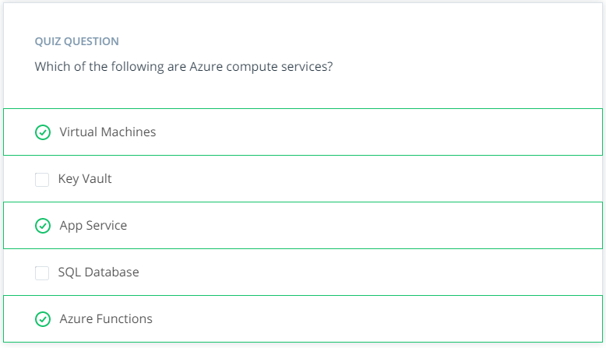

**Subscriptions and Resource Groups**

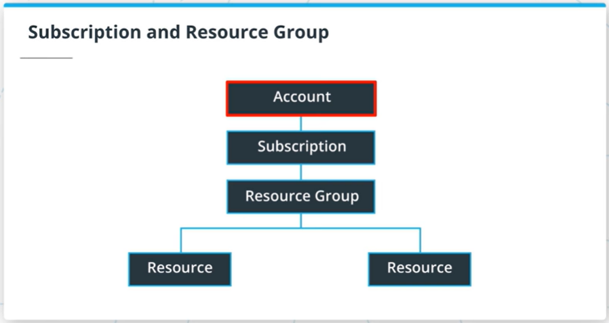

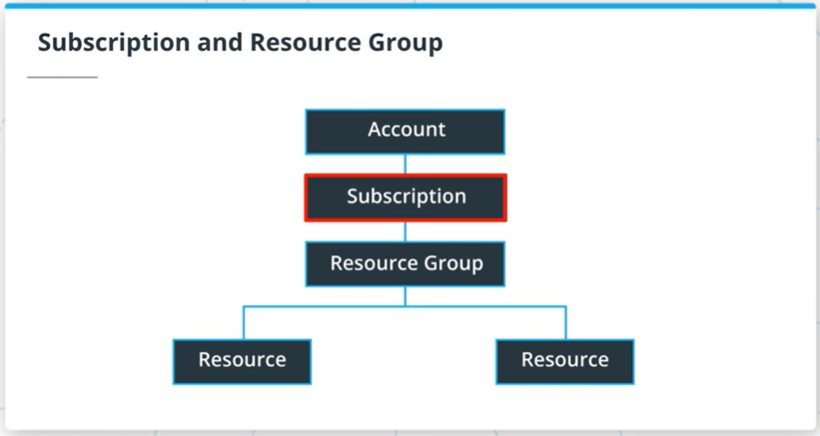

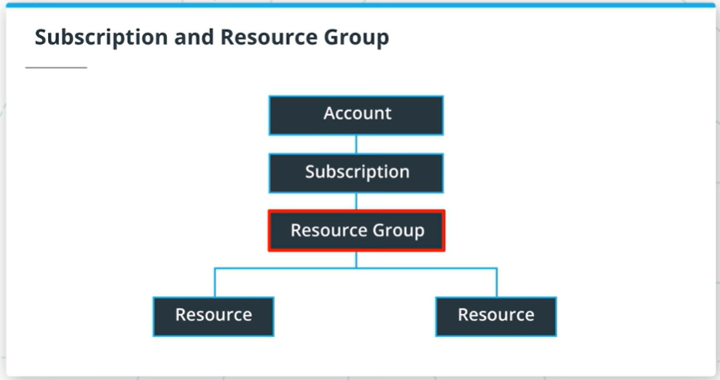

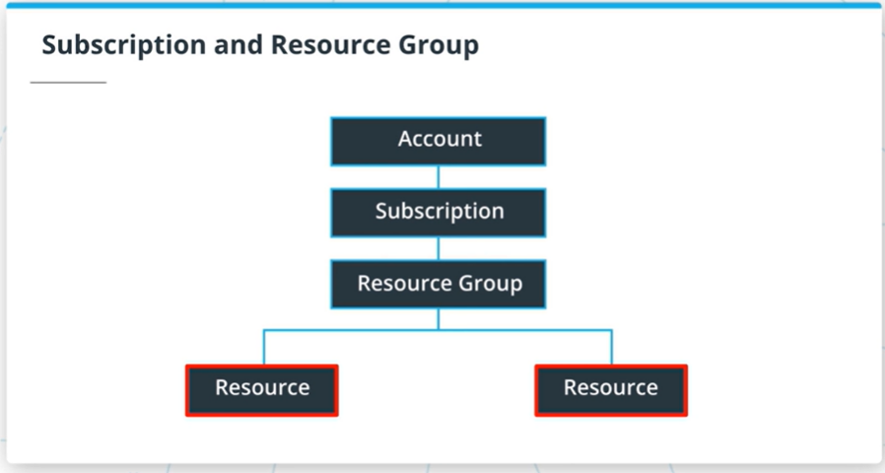

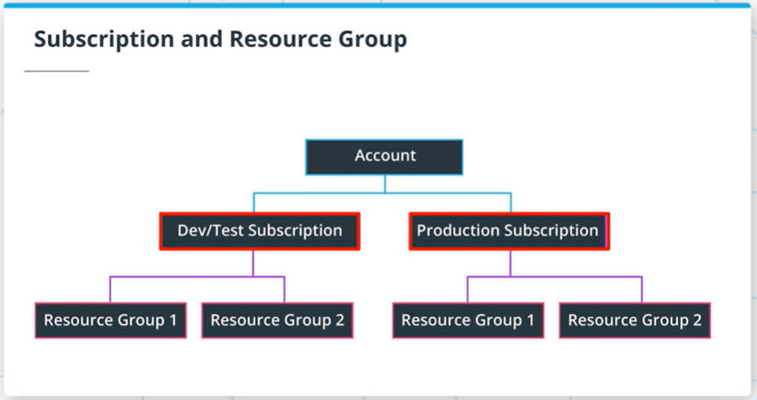

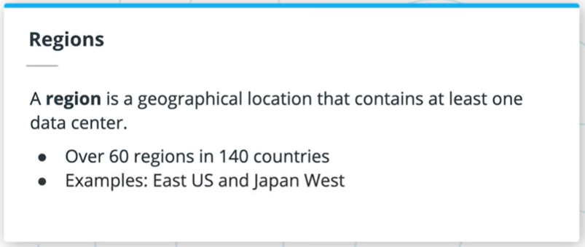

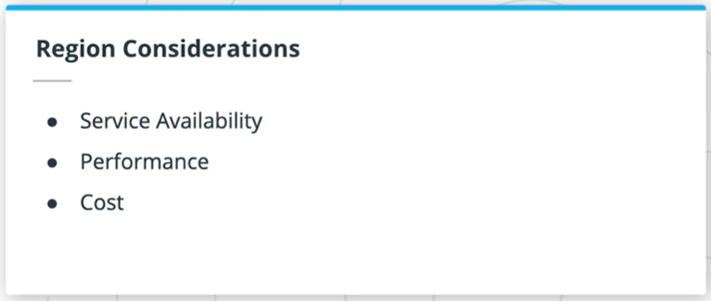

Azure uses a hierarchical system to keep resources organized and to manage expenses easily.

This starts at the top with your **Azure Account**. The next level down is the **Subscription** level; in this course you will likely only work with one subscription, but it's likely in your day-to-day Azure work that you may be working with more than one. For instance, there may be one subscription for development and testing, and another for production systems.

Below the subscription level is where you'll find **Resource Groups**. These help to organize resources you use, such as Virtual Machines and App Services (as well as storage options and other resources we'll discuss in later lessons), in order to make resource management easier. You may have a resource group for a specific project, or because resource groups are tied to a **Region**, you may have resource groups containing similar resources in multiple locations across the world. A region contains at least one data center, but could have multiple data centers that are close by and networked together through a low-latency network. There are over 60 regions available worldwide and available in 140 countries, such as East US and Japan West.

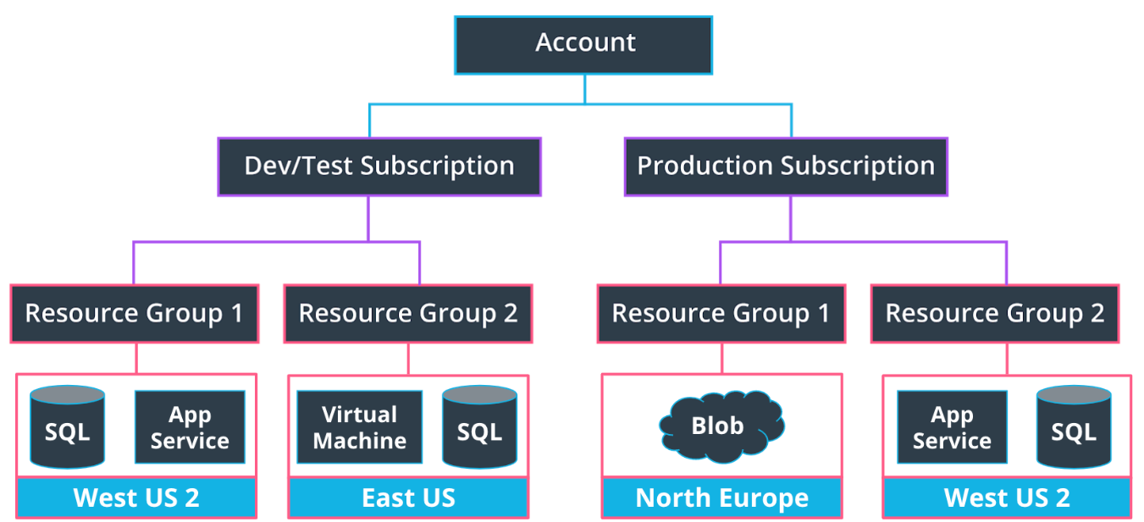

Resource groups can encompass multiple services in a region.

When choosing a region, it's important to consider what you are trying to achieve. For development and testing purposes, you likely want a region close to yourself; for production purposes, you often want resources to be close to your user. Keep the following in mind:

* Service availability - Some services may not be available in a particular region.
* Performance - Latency determines network service performance; are you creating resources for yourself or your end user?
* Cost - Costs of services vary by region. If latency isn’t an issue, you might want to deploy your services in the cheapest region.

### **Creating a Resource Group in the Azure Portal**

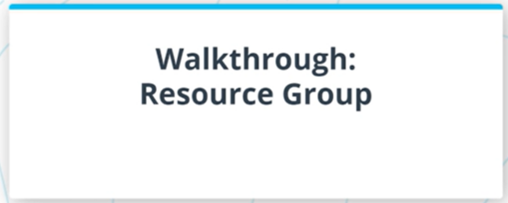

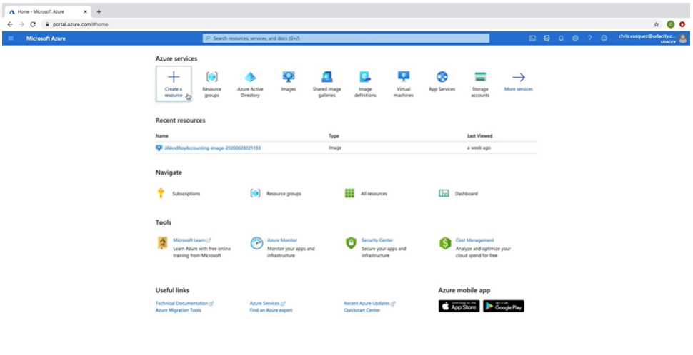

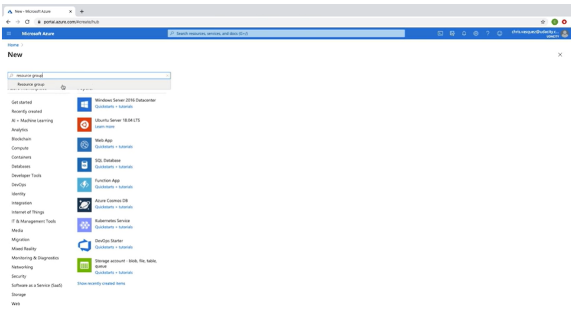

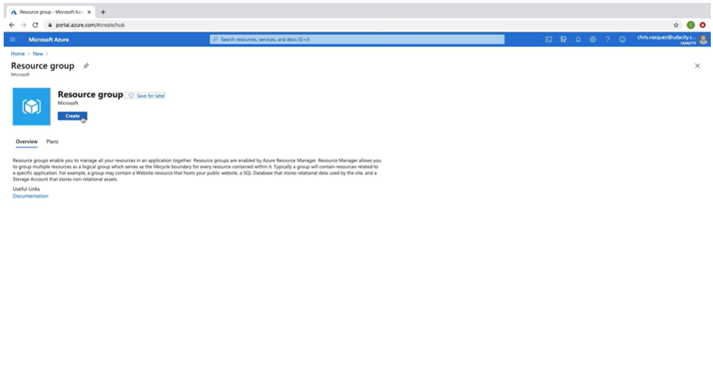

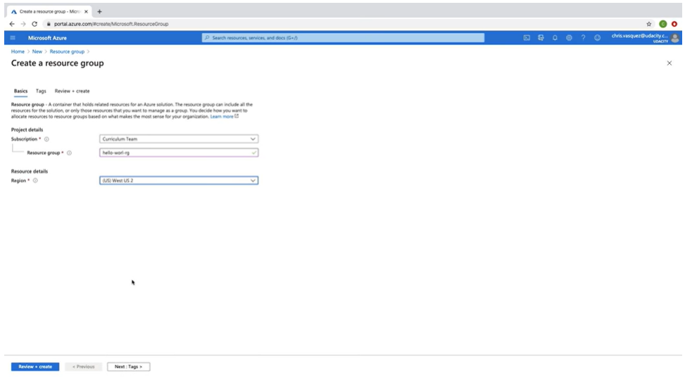

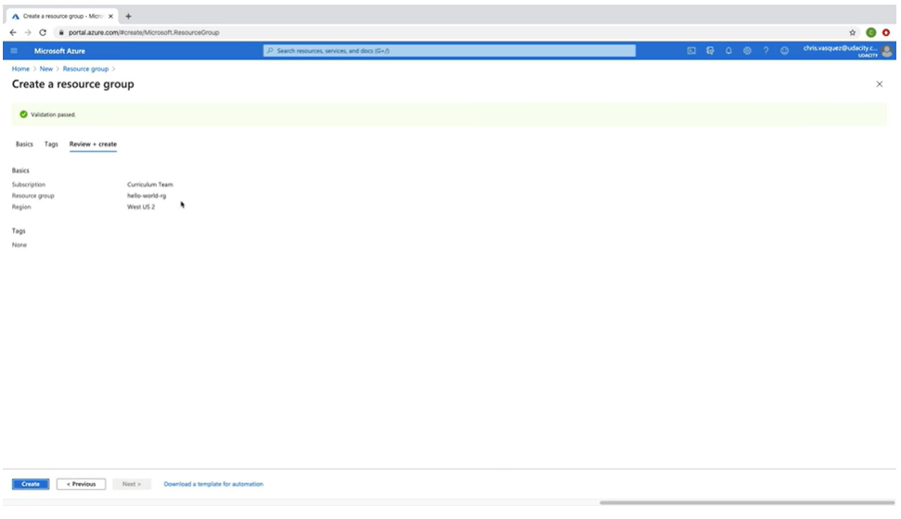

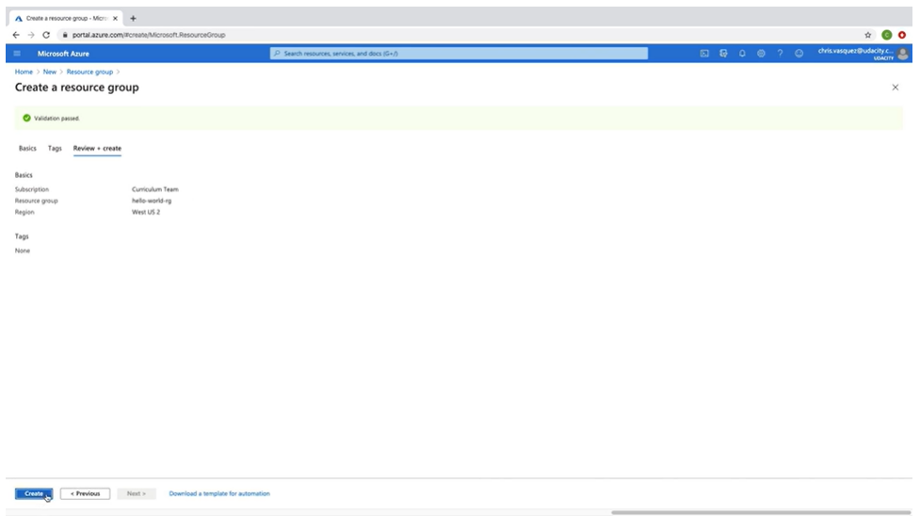

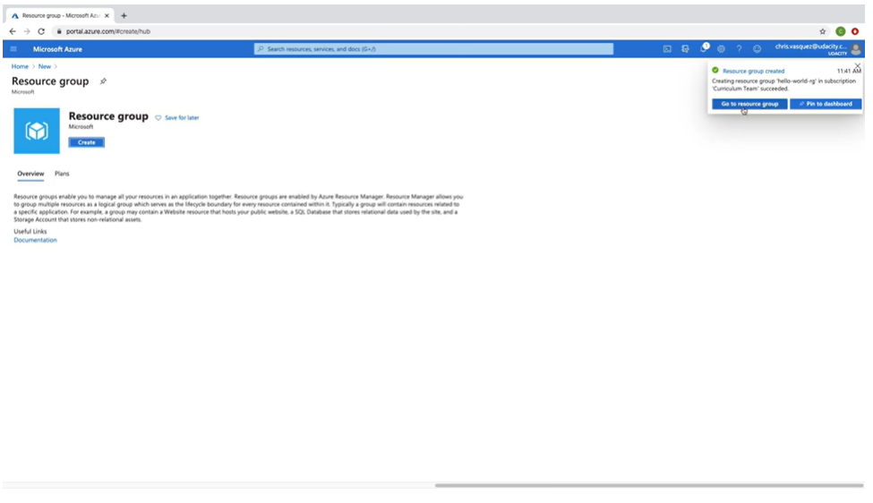

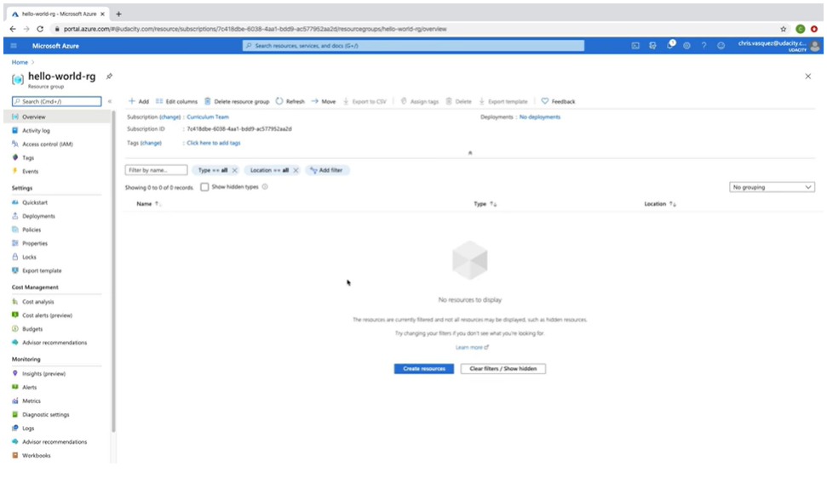

To set up a resource group in the Azure Portal:

* Go to the [Azure Portal homepage](https://portal.azure.com/#home)
* Click "Create a Resource Group"
* Search for "Resource group" and click "Create"
* You'll need to select the subscription for the resource group, name it, and select a region
* Make sure once you select "Review and create" to actually review the information! While it doesn't take too much time to go back and create a new resource group, you'll want to check for any typos in the name or if the wrong region was selected. When we work out of Azure CLI later, this becomes even more important, as you could cause other scripts to fail if things are named incorrectly or are in an inappropriate region.
* Click "Create" once you are done reviewing.

You'll practice this yourself in the upcoming exercise.

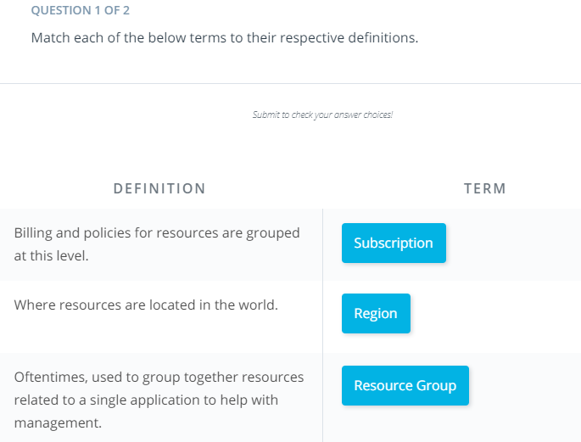

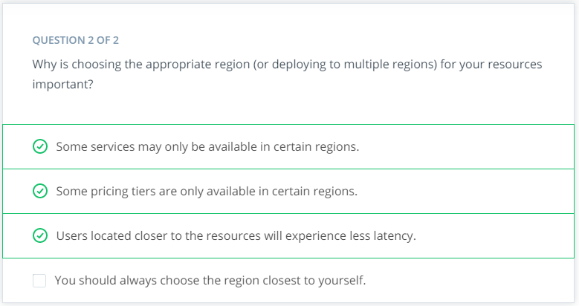

# Exercise: Create A Resource Group

## Exercise: Create a Resource Group

## *Cloud Lab users are not allowed to create Resource Groups in the temporary Azure account. Instead, the Cloud Lab users should use the existing Resource group in their account, such as cloud-demo-XXXXXX.*

In this exercise, you'll create a resource group in Azure. This is a quick exercise, but will set you up for success through the rest of the course!

* Create a Resource Group named **resource-group-west** in [Azure](https://www.portal.azure.com/) in the **West US** region.

**Note:** We will use this resource group throughout the course, so do not delete it after creation. Resource Groups are fully covered in the Azure free account.

# Solution: Subscriptions and Resource Groups

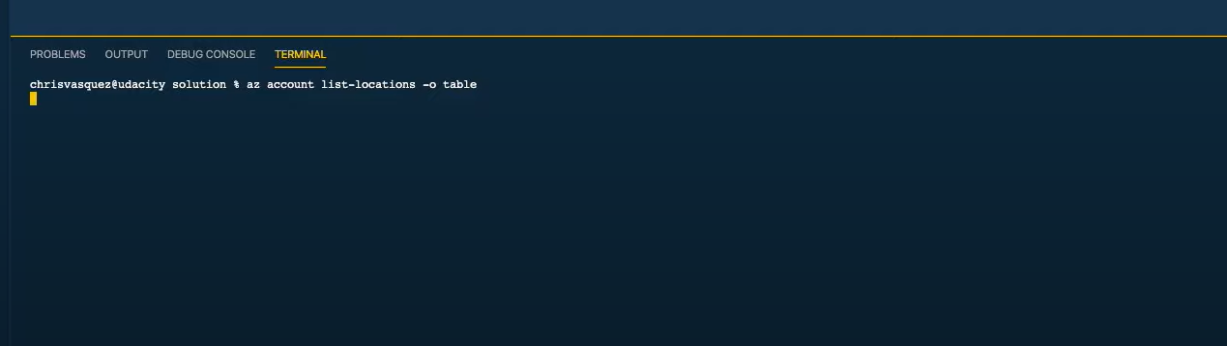

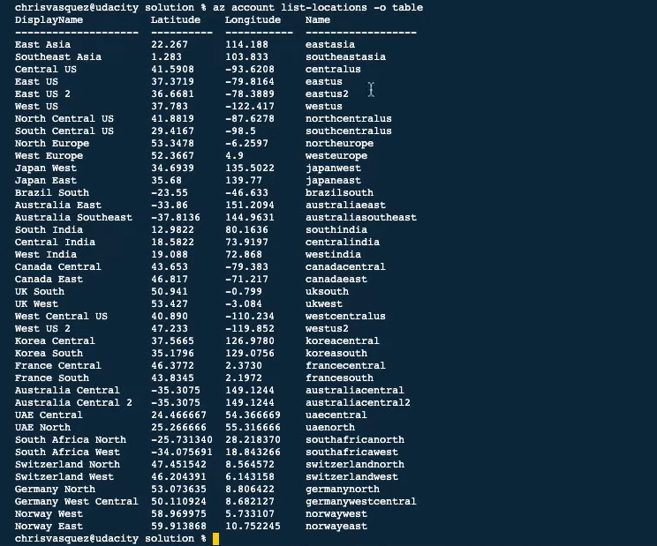

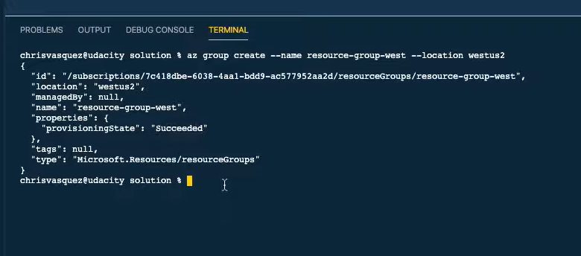

In this solution video, I showed you an alternative way to create a resource group using Azure CLI. Use whichever method you feel more comfortable with moving forward.

**Steps to Create a Resource Group using the Azure CLI:**

1. Log in using az login.
2. We'll use the Azure CLI command az group create and pass in two flags:
   * resource group --name
   * --location which is the same as the "region" field on the Azure portal.
3. If you want to see a list of all locations, you can run az account list-locations -o table to output the list in table format.
4. I want to create my resource group in the West US 2 region:

az group create --name resource-group-west --location westus2

The resource group will be created and a JSON response will be returned with the status.

Alternatively, you can check out the screenshot below for how you might do the same from the Portal (note that the below uses the West US region and not West US 2).

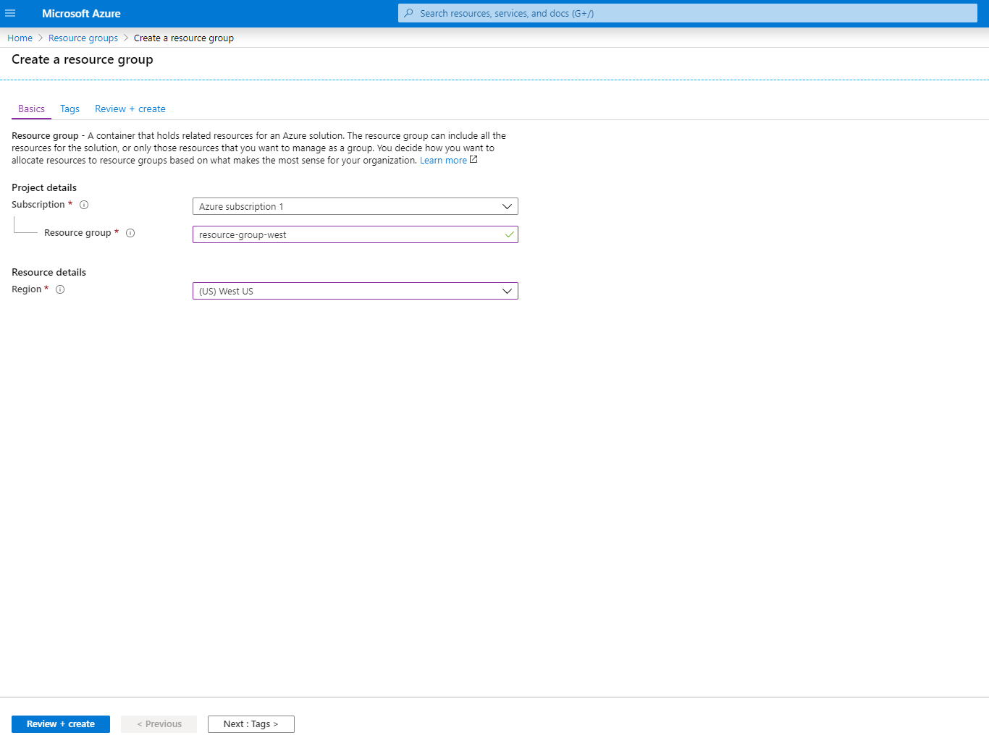

## Azure CLI Documentation

You can reference the [Azure CLI documentation](https://docs.microsoft.com/cli/azure/?view=azure-cli-latest&WT.mc_id=udacity_learn-wwl) for further information on other commands.

# Virtual Machines vs. App Services

### 

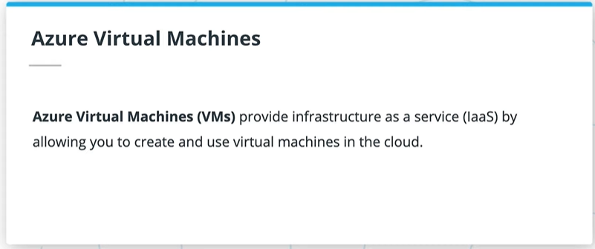

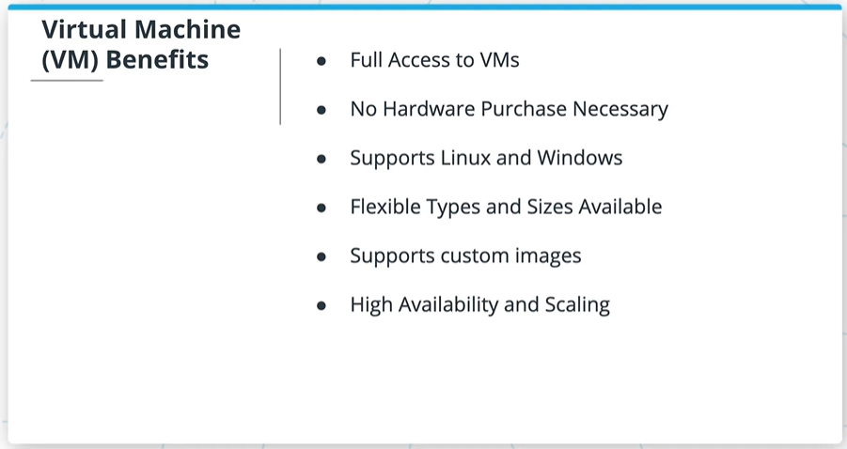

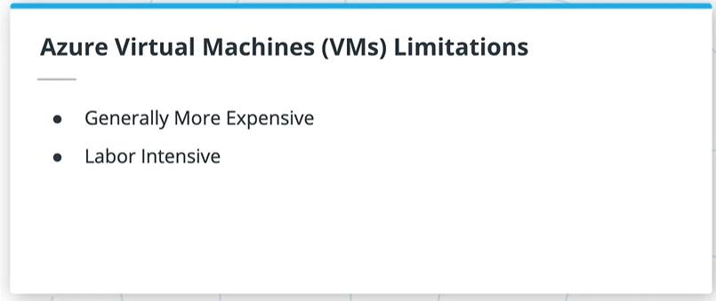

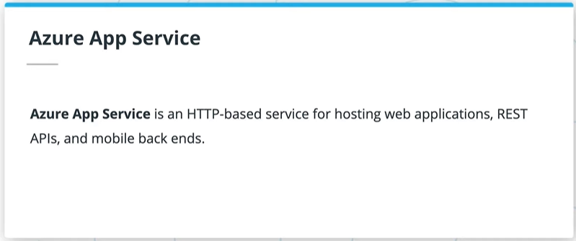

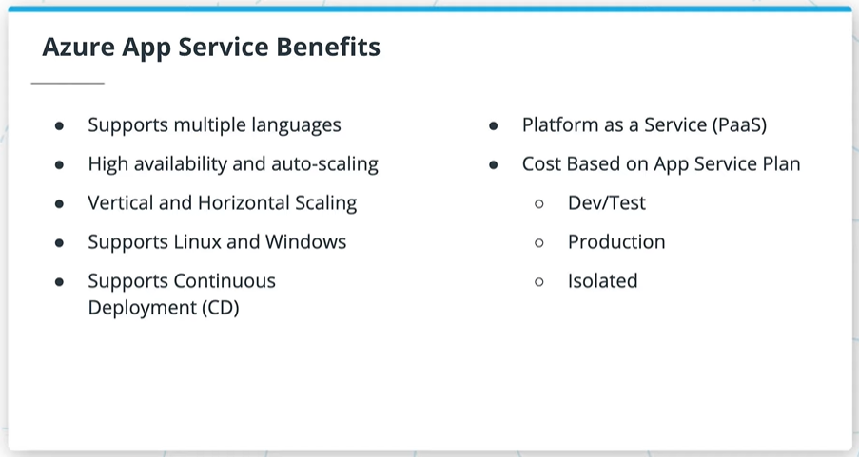

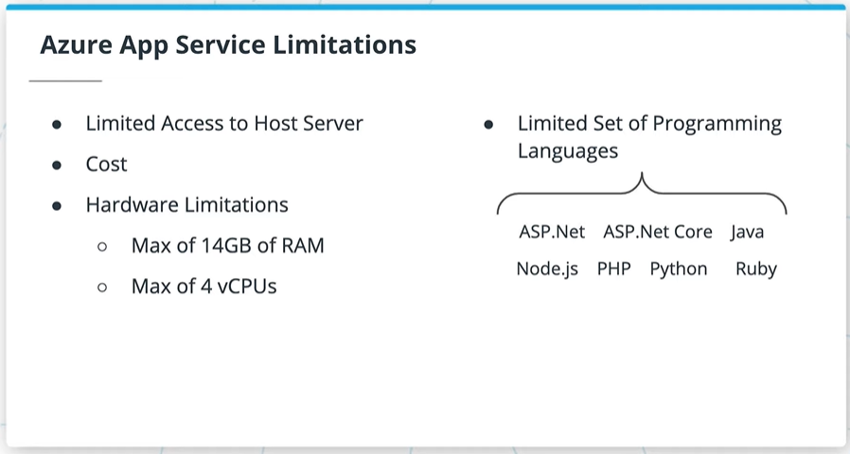

### Virtual Machines

**Virtual Machines**

**Azure Virtual Machines** (VMs) provide infrastructure as a service (IaaS) by allowing you to create and use virtual machines in the cloud.

Some of the benefits of VMs are:

* VMs allow you full access and control of the VM.
* Lower up-front cost compared to purchasing and maintaining hardware.
* Support of both Linux and Windows VMs.
* Multiple types to choose from, such as compute or memory-optimized VMs, along with varying amounts of CPU, RAM and storage.
* VMs allow for the installation of custom images and are an excellent choice for migrating from an on-premises server to the cloud.
* Multiple VMs can be grouped to provide high availability, scalability, and redundancy. There are two options when it comes to scaling—Virtual Machine Scale Sets and Load Balancers. These will be covered in a different course.

Some of the limitations of VMs are:

* They are more expensive
* They can be more time consuming for the developer than other compute options

### **App Service**

**Azure App Service** is an HTTP-based service for hosting web applications, REST APIs, and mobile back ends. It is a Platform as a Service (PaaS) that allows a developer to focus on the application while Azure takes care of the infrastructure.

Some of the benefits of using an App Service are:

* Support of multiple languages, such as .NET, .NET Core, Java, Ruby, Node.js, PHP, or Python
* High availability, auto-scaling and support of both Linux and Windows environments.
* Continuous deployment model using GitHub, Azure DevOps, or any Git repo.
* Vertical or Horizontal scaling. Vertical scaling increases or decreases resources allocated to our App Service, such as the amount of vCPUs or RAM, by changing the App Service pricing tier. Horizontal scaling increases or decreases the number of Virtual Machine instances our App Service is running.
* You can set the amount of hardware allocated to host your application, and cost varies based on the plan you choose. There are three different tiers - Dev/Test, Production, and Isolated. We’ll be using the free option within Dev/Test for the exercises in this course.

Some of the limitations of an App Service are:

* You have limited access to the host server, so you are unable to control the underlying OS or install software on the server.
* You’re always paying for the service plan, even if your services or application isn’t running.
* There are hardware limitations, such as a maximum of 14GB of memory and 4 vCPU cores per instance
* While they support multiple languages, as noted in the benefits above, they are limited to just using those languages (as of when this course was built).

### Use Cases

Each of these has their own use cases, although sometimes there is still some ambiguity on when to use each. Virtual Machines are usually better when you need control of the underlying operating system or are using custom software to support your needs; an app service is typically better for lightweight applications and services, especially when you don't have the need for high performance compute services. Additionally, you'll need to take into consideration the hardware limitations of App Services, as noted above.

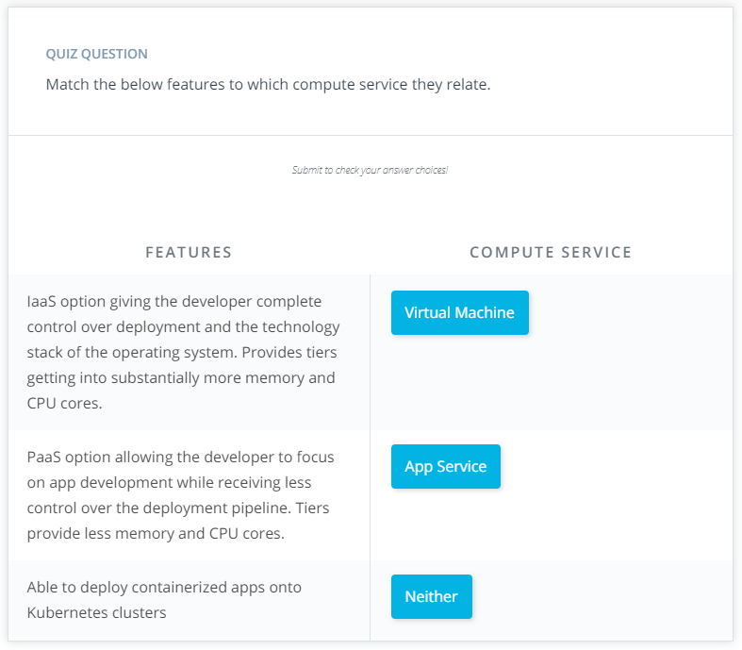

# Exercise: Virtual Machines vs. App Services

## Virtual Machines vs. App Services

For each of the three scenarios below, analyze and determine whether a virtual machine or an app service would be best served for the situation. It's important to note that this involves some level of ambiguity - you should feel free to expand beyond the given scenario and consider any other areas that might be important in making your decision.

### Scenario 1

*Your company wants to deploy a series of lightweight APIs as part of their plan to shift to using microservices in the future. The company is very cost-conscious due to the current economic environment, and wants to focus on using the correct services right now, and is less concerned about scaling concerns due to stagnant growth.*

## Scenario 1 Scratchpad

You can use this space as a scratchpad of your thoughts on Scenario 1. Note that this will lock after you submit it.

### Your reflection

**App Services**

### Things to think about

Thanks for your response! You can continue onto the next scenario for now, I'll cover my own approach on the next page.

### Scenario 2

*Your company has recently signed a sizable government contract in which you will deploy various apps for the related government departments to use. The contract was a big win for the company, as it vastly increases the number of users of your apps. Additionally, the contract does contain provisions that require dedicated servers for security reasons to host any of the government department's services and information. Relatedly, some of the different departments' applications are required to be maintained on different servers.*

## Scenario 2 Scratchpad

You can use this space as a scratchpad of your thoughts on Scenario 2. Note that this will lock after you submit it.

### Your reflection

**Virtual Machines**

### Things to think about

Thanks for your response! You can continue onto the next scenario for now, I'll cover my own approach on the next page.

### Scenario 3

*You have been assigned to determine the cloud needs for a new product your company will soon be launching. In the past couple of years, your company has been on a roller coaster ride - some product launches meet massive success, while others flounder pretty quickly out of the gates. As such, the product manager is a bit wary of immediately creating a bunch of resources without knowing for sure what the real demand for this new product will be. The application currently utilizes ~5 GB on 2 CPUs during your stress testing, but is definitely a minimum viable product, and could grow vastly in size and compute resources if successful.*

## Scenario 3 Scratchpad

You can use this space as a scratchpad of your thoughts on Scenario 3. Note that this will lock after you submit it.

### Your reflection

**App Services**

### Things to think about

Thanks for your response! I'll cover my own approach on the next page.

# Solution: Virtual Machines vs. App Services

### 

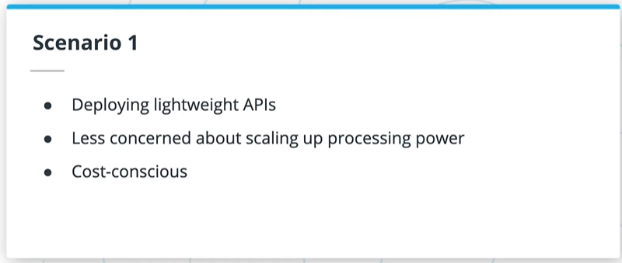

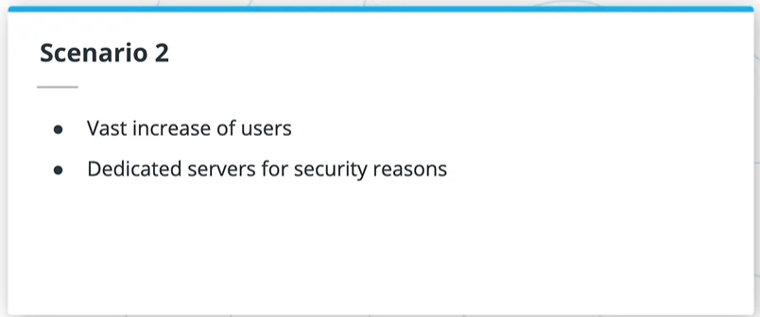

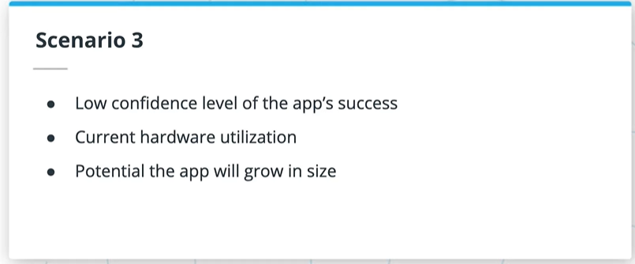

### Scenario 1

*Your company wants to deploy a series of lightweight APIs as part of their plan to shift to using microservices in the future. The company is very cost-conscious due to the current economic environment, and wants to focus on using the correct services right now, and is less concerned about scaling concerns due to stagnant growth.*

Some key points that stood out to me were:

* Deploying a series of lightweight APIs
* Less concern about scaling up processing power
* Cost-consciousness

I would choose an **App Service** in this situation. Lightweight APIs tend to be well-suited to App Services over VMs, and won't approach the size limit for App Services very easily. Additionally, App Services cost less than VMs do. Lastly, since the ability to scale quickly is less of a concern, we don't need to factor that into the analysis.

As the company shifts into microservices, Azure Functions would also be a good compute option for them to consider, but that won’t be covered until a later course.

### Scenario 2

*Your company has recently signed a sizeable government contract in which you will deploy various apps for the related government departments to use. The contract was a big win for the company, as it vastly increases the number of users of your apps. Additionally, the contract does contain provisions that require dedicated servers for security reasons to host any of the government department's services and information. Relatedly, some of the different departments' applications are required to be maintained on different servers.*

A couple of key points that stood out to me were:

* A vast increase in the number of users
* The need for dedicated servers for security reasons

This situation is likely best for **Virtual Machines**. Handling the vast increase in the number of users, with separate, dedicated servers, is going to be better achieved this way.

### Scenario 3

*You have been assigned to determine the cloud needs for a new product your company will soon be launching. In the past couple of years, your company has been on a roller coaster ride - some product launches meet massive success, while others flounder pretty quickly out of the gates. As such, the product manager is a bit wary of immediately creating a bunch of resources without knowing for sure what the real demand for this new product will be. The application currently utilizes ~5 GB on 2 CPUs during your stress testing, but is definitely a minimum viable product, and could grow vastly in size and compute resources if successful.*

This is a bit of a tough one - it's important to remember that in real-life situations, there may not always be a clear dividing line on exactly which service is best.

Some key points that stood out to me were:

* The confidence level of this application being a massive success seems low (do we want to assume we'll need a lot of scaling?)
* The application currently utilizes ~5 GB on 2 CPUs during stress testing
* The potential the app will grow in resource needs

The answer here depends greatly on which of the above points you highlight. In the current situation, an App Service likely works fine - it can scale vertically to meet different demand levels, and the compute resources needed are well within App Service limits. However, there's some consideration that Virtual Machines may be necessary in the near future if many more features are added, or demand changes in a way that requires vertical scaling. In fact, I'd argue that the problem so far is a bit ill-defined - I'd want to know what level of control we need over the underlying OS, security requirements we have, etc.

# Creating a Virtual Machine

## Creating a Virtual Machine

In this exercise, you will create resources (Virtual Machines) in Azure. Once you create these resources they will result in charges in your Azure account if they are not stopped or deleted. Make sure you stop or delete running resources immediately after completing this exercise or while you are not actively working on it.

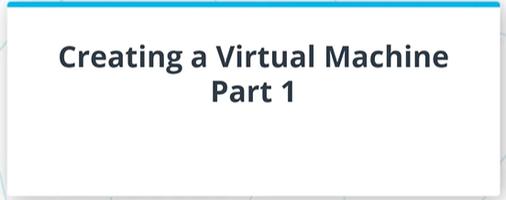

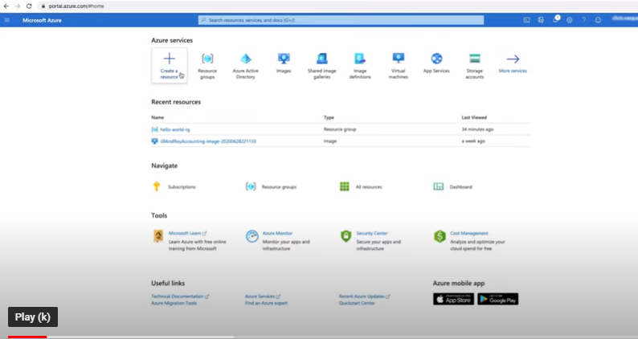

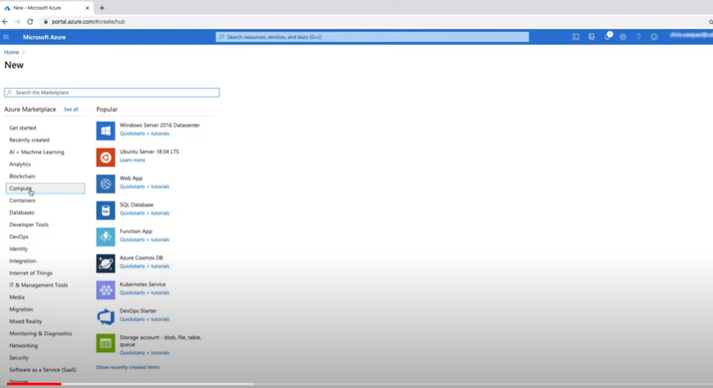

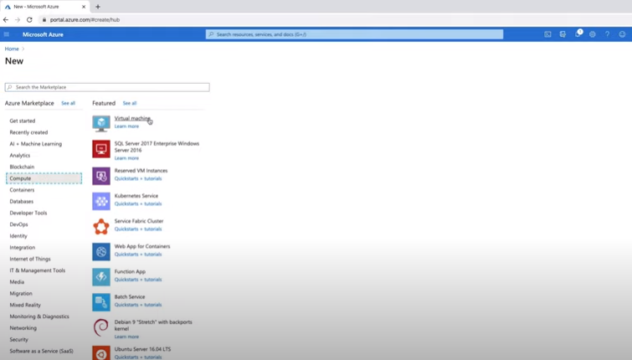

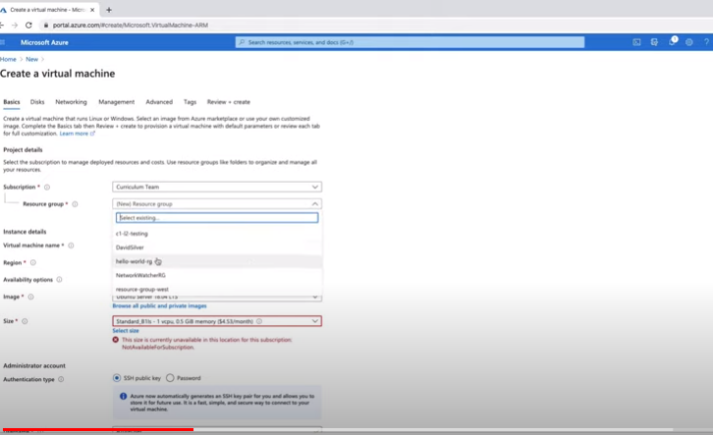

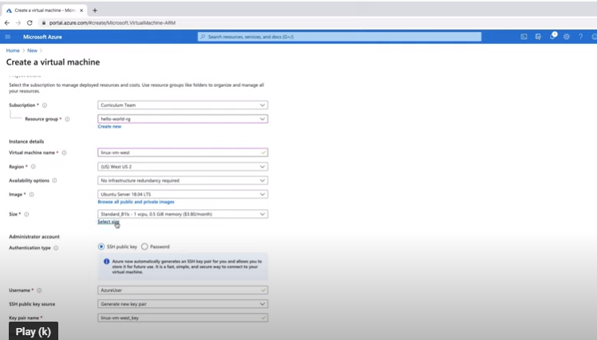

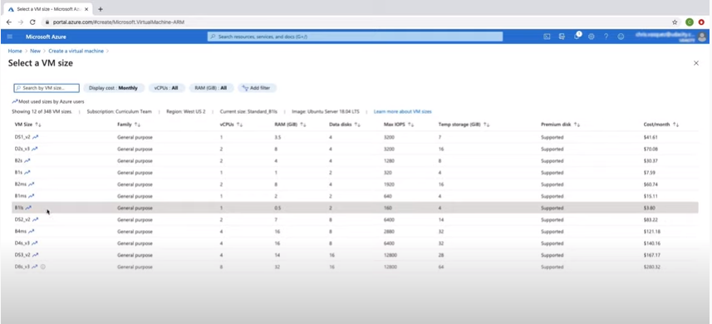

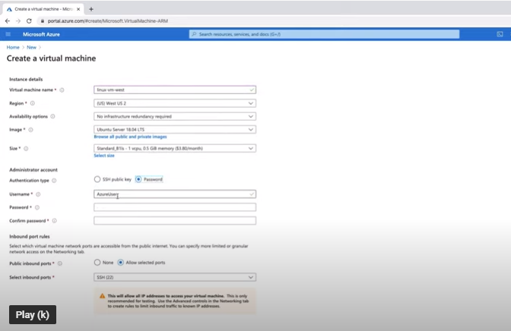

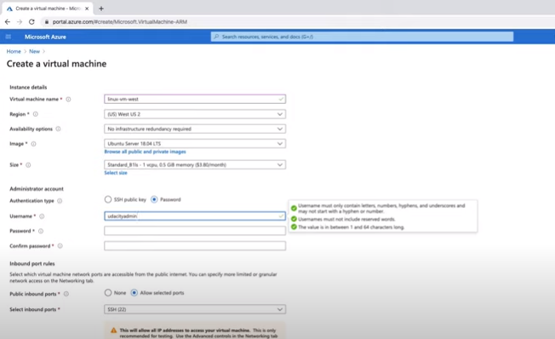

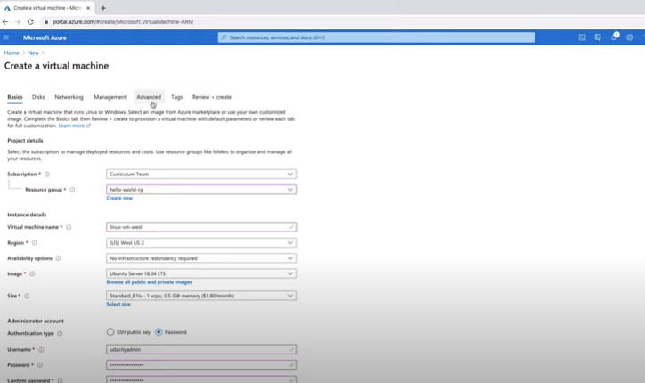

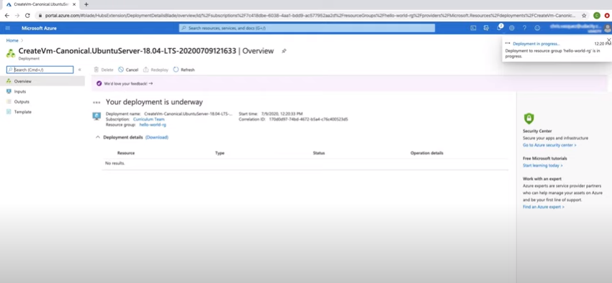

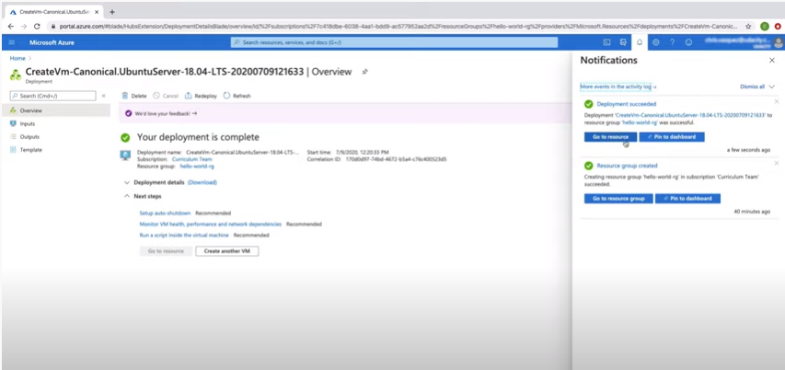

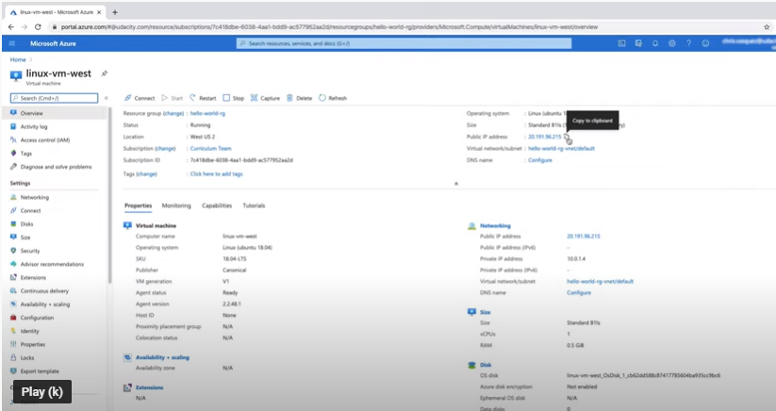

The steps I took to create a Linux Virtual Machine on Azure were:

1. On the homepage, click "Create a resource"
2. Click on "Compute" in the left menu
3. Click on "Virtual Machine"
4. Create a Linux VM with the following details:
   * Subscription: This will vary for you. Should default to your subscription.
   * Resource Group: "hello-world-rg"
   * VM Name: "linux-vm-west"
   * Region: West US 2 or a region closest to you that's available
   * Availability Options: Default option of "No infrastructure redundancy required" is fine here.
   * Image: Ubuntu Server (any version) but I'm going to use the latest version 18.04 LTS
   * Azure Spot instance: No
   * Size: Click on "Select Size" and select "Standard B1ls"
   * Authentication type: Password
   * Username: (any username you choose) something other than the default "AzureUser" I used "udacityadmin"
   * Password: (any password you choose) "Udacityadmin@123"
   * Inbound Port Rules: "Allow Select Ports" and make sure from the drop-down menu, 22 and 80 are selected.

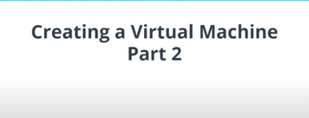

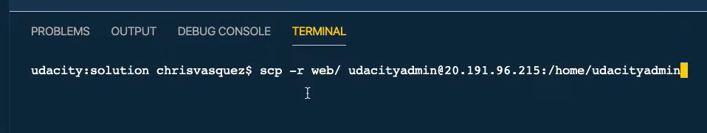

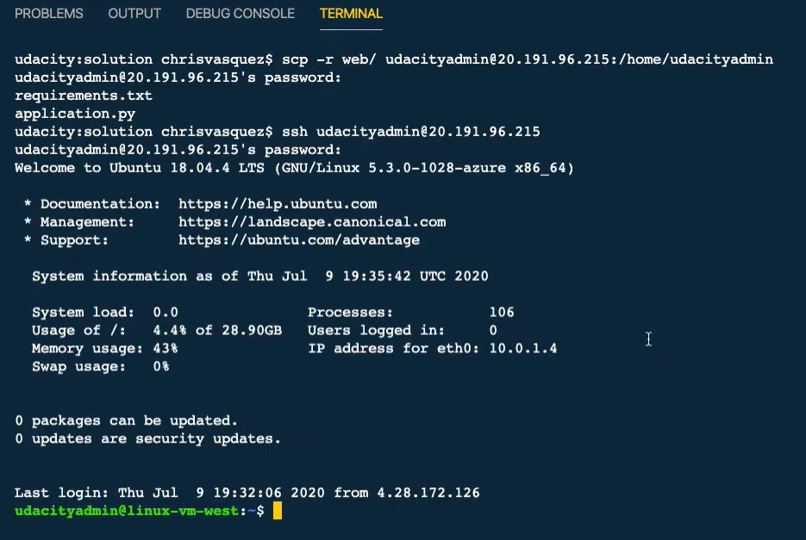

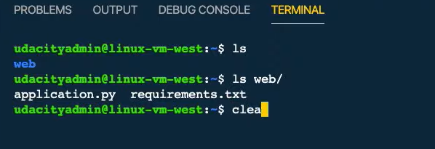

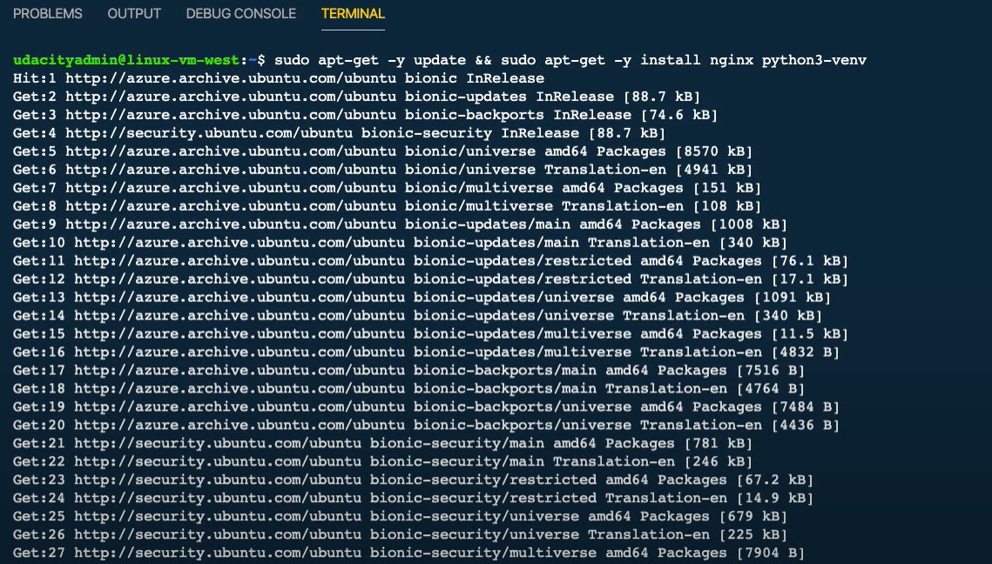

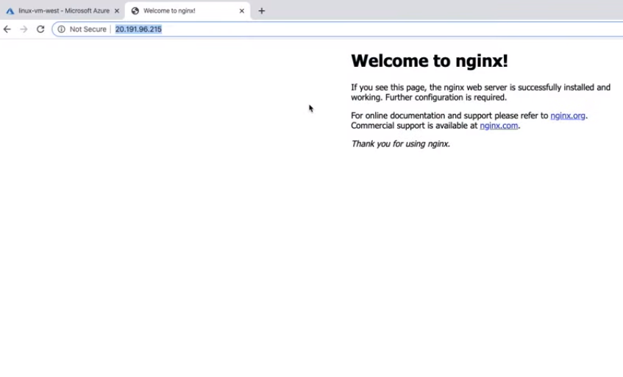

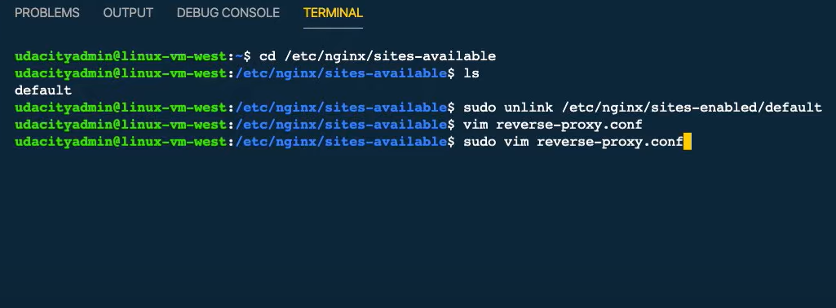

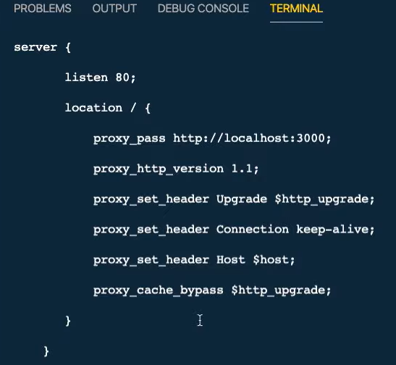

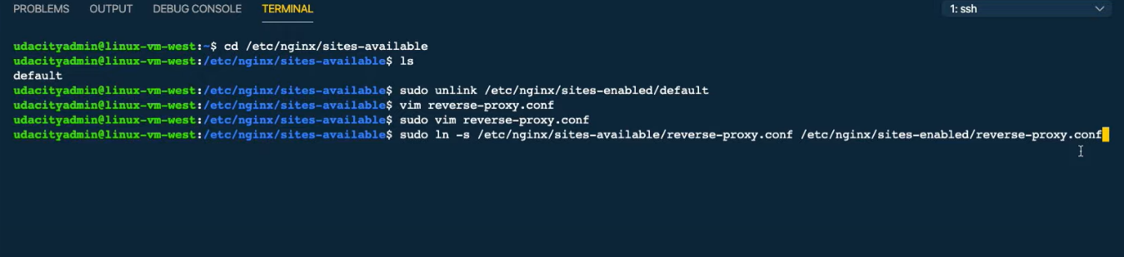

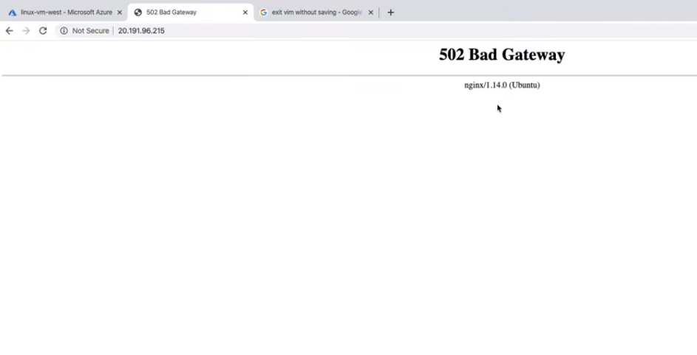

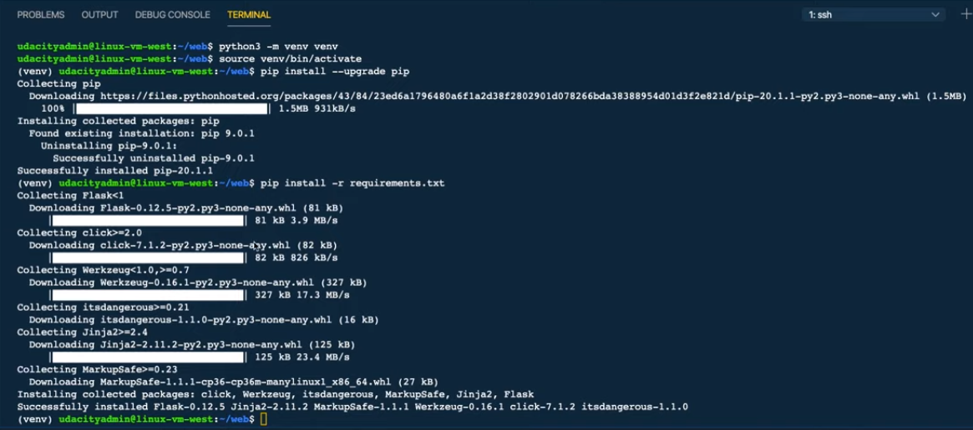

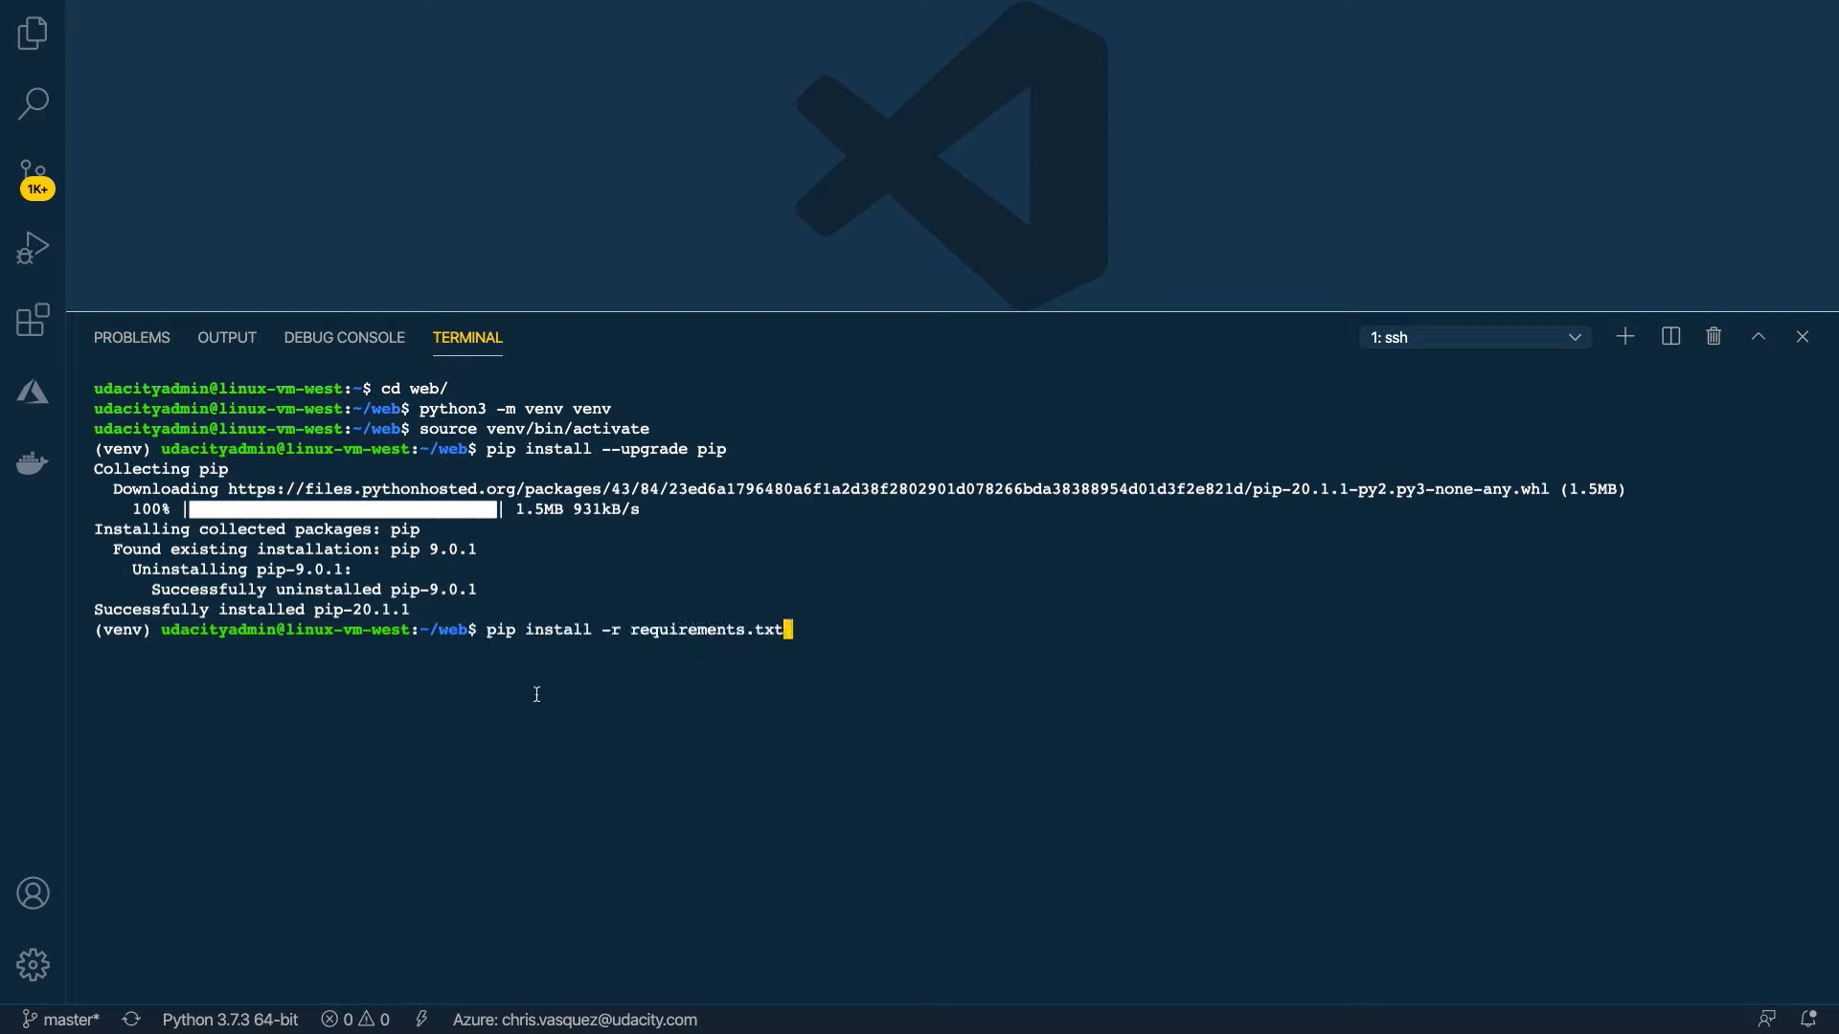

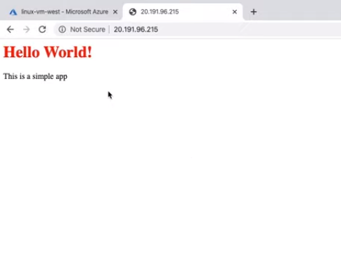

To connect to the created VM, I did the following (note that Windows users should use PowerShell or Bash):

1. We'll need our admin username we set when creating the VM - "udacityadmin"
2. We'll need the public IP address of our VM. You can use the following command to grab the IPs addresses for a particular VM from the CLI— az vm list-ip-addresses -g <RESOURCE-GROUP> -n <VIRTUAL-MACHINE-NAME> or use Azure portal.
3. Next, we're going to copy a basic Flask app from my local machine to the VM. We'll be using the secure copy utility—scp -r <SOURCE-DIR> [ADMIN-NAME]@[PUBLIC-IP]:<TARGET-DIR>. In this example, I used—scp -r ./web udacityadmin@IPADDRESS:/home/udacityadmin **NOTE**: The first time you try connecting to the VM, you'll see a similar message to the one below and should answer 'yes' to permanently add the IP address to the list of known hosts.

*The authenticity of host '52.191.135.139 (52.191.135.139)' can't be established.  
ECDSA key fingerprint is SHA256:7bBVTsYNImhXxAn+xscCHm/OkcodHZS615VSKO3GP8c.  
Are you sure you want to continue connecting (yes/no)?*

1. Once the files have been copied to the VM, we can connect to the VM using—ssh [ADMIN-NAME]@[PUBLIC-IP]
2. We can usels to see the web directory we just uploaded
3. Python 3 is already installed on the VM. We'll install Python Virtual Environment and NGNIX to use as a reverse proxy sudo apt-get -y update && sudo apt-get -y install nginx python3-venv
4. Before we run the app, we have to configure Nginx to redirect all incoming connections on port 80 to our app that is running on localhost port 3000
   * By default, Nginx has a default page that is displayed. If you visit the public IP address in your browser, you should see this page rendered.
   * We'll navigate to the **/etc/nginx/sites-available** directory—cd /etc/nginx/sites-available
   * We’ll first unlink the default site using sudo unlink /etc/nginx/sites-enabled/default
   * Then we’ll create a new file **reverse-proxy.conf** in the **/etc/nginx/sites-available**—sudo vim reverse-proxy.conf
   * We're going to add the following code to this file:
5. **server** {
6. **listen** 80;
7. **location** / {
8. **proxy_pass** http://localhost:3000;
9. **proxy_http_version** 1.1;
10. **proxy_set_header** Upgrade $http_upgrade;
11. **proxy_set_header** Connection keep-alive;
12. **proxy_set_header** Host $host;
13. **proxy_cache_bypass** $http_upgrade;
14. }
15. }

Now we’ll activate the directories by creating a sym link to the **/sites-enabled** directory sudo ln -s /etc/nginx/sites-available/reverse-proxy.conf /etc/nginx/sites-enabled/reverse-proxy.conf

* + We have to restart nginx so the changes take effect. sudo service nginx restart

1. cd to web
2. Create venv python3 -m venv venv
3. Activate the env source venv/bin/activate
4. Upgrade pip in our virtual environment and then Install dependencies pip install --upgrade pip pip install -r requirements.txt
5. We'll run our app python application.py
6. In a web browser, we can visit the public IP address of the VM and you should see the application
7. Type "exit" to disconnect from the VM

**Note:** Azure free account only allows 750 hours of free hosting. Make sure to delete this VM after creation for any exercises to avoid charges.

### Cleanup

If we no longer need a resource, we can delete them through the portal.

1. From the homepage, click on "Resource Group"
2. Click on the resource group you want to manage
3. You have two options—"Delete resource group" or if you want to keep the resource group, you can click on the individual or collection of resources you want to delete and click on "Delete"

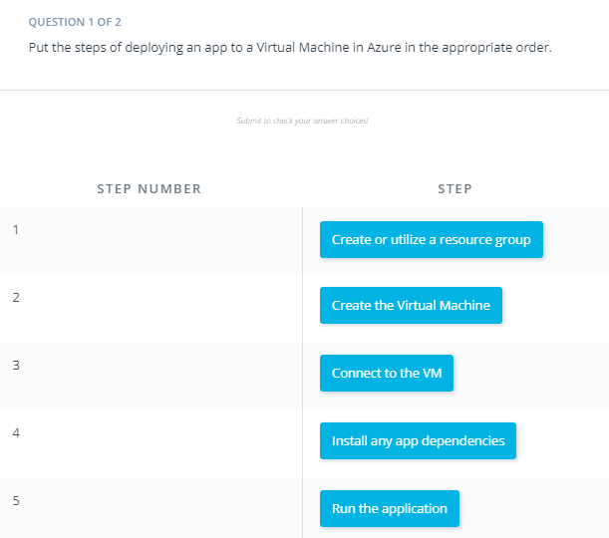

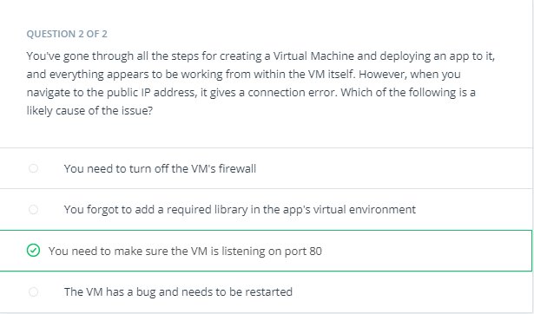

# Exercise: Creating a Virtual Machine

In this exercise, you will create resources (Virtual Machines) in Azure. Once you create these resources they will result in charges in your Azure account if they are not stopped or deleted. Make sure you stop or delete resources immediately after completing this exercise or while you are not actively working on it.

## Create a Linux Virtual Machine

In this exercise, you'll create and connect to a Linux Virtual Machine in Azure.

**Prerequisite:** If you're using Windows, you’ll need PowerShell or Bash to connect to the VM with ssh. Windows 10 should already have Powershell installed. If you don't have it already installed, [here is a guide](https://docs.microsoft.com/powershell/scripting/install/installing-powershell-core-on-windows?view=powershell-7&WT.mc_id=udacity_learn-wwl) on how to install it.

1. Create a Linux VM called “linux-vm-west” inside “resource-group-west” which was created in a previous exercise. The VM should have the following configurations:
   * VM Name: "linux-vm-west"
   * Region: West US or the closest region to you that's available
   * Availability Options: No infrastructure redundancy required.
   * Image: Ubuntu Server (any version)
   * Azure Spot instance: No
   * Size: Standard B1ls
   * Authentication type: Password
   * Username: (any username you choose)
   * Password: (any password you choose)
   * Inbound Port Rules: Allow both 22 and 80
2. After creating the VM, use **secure copy** to copy the web directory from [here](https://video.udacity-data.com/topher/2020/July/5f1875e2_create-vm-starter/create-vm-starter.zip) to the VM. scp -r ./web <USERNAME>@<IPADDRESS>:/home/<USERNAME>
3. After copying the files to the VM, **connect** to it and run the command ls to check the web directory is on the VM.
4. Next, install python3-env and nginx sudo apt-get -y update && sudo apt-get -y install nginx python3-venv
5. Next, configure nginx to listen for incoming traffic on port 80 and set port 3000 as the proxy.
   * Navigate to /etc/nginx/sites-avaiable
   * Remove the default file
   * Replace it with a file containing:
   * **server** {
   * **listen** 80;
   * **location** / {
   * **proxy_pass** http://localhost:3000;
   * **proxy_http_version** 1.1;
   * **proxy_set_header** Upgrade $http_upgrade;
   * **proxy_set_header** Connection keep-alive;
   * **proxy_set_header** Host $host;
   * **proxy_cache_bypass** $http_upgrade;
   * }
   * }
   * After saving the file, restart nginx sudo service nginx restart
6. Change to the web directory and create and activate a virtual env
7. As a best practice, update pip in a newly created virtual env
8. Install dependencies from **requirements.txt**
9. Run the application and visit the public IP address in your browser. You should see the application running if done correctly.

### **Cleanup**

Once you're done with the exercise, be sure to delete the VM and it's resources to avoid incurring unwanted charges.

**Note:** Azure free accounts only allow 750 hours of free hosting. Make sure to delete this VM after completing the exercise to avoid charges.

#### **Supporting Materials**

[**create-vm-starter.zip**](https://video.udacity-data.com/topher/2020/July/5f1875e2_create-vm-starter/create-vm-starter.zip)

# Solution: Creating a Virtual Machine

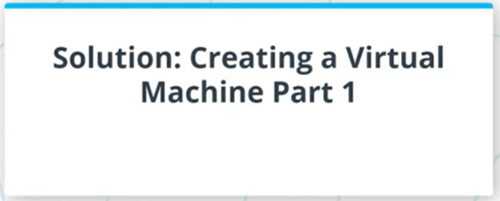

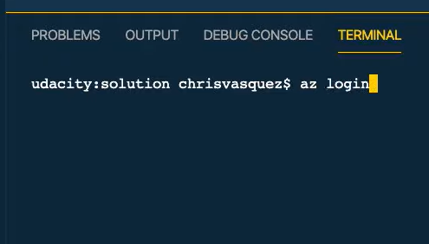

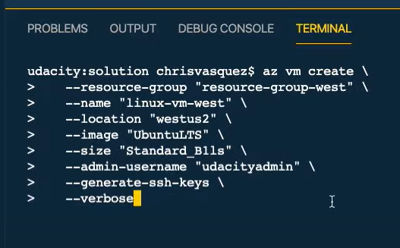

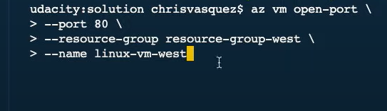

In this solution video, I showed you an alternative way to create a Linux VM using Azure CLI. Use whichever method you feel more comfortable with moving forward. Connecting to the VM is done the same way in both instances.

1. First, we'll login using az login
2. Next, we'll create our VM using az vm create. If we don't pass a location, it defaults to the location of the resource group. This would be fine in most cases, but it's worth noting that sometimes a VM size might not be available in the same region as your resource group, so you'd have to pass in a location for a different region.

az vm create \

--resource-group "resource-group-west" \

--name "linux-vm-west" \

--location "westus2" \

--image "UbuntuLTS" \

--size "Standard_B1ls" \

--admin-username "udacityadmin" \

--generate-ssh-keys \

--verbose

1. Upon success, you will have a JSON response.
2. Next we will open port 80 to allow outside traffic to our VM

az vm open-port \

--port "80" \

--resource-group "resource-group-west" \

--name "linux-vm-west"

1. Upon success, you will receive a JSON response.

Alternatively, you can check the screenshot below for the same approach through the portal.

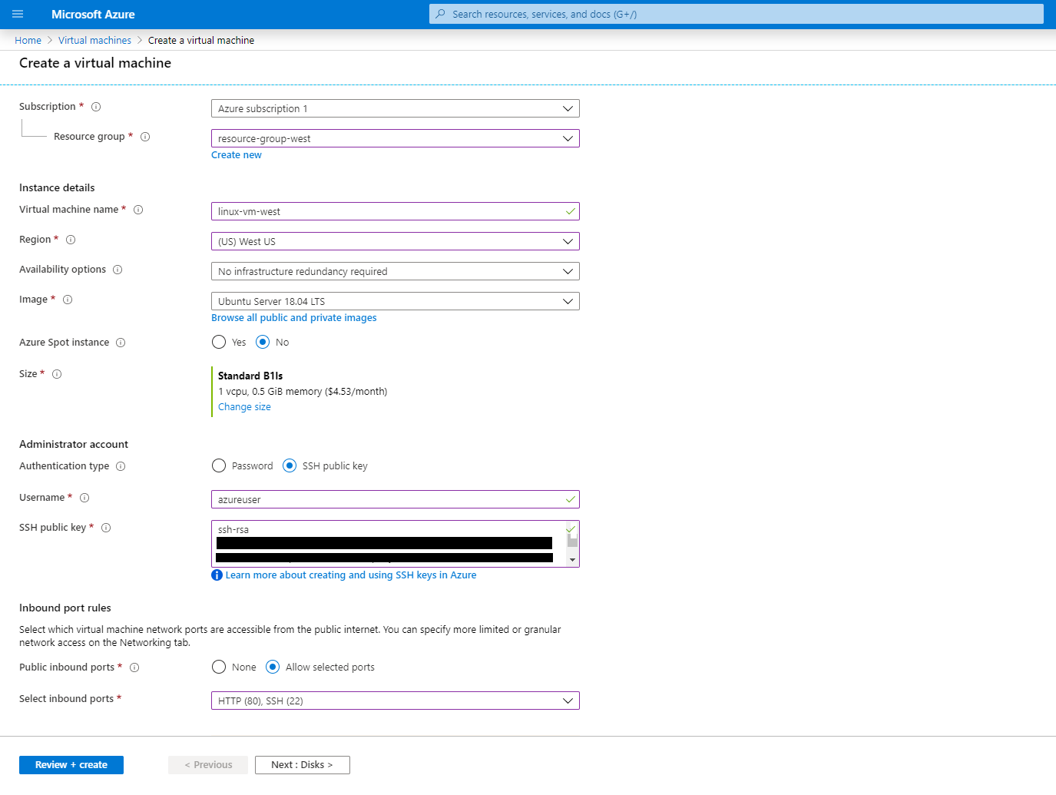

An example of creating a Linux VM in the Azure Portal

### Connecting to the VM

1. We'll need the admin username we set when creating the VM
2. We'll need the public IP address of our VM. You can use the following command to grab the IP address for a particular VM from the CLI. az vm list-ip-addresses -g resource-group-west -n linux-vm-west
3. Next we're going to copy a basic Flask app from my local machine to the VM. We'll be using the [secure copy utility](http://www.hypexr.org/linux_scp_help.php). scp -r ./web udacityadmin@IPADDRESS:/home/udacityadmin
4. Now we can connect to the VM with “ssh [username]@[IP Address]” **Note**: Since we generated SSH keys, you won't be prompted for a password.
5. Run ls to see the web directory we just uploaded
6. Python 3 is already installed on the VM. We'll install Python Virtual Environment and NGNIX to use as a reverse proxy sudo apt-get -y update && sudo apt-get -y install nginx python3-venv
7. Before we run the app, we have to configure Nginx to redirect all incoming connections on port 80 to our app that is running on localhost port 3000
   * By default, Nginx has a default page that is displayed. If you visit the public IP address in your browser, you should see this page rendered.
   * We'll navigate to the **/etc/nginx/sites-available** directory—cd /etc/nginx/sites-available
   * We’ll first unlink the default site using sudo unlink /etc/nginx/sites-enabled/default
   * Then we’ll create a new file **reverse-proxy.conf** in **/etc/nginx/sites-available**—sudo vim reverse-proxy.conf
   * We're going to add the following code to this file:
8. **server** {
9. **listen** 80;
10. **location** / {
11. **proxy_pass** http://localhost:3000;
12. **proxy_http_version** 1.1;
13. **proxy_set_header** Upgrade $http_upgrade;
14. **proxy_set_header** Connection keep-alive;
15. **proxy_set_header** Host $host;
16. **proxy_cache_bypass** $http_upgrade;
17. }
18. }
19. Now we’ll activate the directories by creating a sym link to the **/sites-enabled** directory sudo ln -s /etc/nginx/sites-available/reverse-proxy.conf /etc/nginx/sites-enabled/reverse-proxy.conf
    * We have to restart nginx so the changes take effect. sudo service nginx restart

### Deploying the App to the VM

This section is the same as the earlier walkthrough, so we'll skip a solution video for it.

To deploy the app on the virtual machine, I did the following:

1. CD to web
2. Create venv python3 -m venv venv
3. Activate the env source venv/bin/activate
4. Upgrade pip in our virtual environment and then Install dependencies—pip install --upgrade pip pip install -r requirements.txt
5. We'll run our app python application.py
6. In a web browser, we can visit the public Ip address
7. Type "exit" to disconnect from the VM

### **Cleanup**

If we no longer need a resource, we can delete them through the portal. The quickest way to do this from the CLI is to delete the resource group. This will delete all resources in that group

az group delete -n resource-group-west

# Creating an App Service

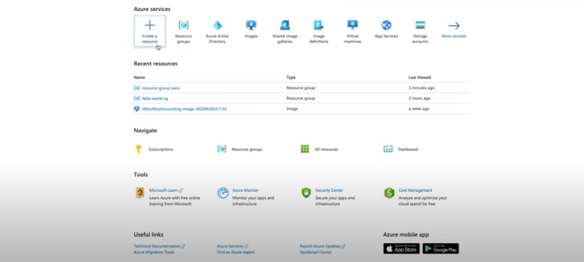

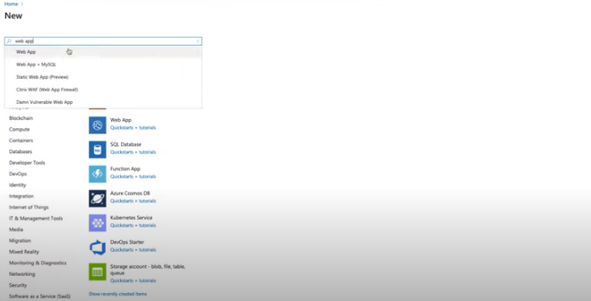

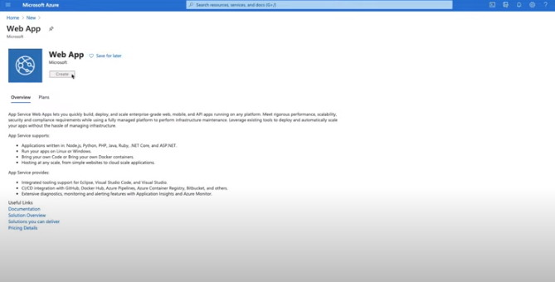

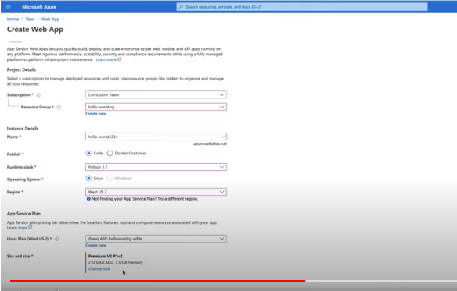

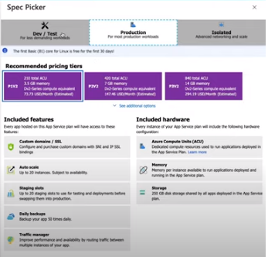

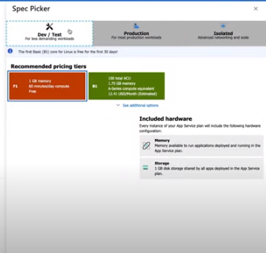

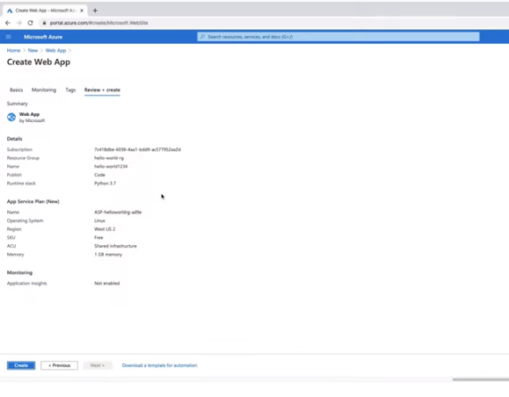

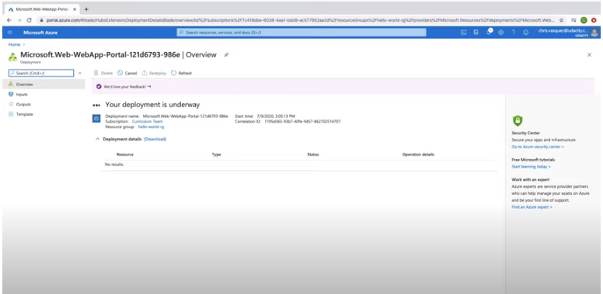

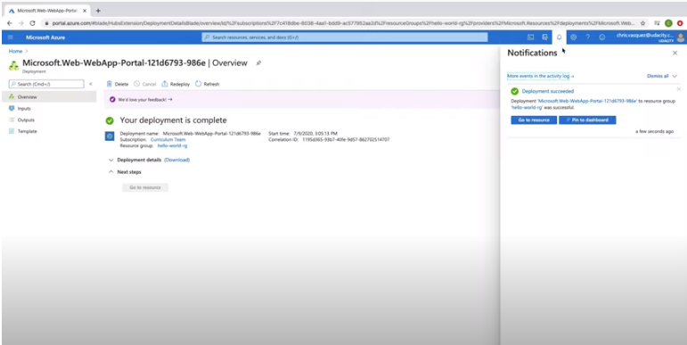

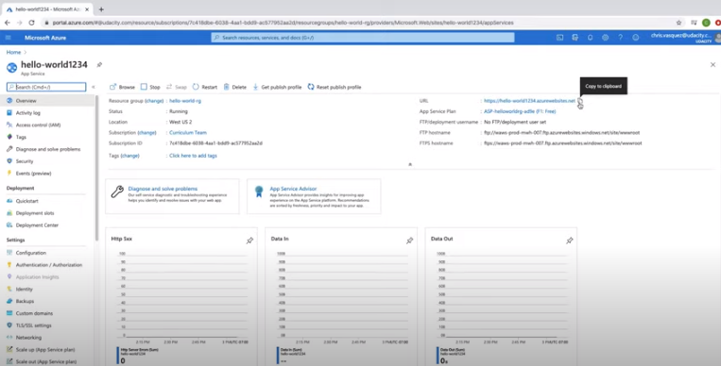

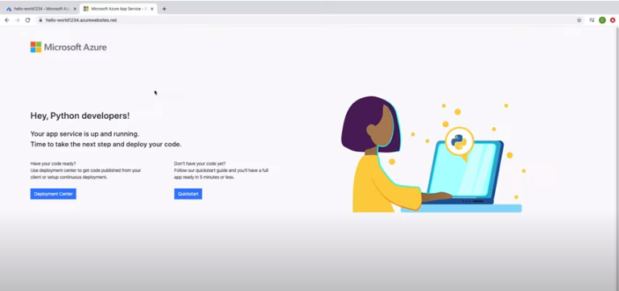

I took the following steps to create an App Service Web App using the Azure Portal

1. On the homepage, click "Create a resource"
2. Search for "Web App"
3. Click "Create"
4. Select your subscription
5. Select your resource group "resource-group-west"
6. Enter a name for your web app—This needs to be a unique name and is unique to Azure as a whole and not just your Azure account. I used "hello-world1234" as my unique name.
7. For Publish, select "Code"
8. For the "Runtime Stack", select "Python 3.7" or greater.
9. For the "Operating System" select "Linux"
10. Select a region for your app service
11. Create a new App Service Plan. You can keep the default name Azure gives you or you can create your own name.
12. For SKU and size, select "F1" (Free).
13. Click "Review + Create"
14. Click "Create"

Then, I clicked on the URL to see the app service, which confirmed the app service was up and running. Now we need to deploy our code.

**Note:** Azure free account only allows 1 Linux App Service of size F1. You will need to delete the App Service Web App along with the App Service Plan after each exercise since we will create other Linux App Services throughout this course.

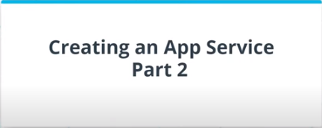

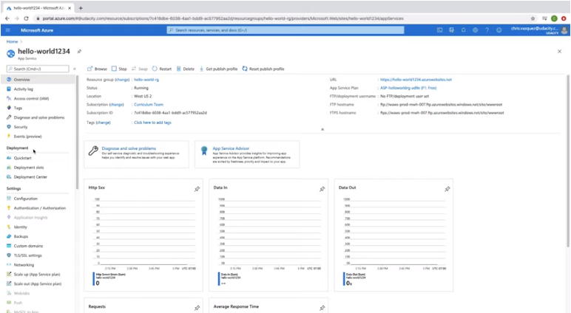

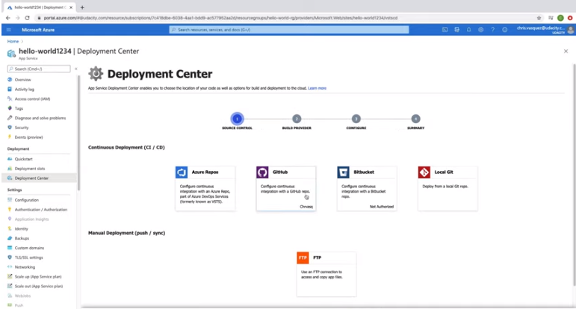

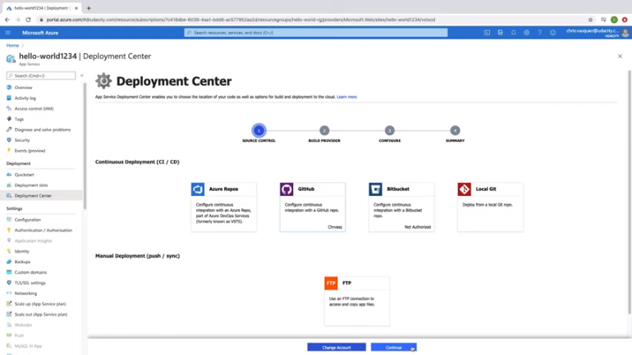

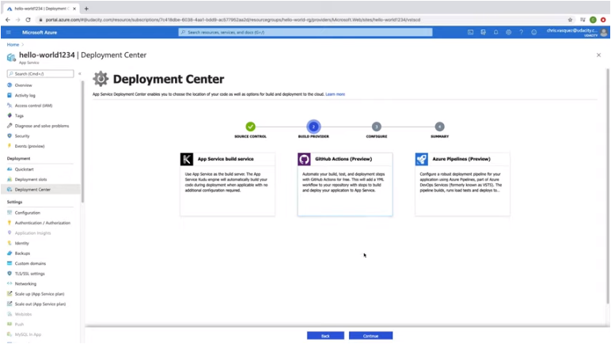

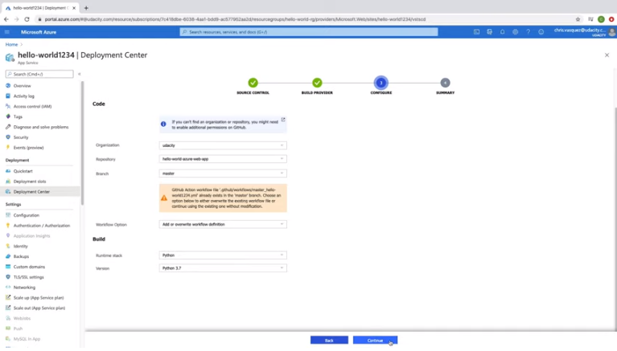

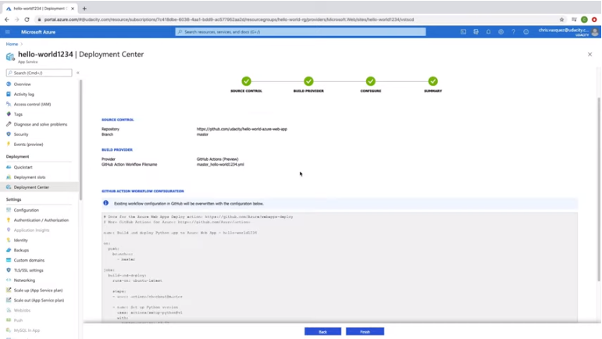

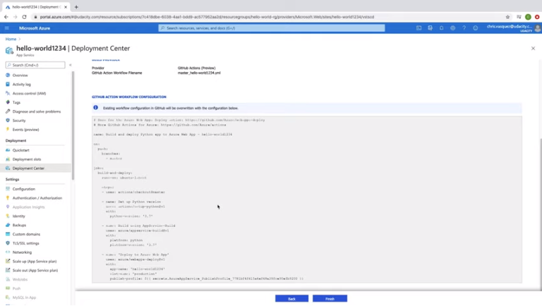

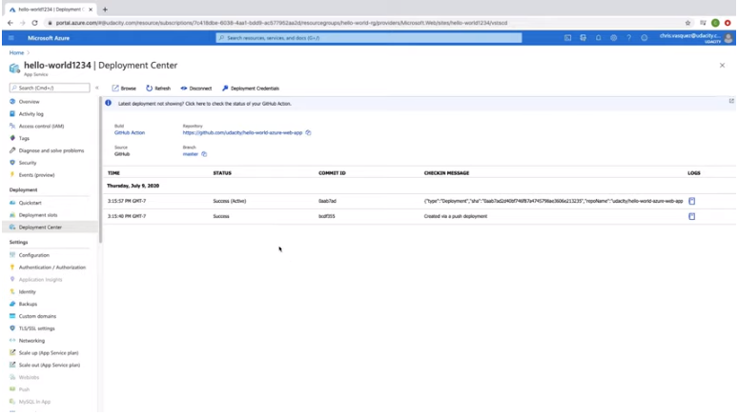

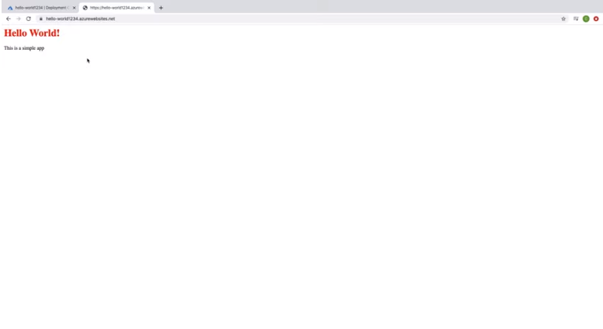

To clean de resources:

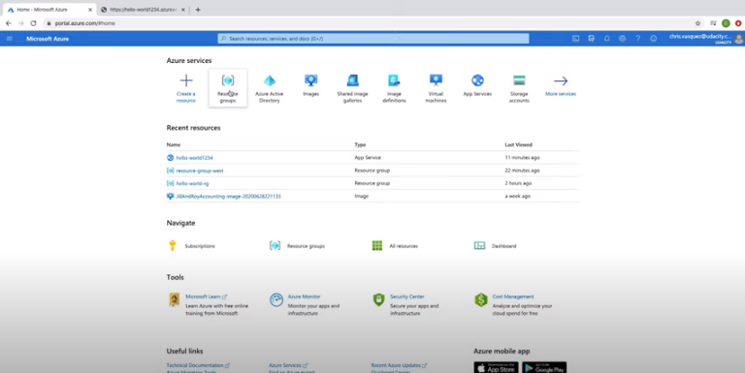

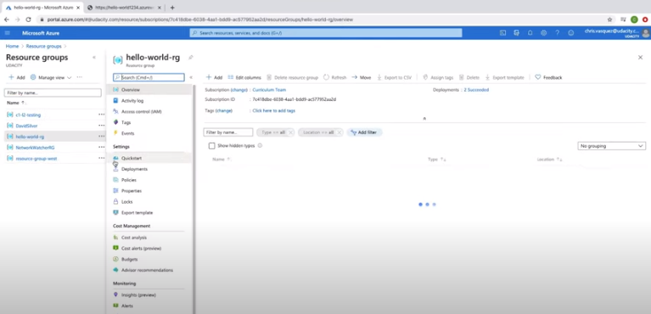

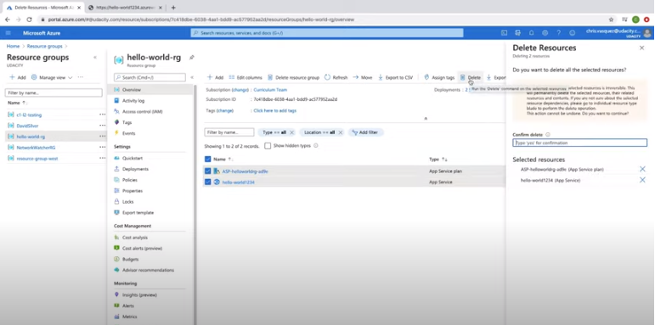

To deploy an App Service from a GitHub repository, I did the following:

1. Go to Deployment Center
2. Choose GitHub
3. Choose org and repo
4. Go through the prompts; deployment takes a few minutes
5. Go to URL of web app and should see the app deployed

### **Cleanup**

If we no longer need a resource, we can delete them through the portal.

1. From the homepage, click on "Resource Group".
2. Click on the resource group you want to manage.
3. You have two options—"Delete resource group" or if you want to keep the resource group, you can click on the individual or collection of resources you want to delete and click on "Delete".

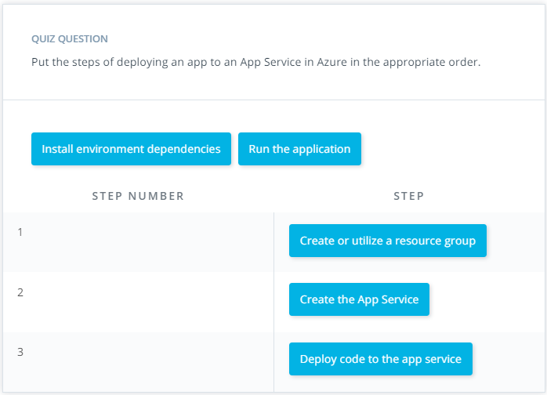

# Exercise: Creating an App Service

In this exercise, you will create resources (App Services) in Azure. Once you create these resources they will result in charges in your Azure account if they are not stopped or deleted. Make sure you stop or delete resources immediately after completing this exercise or while you are not actively working on it.

## Create and Deploy an App Service Web App

In this exercise, you'll create and deploy an app service web app.

**Prerequisites:**

* A GitHub Account. If you don’t have one, create one [here](https://github.com/).

### **Create an App Service Web App**

Create an App Service Web App with the following configuration:

* Resource-Group: resource-group-west
* Web App Name: unique name
* Publish: Code
* Runtime stack: Python 3.7
* Operating System: Linux
* Region: West US or the closest region to you
* App Service Plan: Default name or Create new with a name of your choice
* SKU and size: F1 (Free)

**Note:** Azure free account only allows one Linux App Service of size F1. You will need to delete the App Service along with the App Service Plan after this exercise since you will create other Linux App Services throughout this course.

### **Deploy the App Service Web App**

It’s finally time to deploy some code to Azure! Download the web app code provided [here](https://video.udacity-data.com/topher/2020/July/5f18767d_create-app-service-starter/create-app-service-starter.zip).

1. Create a new repo and push the web app code to the repo
2. On Azure portal in the Deployment Center, deploy the web app from GitHub
3. Navigate to the deployed URL

#### Supporting Materials

* [create-app-service-starter.zip](https://video.udacity-data.com/topher/2020/July/5f18767d_create-app-service-starter/create-app-service-starter.zip)

# Solution: Creating an App Service

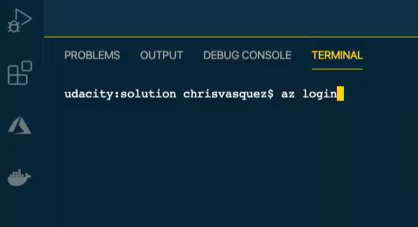

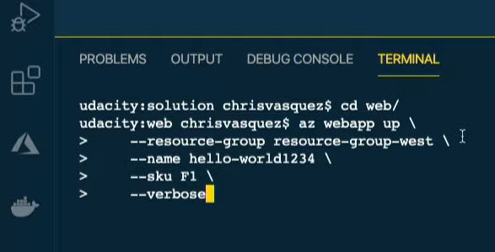

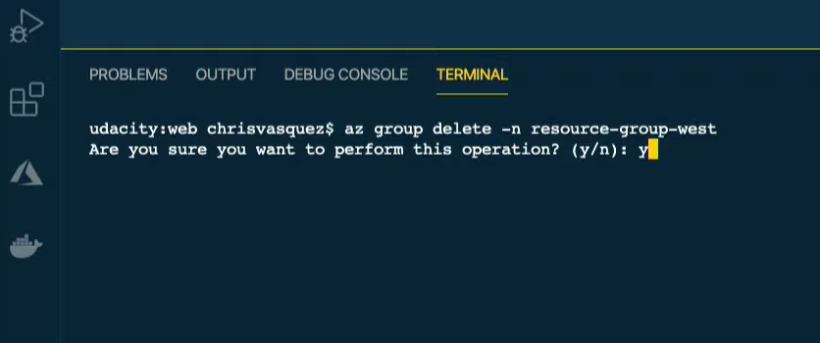

In this solution video, I showed you an alternative way to create and deploy an Azure App Service Web App using Azure CLI. Use whichever method you feel more comfortable with moving forward.

**Steps to Create and Deploy an App Service Web App from a Directory using Azure CLI:**

1. Sign in to Azure az login
2. cd to web directory
3. Run the following command:
4. az webapp up \
5. --resource-group resource-group-west \
6. --name hello-world1234 \
7. --sku F1 \
8. --verbose
9. If you visit the URL, you should see your site deployed.
10. If you want to update your app, make changes to your code and then run (**Note**: this may not update new requirements you may have added):
11. az webapp up \
12. --name hello-world1234 \
13. --verbose

Alternatively, you can create the initial web app from the Portal as shown in the below screenshot (and then deploy code to it separately, as shown in the earlier video).

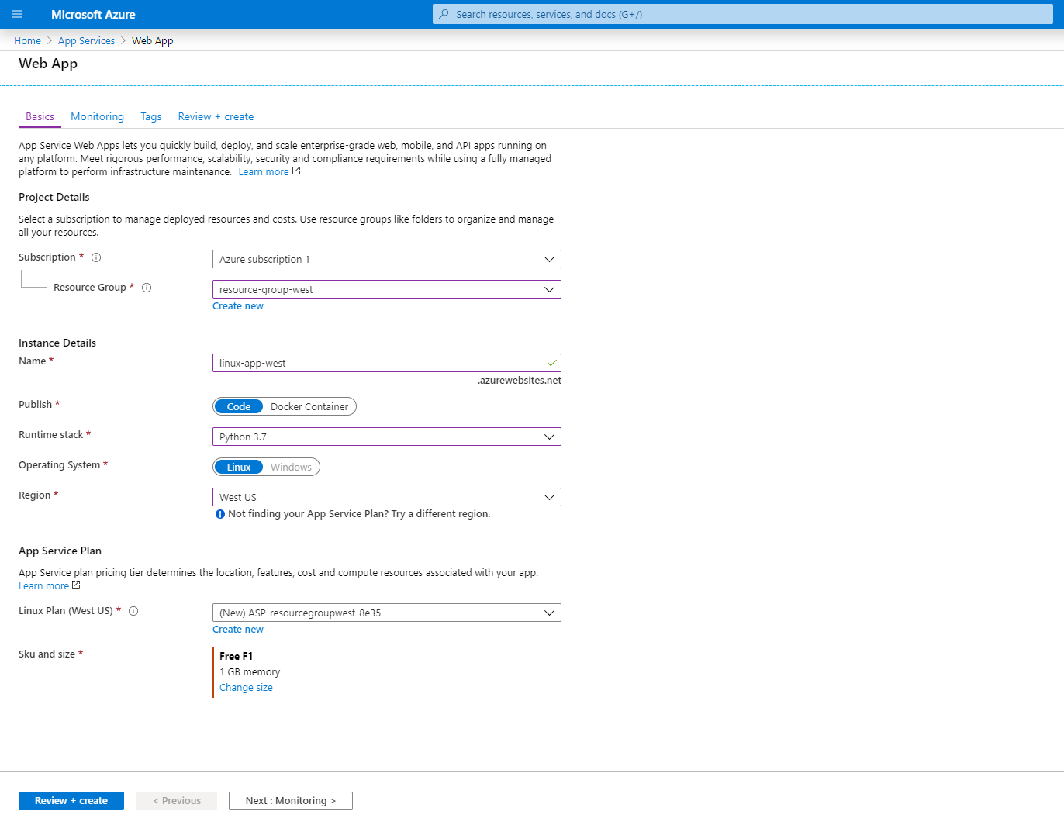

### **Cleanup**

If we no longer need a resource, we can delete them through the portal. The quickest way to do this from the CLI is to delete the resource group. This will delete all resources in that group

az group delete -n resource-group-west

Alternatively, if you want to just delete the App Service and App Service plan individually, you can do so with the following commands:

**Delete an App Service**

az webapp delete \

--name hello-world1234 \

--resource-group resource-group-west

**Delete an App Service plan**

az appservice plan delete \

--name [App Service Plan Name] \

--resource-group resource-group-west

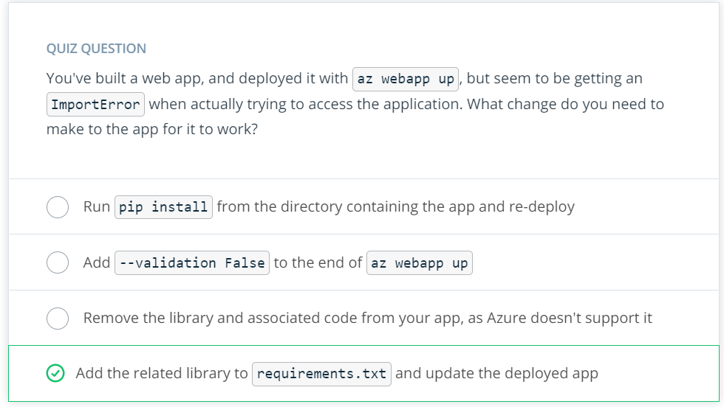

# Lesson Conclusion

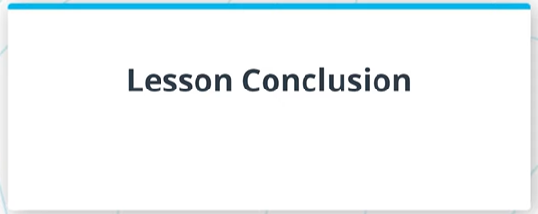

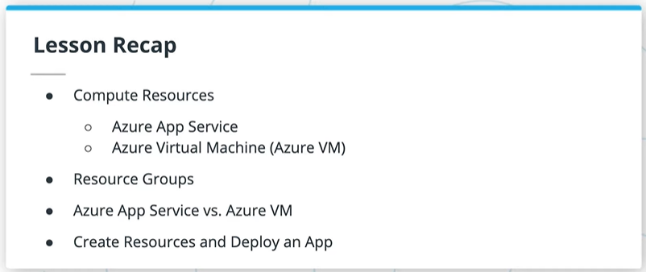

In this lesson, we focused on Azure Compute Services:

* We took a look at some of the various compute options available
* Then, we discussed subscriptions and resource groups, and you created your own resource group
* From there, we took a deeper dive into two compute services in Azure: Virtual Machines and App Services
* After comparing and contrasting these two, you created both resources and deployed an app to them

# Glossary

| **Key Term** | **Definition** |
| --- | --- |
| Subscription | Multiple of these can exist within a single Azure account; often used for billing and other management purposes. |
| Resource Group | Help to organize resources you use, such as Virtual Machines, App Services or storage, in order to make resource management easier. Groups are often set up for different projects or regions. |
| Region | Locations of Azure data centers around the world. The closer the region of app resources is to the end user, the lower the latency experienced. |
| ARM Templates | Created within Azure Resource Manager to more easily spin up a set of given resources multiple times. |
| Virtual Machines | An Azure IaaS option giving you full access to the underlying operating system of a compute resource. These can be either Windows or Linux machines, with great availability, scalability and redundancy. These require more on-going maintenance and up-keep by cloud developers. |
| App Service | An Azure PaaS option allowing developers to focus more on their apps than the underlying infrastructure. It is an HTTP-based service for hosting web applications, REST APIs, and mobile back ends. It supports multiple languages and continuous deployment. While they are good for scaling, there is also a limit of up to 14 GB or 4 CPU cores on the highest tier. |
| App Service Plan | Contains certain settings of an App Service, such as region, number of VM instances (App Services still run on VMs, but the developer does not have control of the underlying VM, and the app may share the VM with other apps), size of those instances, and pricing tier. |
| Azure Batch | Used for running large-scale and high-performance compute applications beyond the capabilities of an App Service. |
| Azure Functions | A serverless, event-driven, compute-on-demand platform (covered in a later course). |
| Container Instances | A platform for deploying serverless docker containers (covered in a later course), without the container orchestration provided by AKS (see below). |
| Service Fabric | Microsoft's own distributed systems platform, similar to Kubernetes. |
| Azure Kubernetes Service (AKS) | Microsoft's own platform for hosting and managing Kubernetes, including deploying docker containers into clusters (covered in a later course). |

**LESSON 3 Azure Storage**

# Introduction

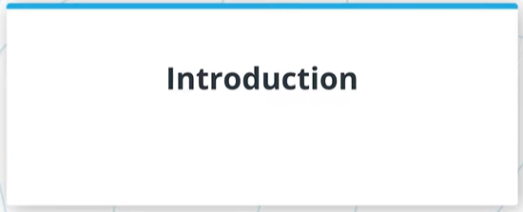

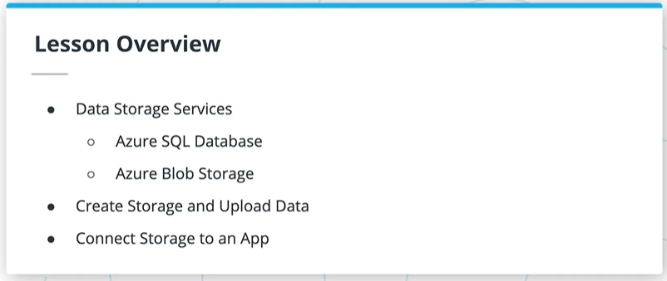

In this lesson, you will:

* Take a look at all the different storage options available in Azure and their benefits
* Take a deep dive on Azure SQL Databases and Blob Storage, including creating the related resources and uploading data
* Connect those storage services to your app

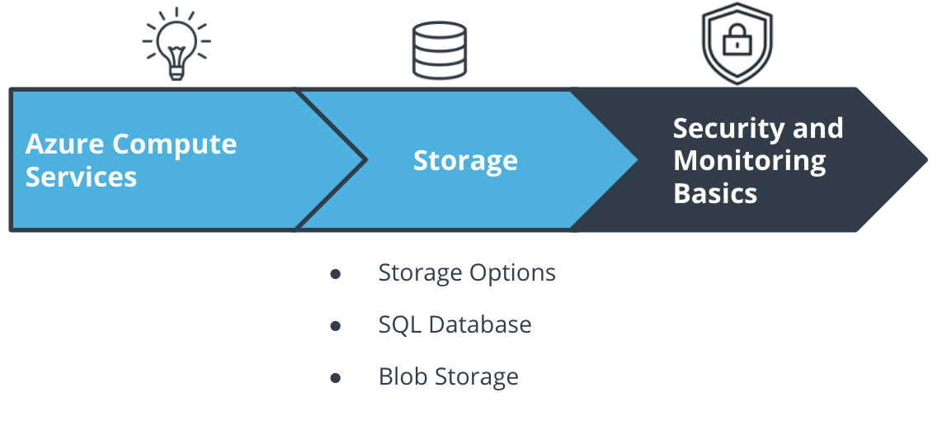

The Course and Lesson Outline

# Big Picture: Storage

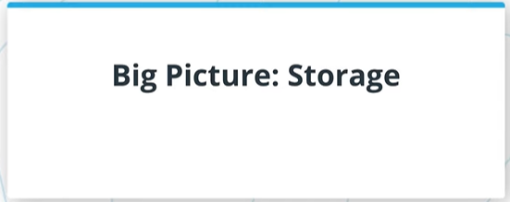

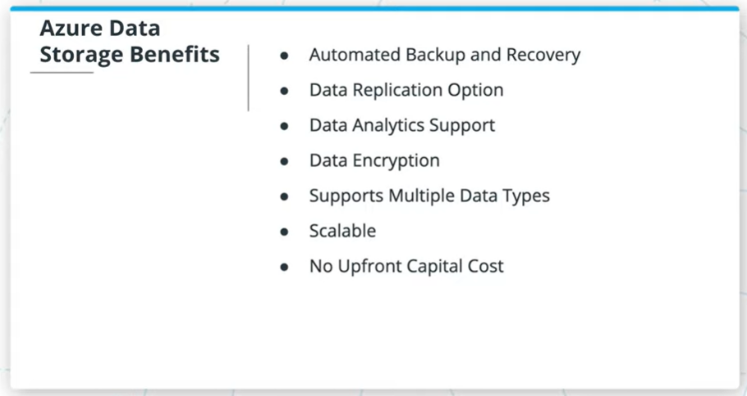

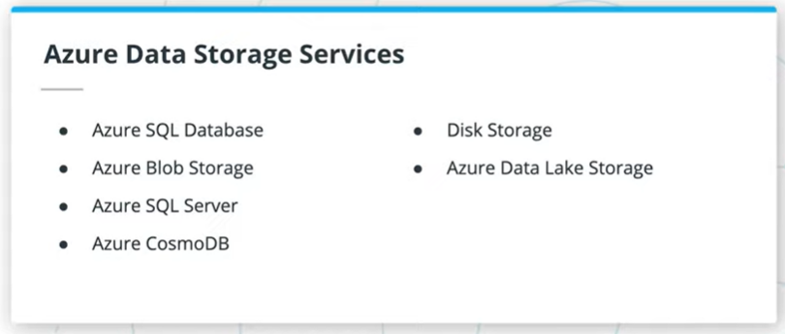

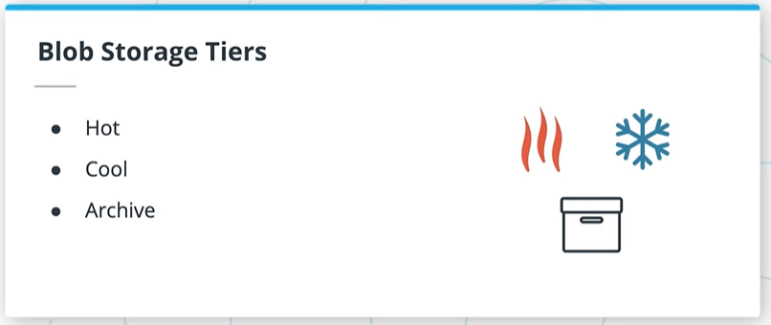

Some of the benefits of using Azure for storage are:

* Automated backup and recovery
* An option to replicate data at multiple data centers worldwide to help prevent outages from unplanned events, such as hardware failure.
* Data analytics support
* Data encryption for added security
* Support for the storage of multiple data types. Azure is designed to hold 3 main types data—relational data, non-relational data or NoSQL data, and unstructured data such as images.
* Scale up or scale out when demand is high and scale back when demand is low.
* Eliminate the expense of having to purchase, install, configure, and maintain on premises hardware.

### **Azure Storage Options**

Among others, some of the Azure Storage options are:

* Azure SQL Server and SQL Database
* Azure Blob Storage
* Azure CosmosDB
* Disk Storage
* Azure Data Lake Storage
* HPC Cache

We could spend an entire course just on Azure storage, so we’ll focus on two of these services in this lesson—Azure SQL Database and Azure Blob Storage. CosmosDB will be covered in another course.

We also covered the three tiers of blob storage - hot, cool and archive. We'll come back to this later in the section on Azure Blob Storage.

### QUIZ QUESTION

True or False: My app will only ever use one type of storage.

* 

True

* False

SUBMIT

**Azure SQL Databases**

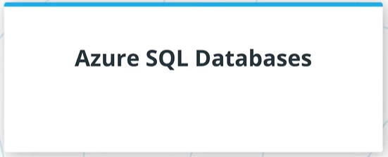

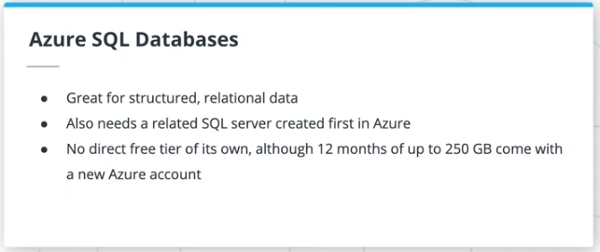

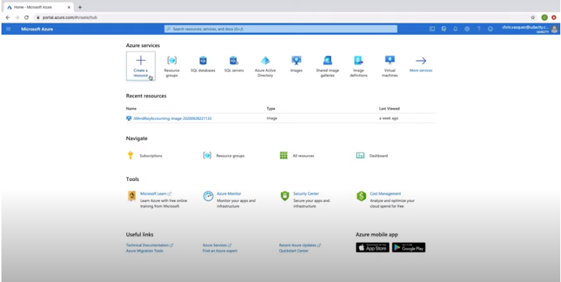

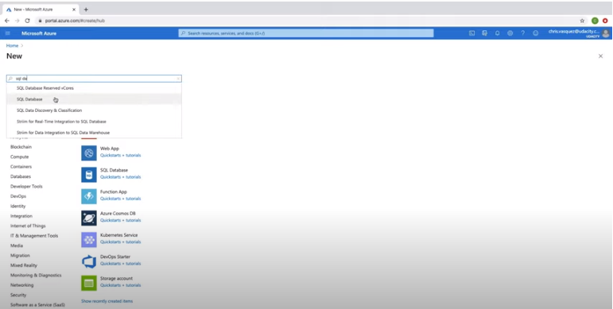

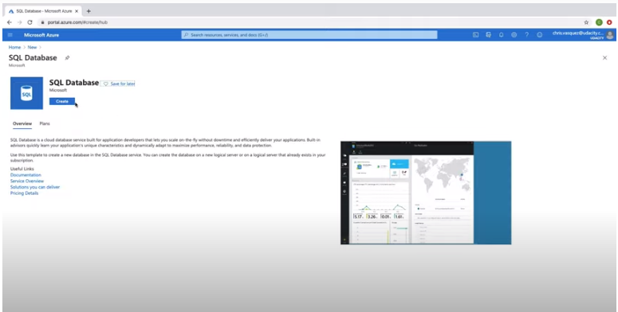

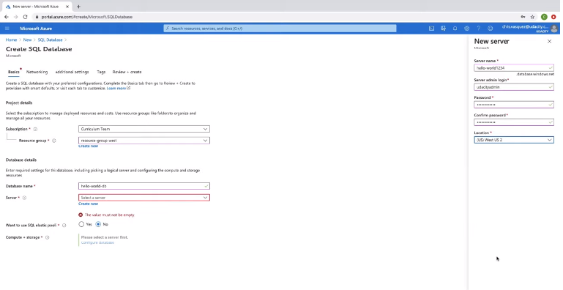

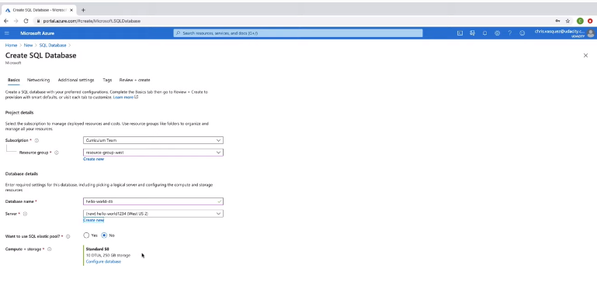

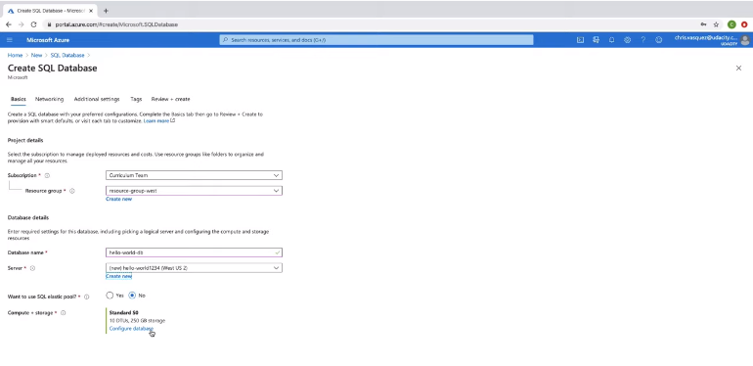

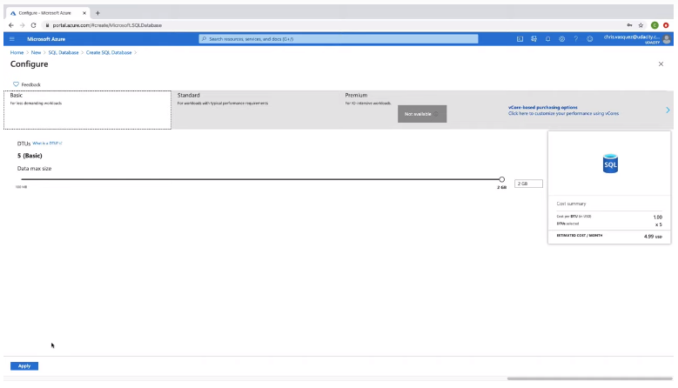

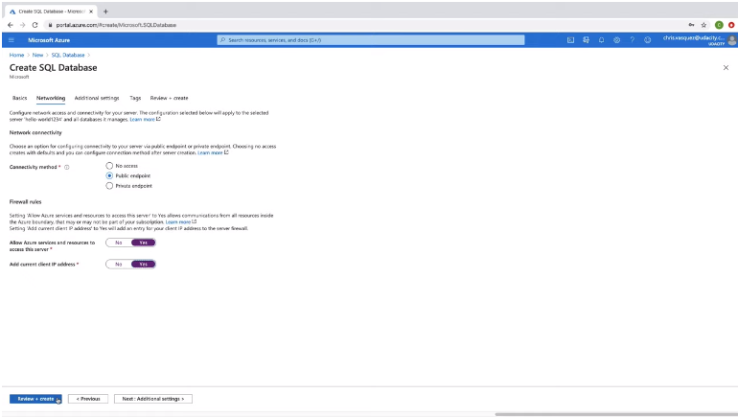

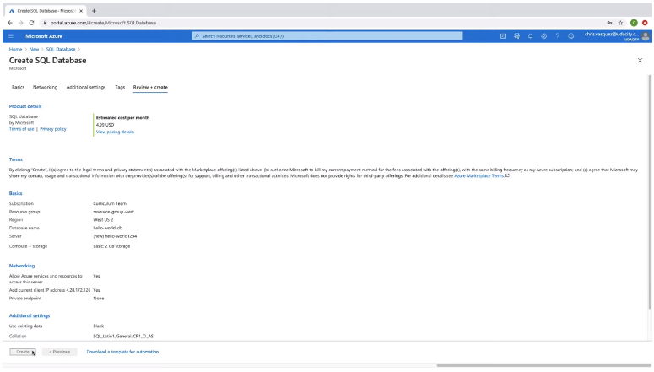

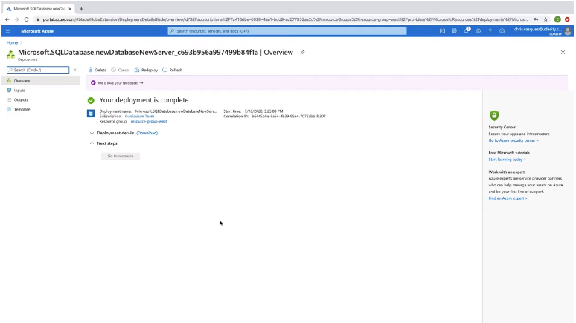

* Azure SQL databases are used for structured, relational data.
* In Azure, you also need to first create a related SQL server to hold the database, although you can create multiple SQL databases under a single SQL server.
* Azure SQL databases do not have a free tier option like we saw with App Services earlier; however, when you sign up for a new free Azure account, you get 12 months of up to 250GB of Azure SQL database storage. The lowest tier is currently ~$5 / month otherwise for a small amount of storage.

### **Creating an Azure SQL Database in the Portal**

To create an Azure SQL Database in the Azure Portal:

1. Find the "SQL databases" service in Azure.
2. Click "Create SQL Database".
3. Select the appropriate subscription and resource group (likely “resource-group-west”).
4. Enter a database name.
5. If you already have a SQL server, you can use it; however, you likely need to click "Create New".
   * If creating a new SQL server, enter a server name, and then admin and password - make sure you can remember these, or you will not be able to access the server when necessary. The admin name cannot just be "admin".
   * Set the location to match the resource group.
6. Keep SQL elastic pool on the default of "No".
7. Under Compute+Storage, click on "Configure Database". While General Purpose won't end up charging you anything for the short time the server is live for these exercises, you might as well press "Looking for basic, standard, premium?", and change it to "Basic".
8. Press the "Next: Networking" button, then select "Public Endpoint", and set both of the Firewall rules that appear to "Yes". This will allow us to more easily access the SQL database later on within our app.
9. Click "Review + Create" and then "Create" to create the database, then wait for it to deploy.

### QUIZ QUESTION

Azure SQL Databases can be left up on the basic tier for no cost forever.

* 

True

* False

SUBMIT

Server name: bucheli-server

Server admin login: buchenadmin

Password: RothWulf@1977

# Adding Data to the Database

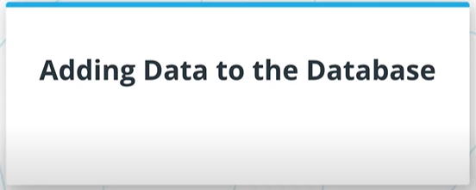

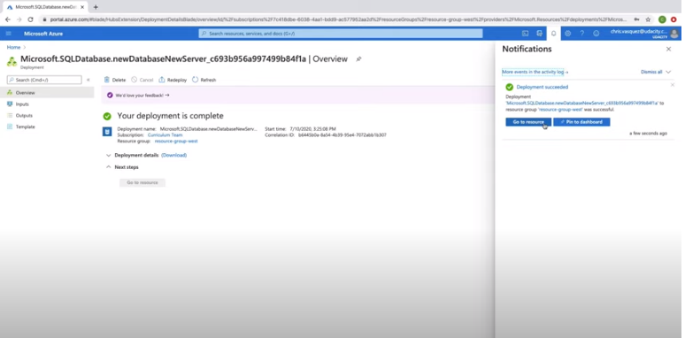

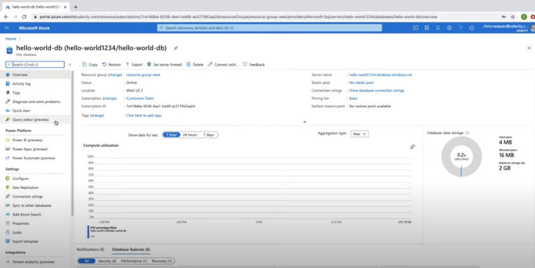

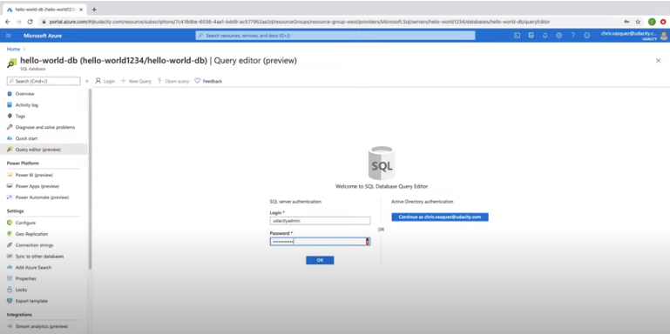

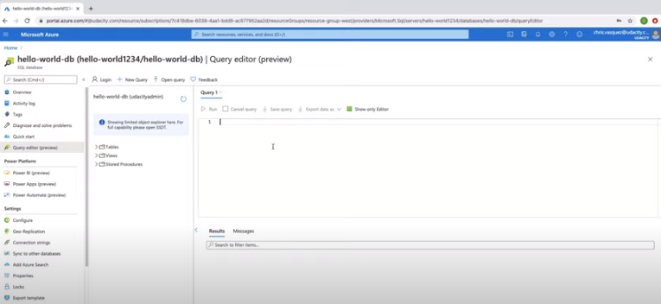

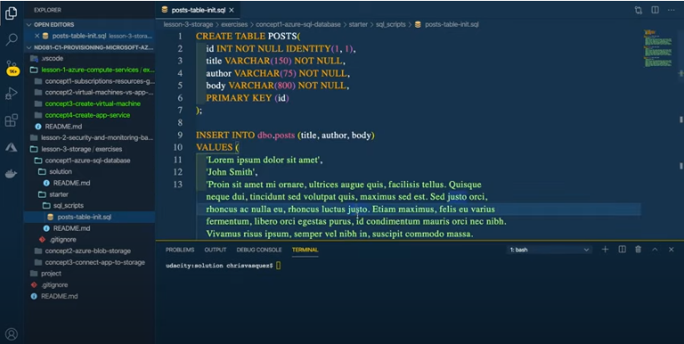

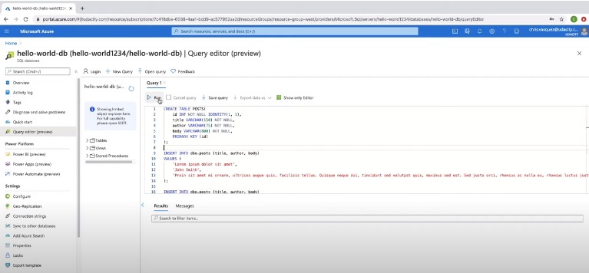

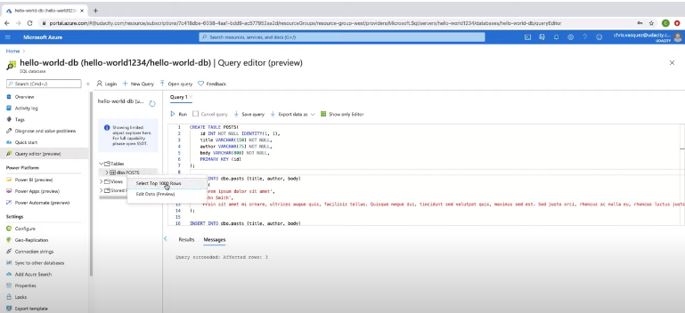

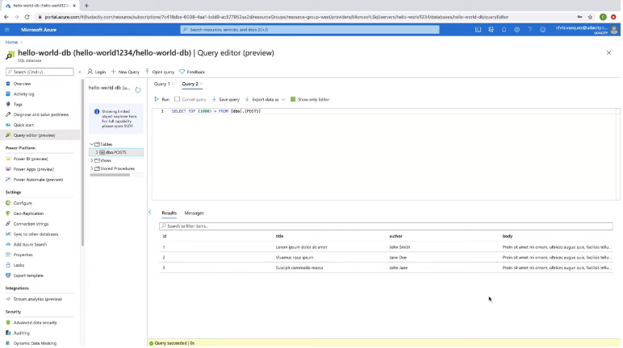

The last step is to delete the resources to don’t be charged.

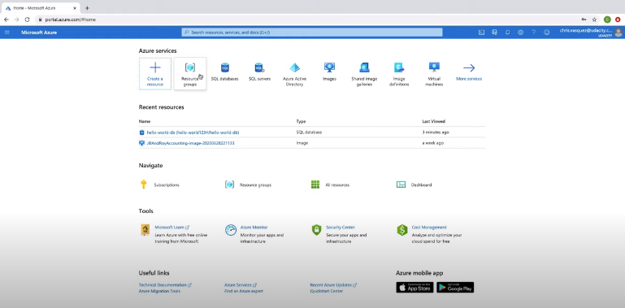

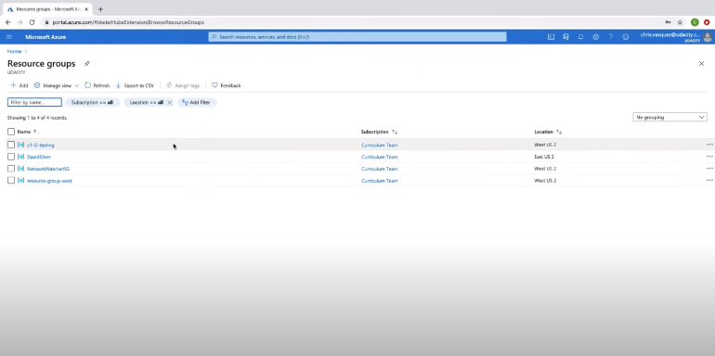

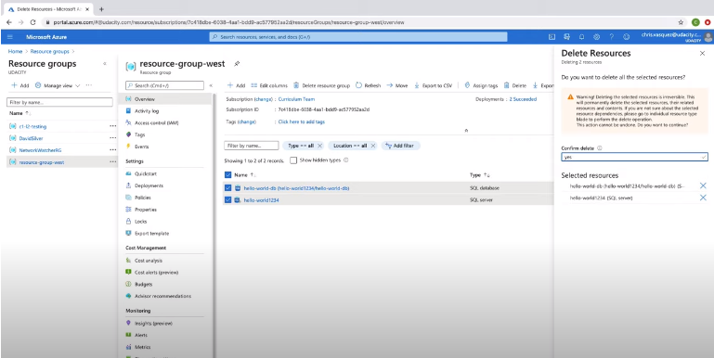

To add data to the SQL Database, I performed the following:

1. Once the SQL database is deployed, click on its name to access it (you may need to go back to the main "SQL databases" page in Azure).
2. Click on the "Query editor" in the left side menu, and then log in with my SQL Server credentials.
3. I pasted the query from my posts-table-init.sql script into the query window, and hit "Run"; you should see Query succeeded: Affected rows: 3.
4. On the left side of the query window, I clicked on the "Tables" folder, and double-checked that the dbo.POSTS table was successfully created with the correct fields.
5. I ran a new query with SELECT * FROM posts, to see the three posts listed.

You'll get to practice this yourself in the upcoming exercise.

### QUIZ QUESTION

Which of the following would be appropriate data to store in a SQL database?

* Information about books like author, title, year published, and summary
* 

Unstructured event data

* 

Images or code repositories

* Sales invoices, such as id, price, and item quantities

**26/09/2021 HERE**

# Exercise: Azure SQL Databases

## Exercise: Azure SQL Databases

In this exercise, you will create an Azure SQL Database and add data to it. This is an [Azure account first-year free service](https://azure.microsoft.com/en-us/free/free-account-faq/). In a later exercise, you will connect an app to the database, so that you can both get and post data from the app into the database.

1. Deploy a SQL Database in Azure called “database-west” to the “resource-group-west” resource group (or whichever resource group you have been using in earlier exercises).
2. Within the Azure portal, add the data from the script in the sql_scripts directory [here](https://video.udacity-data.com/topher/2020/July/5f075d26_sql-scripts/sql-scripts.zip) to the database. You should be able to run a SELECT query afterward on the animals table to see the example animals populated in your database.

**Note**: Azure free accounts only allow 250GB of free storage using SQL Databases. Once you get to the end of this lesson, you will want to delete the SQL Database and SQL Server to avoid incurring any charges, as you'll create a different SQL Database in the final course project.

#### Supporting Materials

* [sql-scripts.zip](https://video.udacity-data.com/topher/2020/July/5f075d26_sql-scripts/sql-scripts.zip)

# Solution: Azure SQL Databases

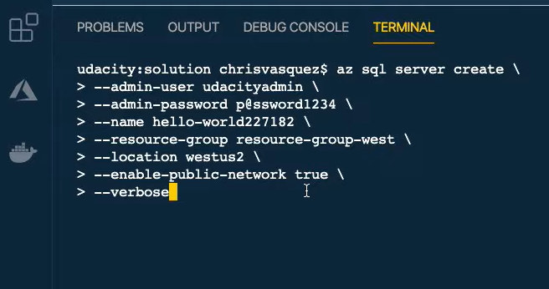

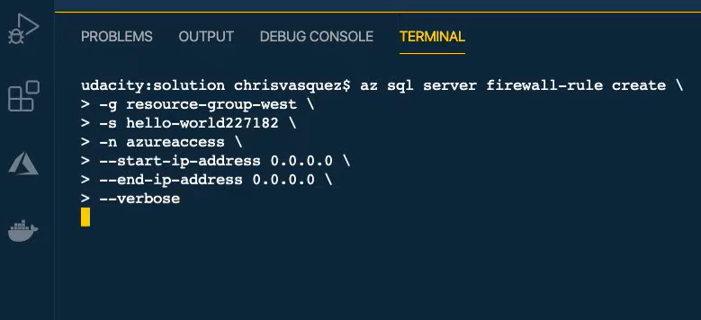

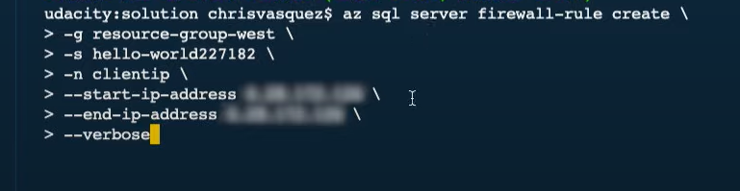

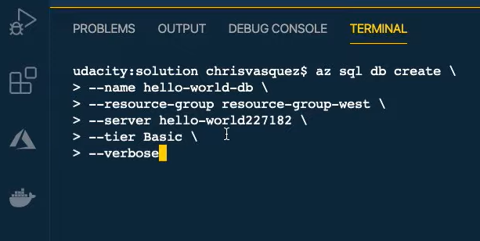

In this solution video, I showed you an alternative way to create an Azure SQL Database using Azure CLI.

### **Create SQL Server**

az sql server create \

--admin-user udacityadmin \

--admin-password p@ssword1234 \

--name hello-world-server \

--resource-group resource-group-west \

--location westus2 \

--enable-public-network true \

--verbose

### **Create Firewall rule**

Next, we have to create two firewall rules. These are the same two rules we checked as yes when we used the portal.

The first one is to allow Allow Azure services and resources to access the server we just created.

az sql server firewall-rule create \

-g resource-group-west \

-s hello-world-server \

-n azureaccess \

--start-ip-address 0.0.0.0 \

--end-ip-address 0.0.0.0 \

--verbose

This second rule is to set your computer's public Ip address to the server's firewall. You'll need to find your computer's public ip address for this part.

I'm using macOS, so I used the command curl ifconfig.me; you can use ipconfig in the command prompt if you are on Windows.

#### **Create clientIp firewall rule**

az sql server firewall-rule create \

-g resource-group-west \

-s hello-world-server \

-n clientip \

--start-ip-address <PUBLIC-IP-ADDRESS> \

--end-ip-address <PUBLIC_IP_ADDRESS> \

--verbose

### **Create SQL Database**

Finally, to create the database itself, I used the below command.

az sql db create \

--name hello-world-db \

--resource-group resource-group-west \

--server hello-world-server \

--tier Basic \

--verbose

### **Adding Data**

We'll again add data to the database through the portal, as that's the most straightforward method for now (until we connect to an app).

### **Cleanup**

You can find the CLI commands for cleaning up the SQL resources below.

#### **Delete DB**

az sql db delete \

--name hello-world-db \

--resource-group resource-group-west \

--server hello-world-server \

--verbose

#### **Delete SQL Server**

az sql server delete \

--name hello-world-server \

--resource-group resource-group-west \

--verbose

# Blob Storage

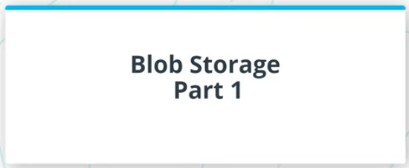

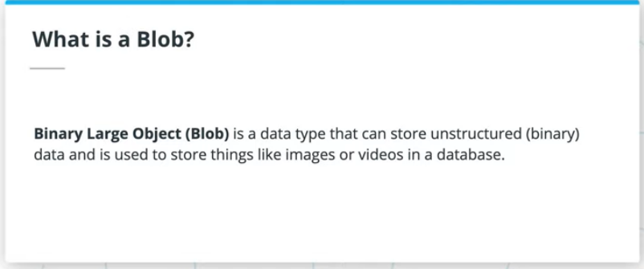

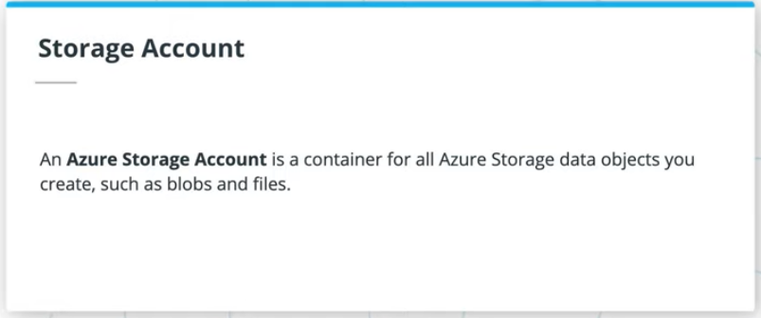

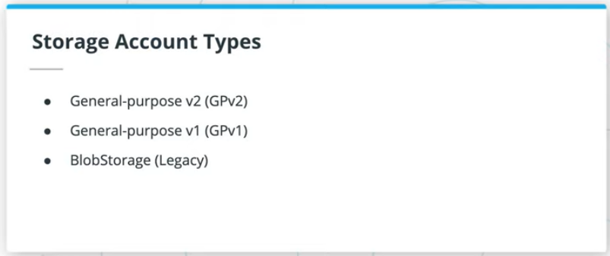

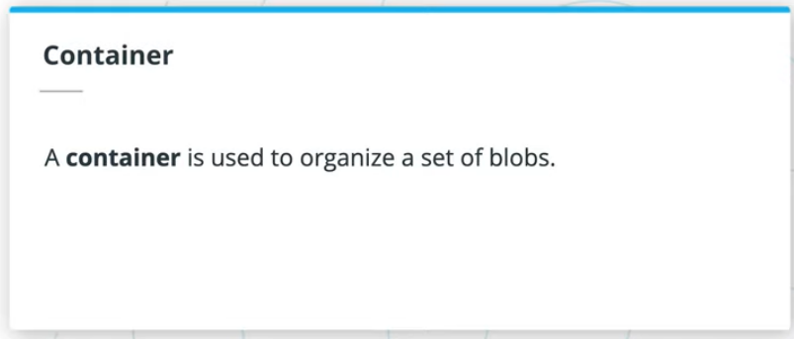

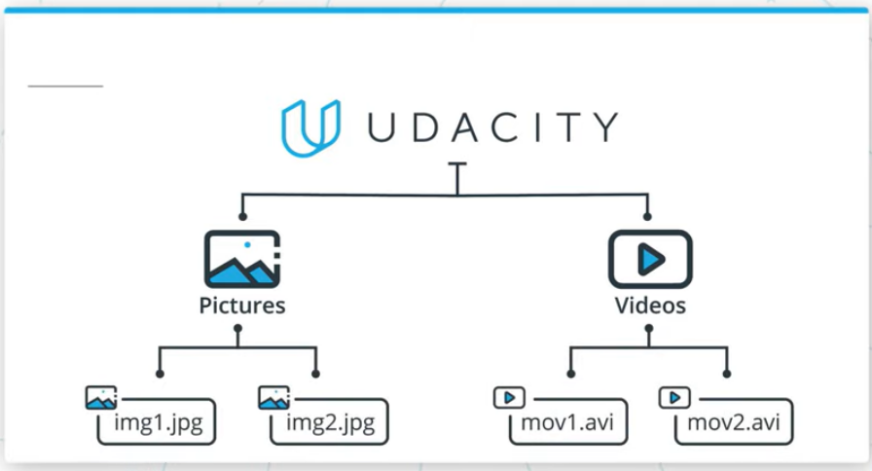

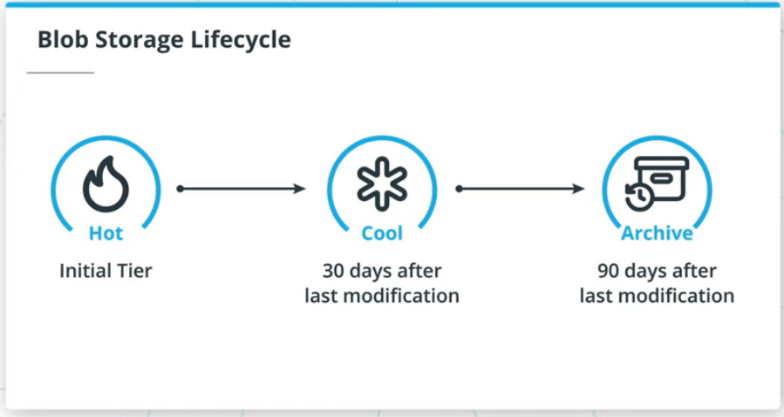

Before discussing Blob Storage Accounts, you may need to know what a **Blob** is in the first place.

A **Binary Large Object** or **Blob** is a data type that can store unstructured (binary) data and is used to store things like images or videos in a database. Blobs are not the go-to choice when it comes to structured data that is queried frequently, such as user profile information. They have higher latency than memory and local disk and don't have the indexing features that make databases efficient at running queries. Blobs are commonly used in combination with databases to store non-queryable data, such as a profile picture for a user's profile. Each user record in the database would include the URL of the blob containing the user's photo.

### Azure Storage Accounts

An Azure storage account can store data objects you create, such as blobs and files. This storage account provides a unique namespace in Azure for your data, and every item that you store has an address that includes your unique account name. It’s worth noting the name of the storage account can contain only lowercase letters and numbers.

In this course, you'll mostly utilize General-purpose v2 storage accounts, which provide support and the latest features for Azure Storage services such as blobs, Data Lake Gen2, Files, Disks, Queues, and Tables. This type of storage account is recommended for most scenarios when using Azure Storage services.

Storage accounts can contain multiple blob containers within them, such as "images" and "movies" containers, to organize different data files. From there, each container can have many blobs inside of them (the files themselves).

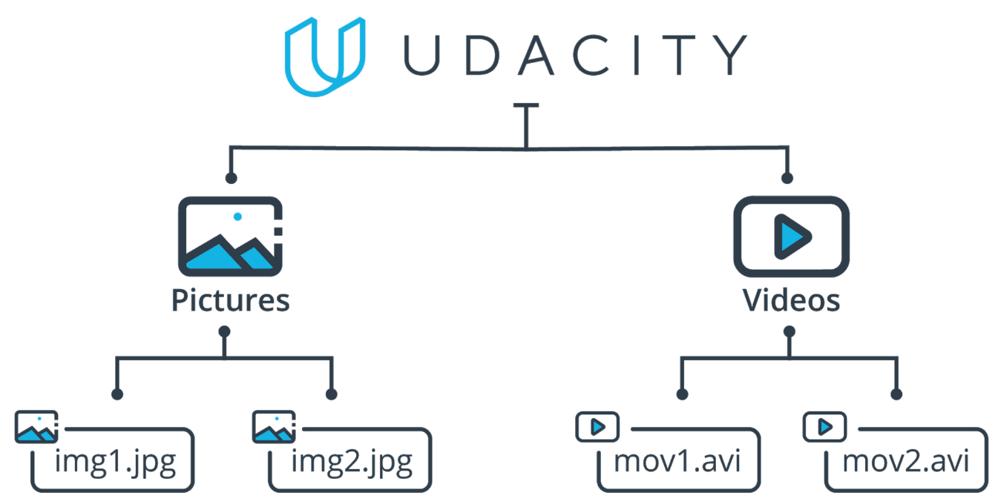

The Blob Storage Hierarchy - "Udacity" is the storage account, with "Pictures" and "Videos" as containers, each with more than one blob inside.

### Blob Storage Lifecycle

In an earlier video, we discussed blob storage tiers—hot, cold, and archive. These are set based on how frequently data will be accessed, with hot accessed the most frequently, with relatedly lower latency for requests, but higher costs.

Blob storage offers a rule-based policy you can use to transition your data between these tiers to optimize performance and cost. This is shown again in the below graphic - while your blobs may start in a Hot container, they could be moved to a Cool container if they have not been modified in the past 30 days. From there, if they have not been modified in 90 days, they could be transitioned to Archive storage; you could then perhaps delete them after a year of non-usage.

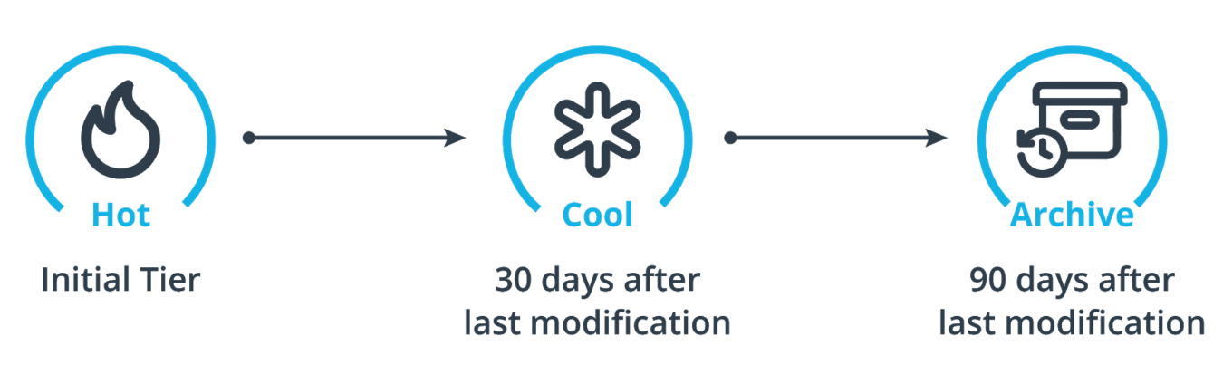

The blob storage lifecycle

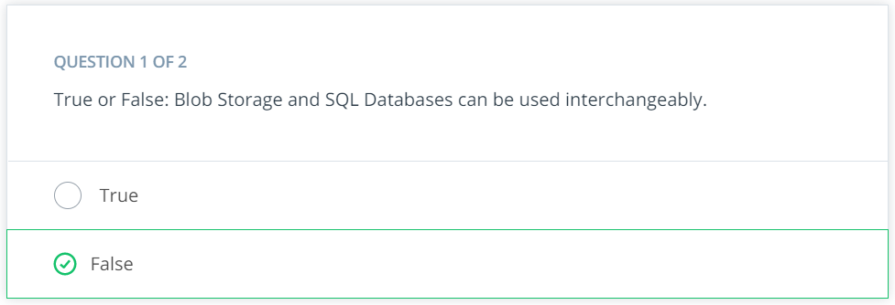

### **Creating Blob Storage in the Portal**

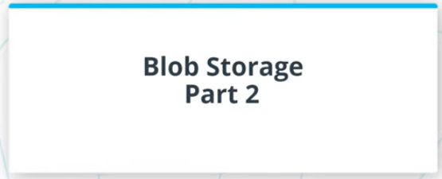

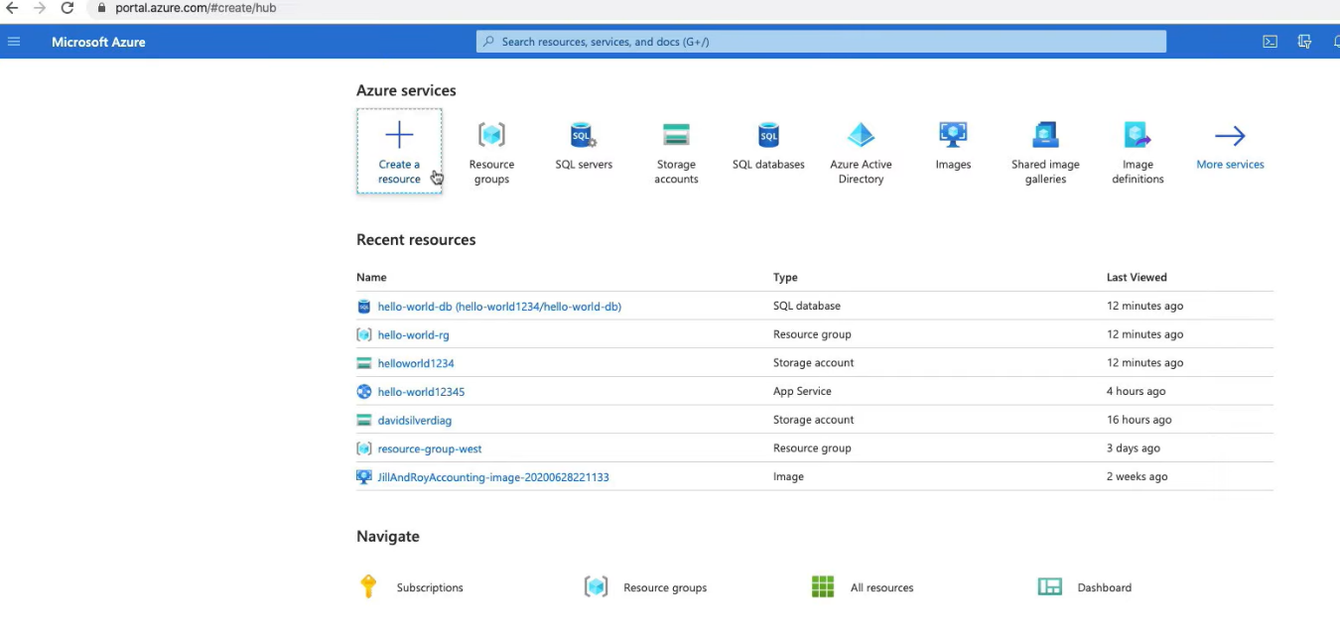

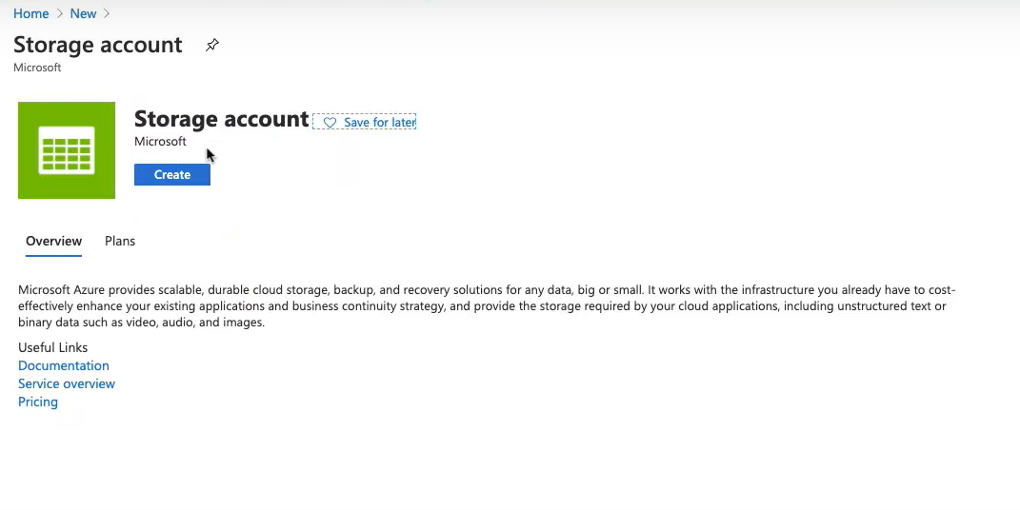

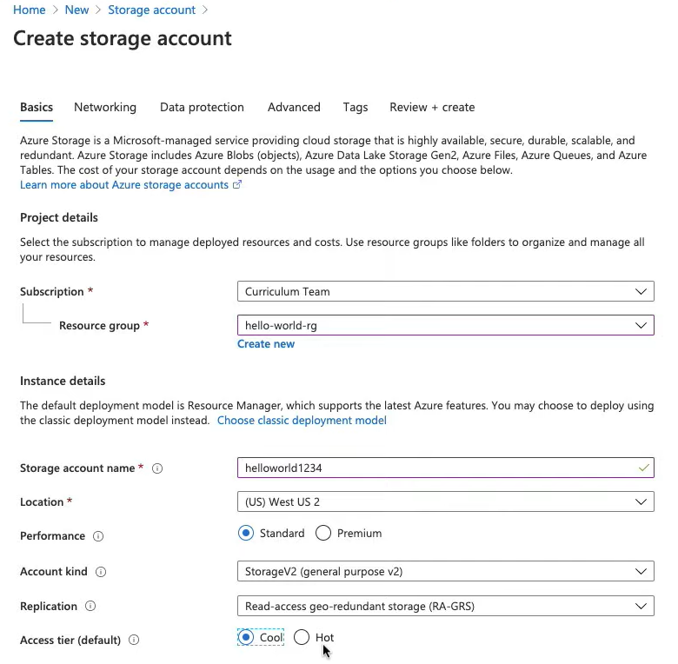

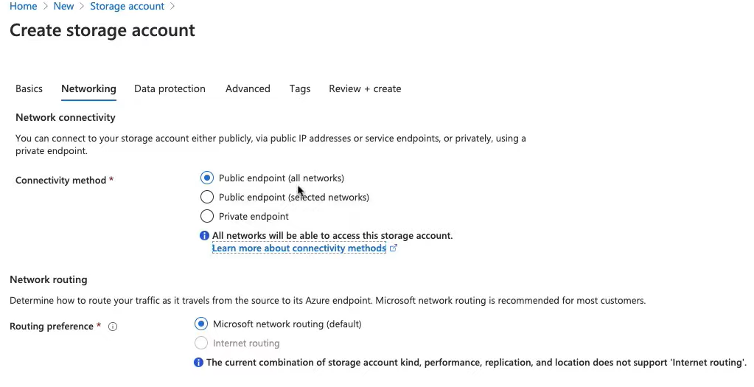

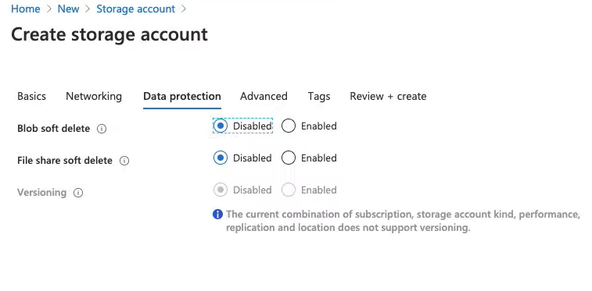

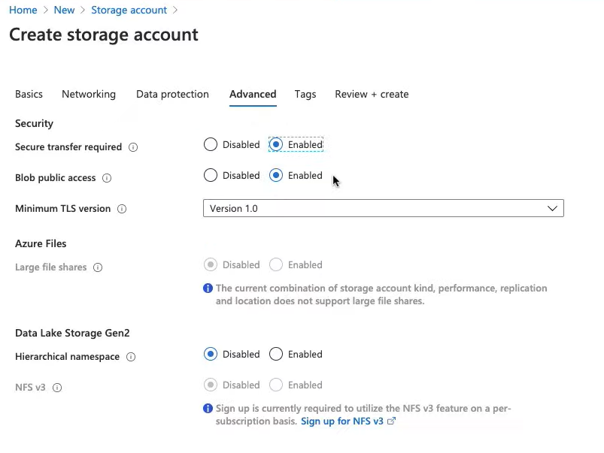

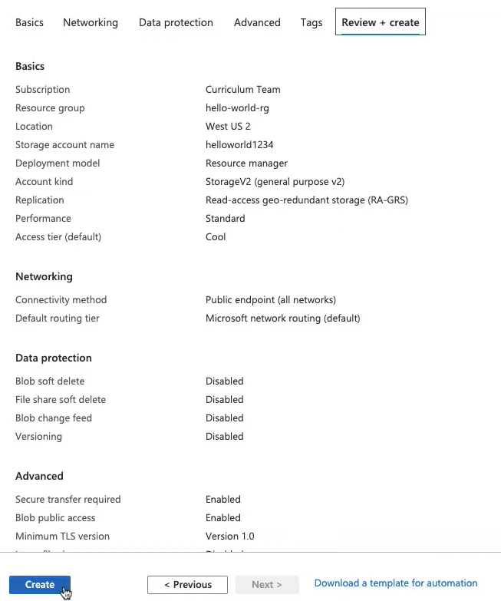

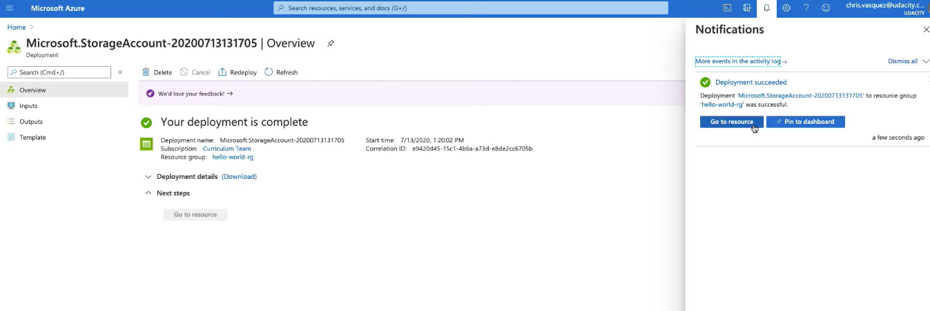

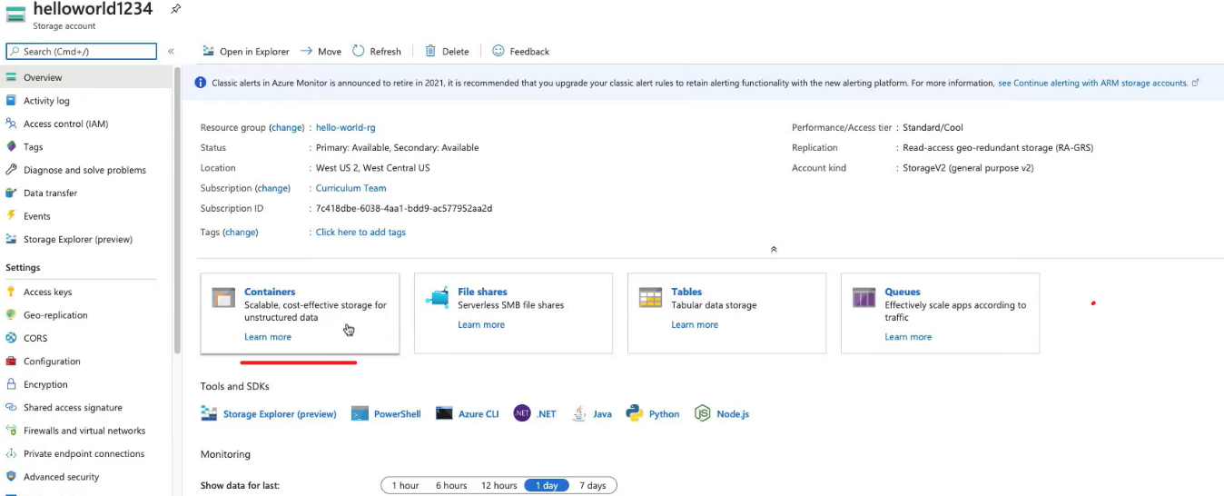

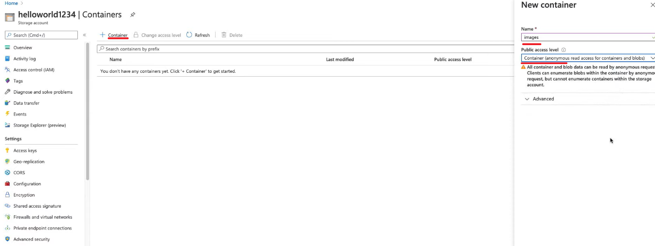

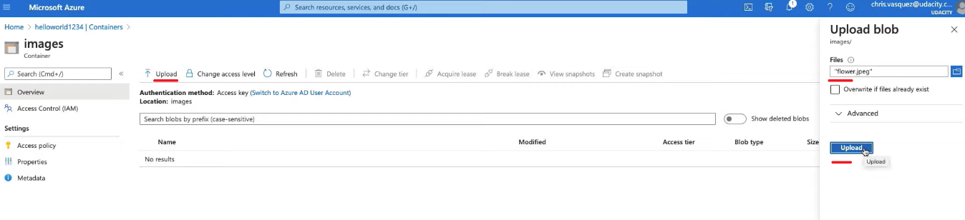

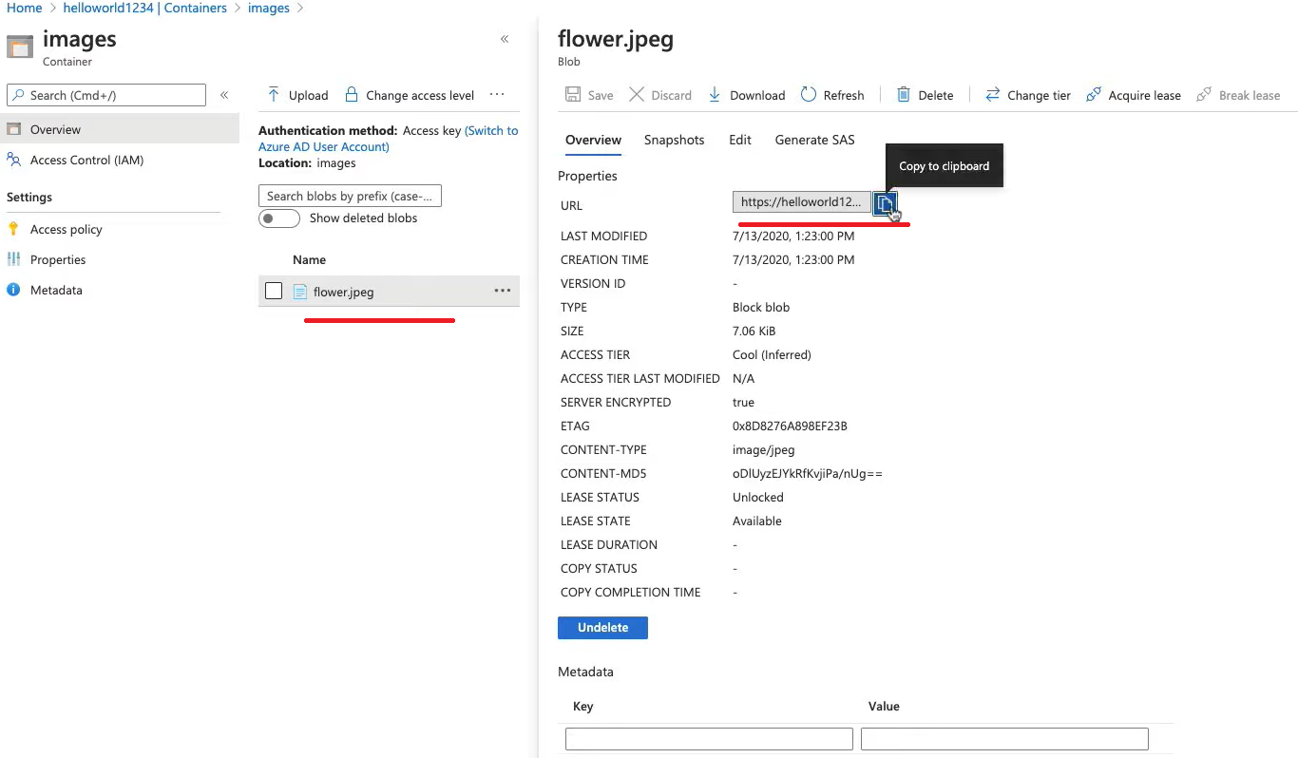

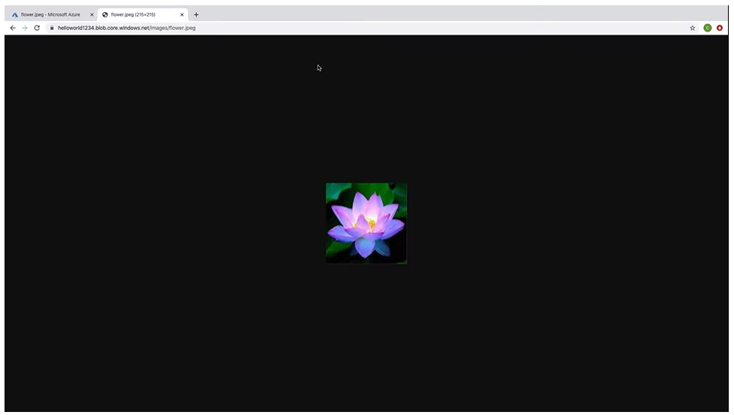

To create a blob storage account on Azure Portal, I did the following:

**Create a Storage Account in Azure**:

1. Click Create a resource
2. Search for storage account
3. Select the appropriate subscription and resource group (likely “resource-group-west”).
4. Enter a storage account name, note—it can only be lowercase letters and numbers. “helloworld1234”
5. Set the location to West US 2 to match the resource group.
6. Leave "Performance" as Standard, while making sure "Account kind" is StorageV2. This could also be BlobStorage, but StorageV2 is preferred.
7. We’ll leave replication on the default setting
8. Set "Access tier" to Cool - in a live production app, you may need this to be Hot, but in our case, Cool will work just fine.
9. Click "Next: Networking" to confirm that the storage account is using a Public endpoint (all networks)
10. Click "Next: Data Protection", "Next: Advanced", then set "Blob public access" to "Enabled".
11. Click "Review + Create" and then "Create" to create the database, then wait for it to deploy.

**To add a Blob Container called images**:

1. Once the Storage account is deployed, click on its name to access it (you may need to go back to the main "Storage accounts" page in Azure).
2. Click on the "Containers" button in the storage account's "Overview" page.
3. Click "+ Container", then add the name of images.
4. Set "Public access level" to Container, and click "Create".

**NOTE**: I had to refresh my page a few times before I could access the container.

### Adding Images to the Container

To add an image to the Blob Container:

1. Click on the container named images.
2. Click "Upload", and add an image of your choosing.
3. Once the image appears within the container view, click on it, and copy the "URL" property.
4. Paste the URL into your browser to see if the image appropriately loads.

You can also download the file from here as well.

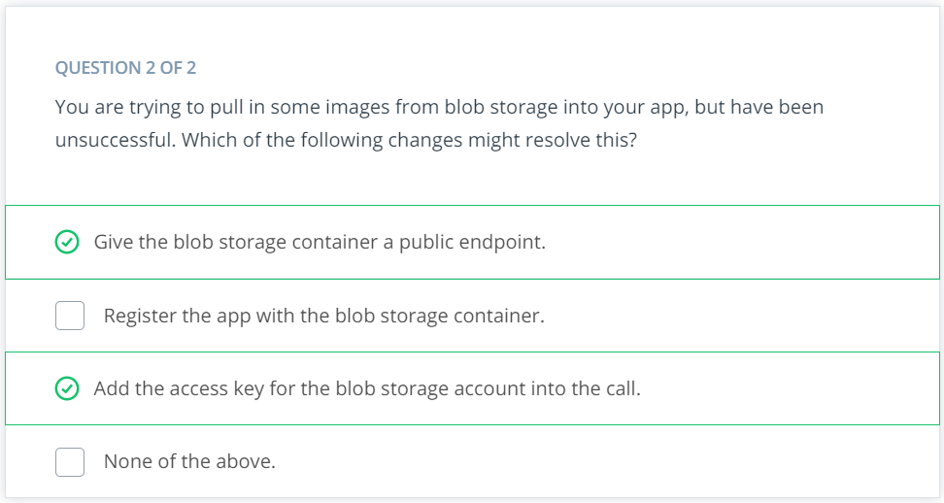

**28/09/2021 HERE**